Activity 5.2.1a The Perpendicular Bisector as a Locus of Points

Use a ruler and protractor to make measurements on the figure below.

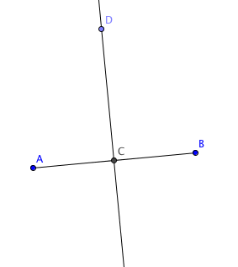
- Measure the distances CA and CB. What do you notice?
- C is the ____________ of $\overline{AB}$.
- Measure $∠$DCB. What do you notice?
- $\overset{⃡}{DC}$ is __________________to $\overline{AB}$.
- $\overset{⃡}{DC}$ is the _______________ _______________ of $\overline{AB}$.
- Measure the distances DA and DB. What do you notice?
- Now place more points E, F, and G on $\overset{⃡}{DC}$.
- Measure these distances
EA = __________ EB = ____________
FA = __________ FB = _____________
GA = __________ GB = _____________
What do you notice?
- Make a conjecture about all points that lie on $\overset{⃡}{DC}$

- Now place a point H in the plane that is not on $\overset{⃡}{DC}$. Measure HA and HB. What do you notice?
- Try to find a point J in the plane that is not on $\overset{⃡}{DC}$ so that JA = JB. What do you notice?
- Make a conjecture about all points that are equidistant from points A and B.

