Activity 5.1.2 Circles Anywhere in the Coordinate Plane

Circles centered at the origin
- If a circle is centered at the origin and has a radius 9, what is an equation for the circle?
- If a circle has an equation x² + y² = 64, where is the center of the circle?
- If a circle has an equation x² + y² = 64, what is the radius of the circle?

For questions 4 through 6, consider the graph and table below.

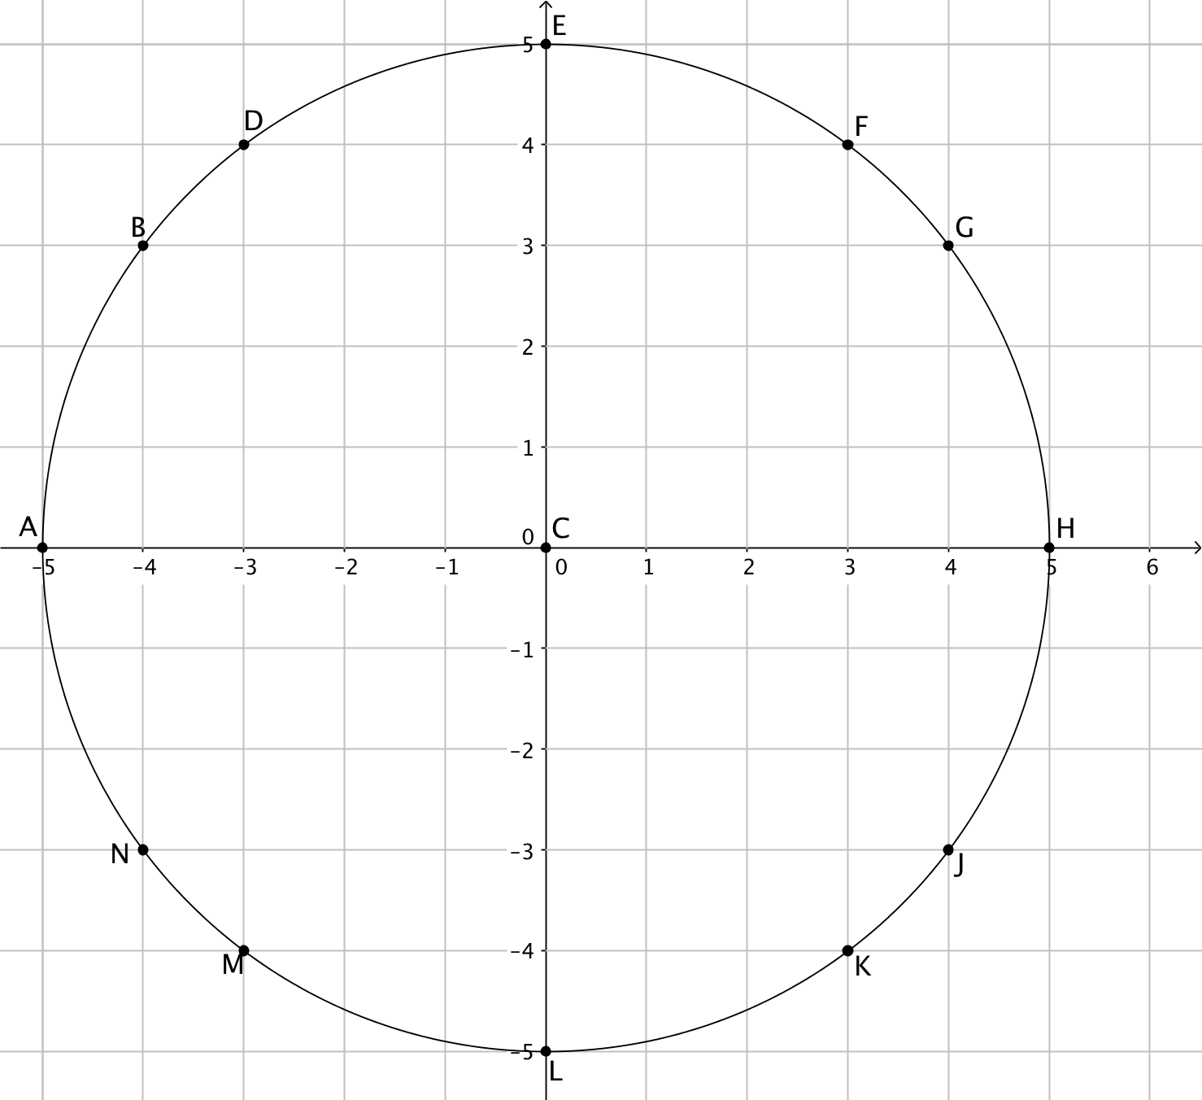 | Point X Y Point X Y  C 0 0 G 4 3  H 5 0  A -5 0 J 4 -3  B -4 3 K 3 -4  D -3 4 L 0 -5  E 0 5 M -3 -4  F 3 4 N -4 -3
- What is the center of the circle?
- For this activity your teacher may assign you letter. Draw the segment from the center to the point on the circle named by your letter. Use the distance formula to find the radius of the circle.
- What is an equation for this circle?
Circles not centered at the origin
For questions 7 through 9, consider the graph and table below.
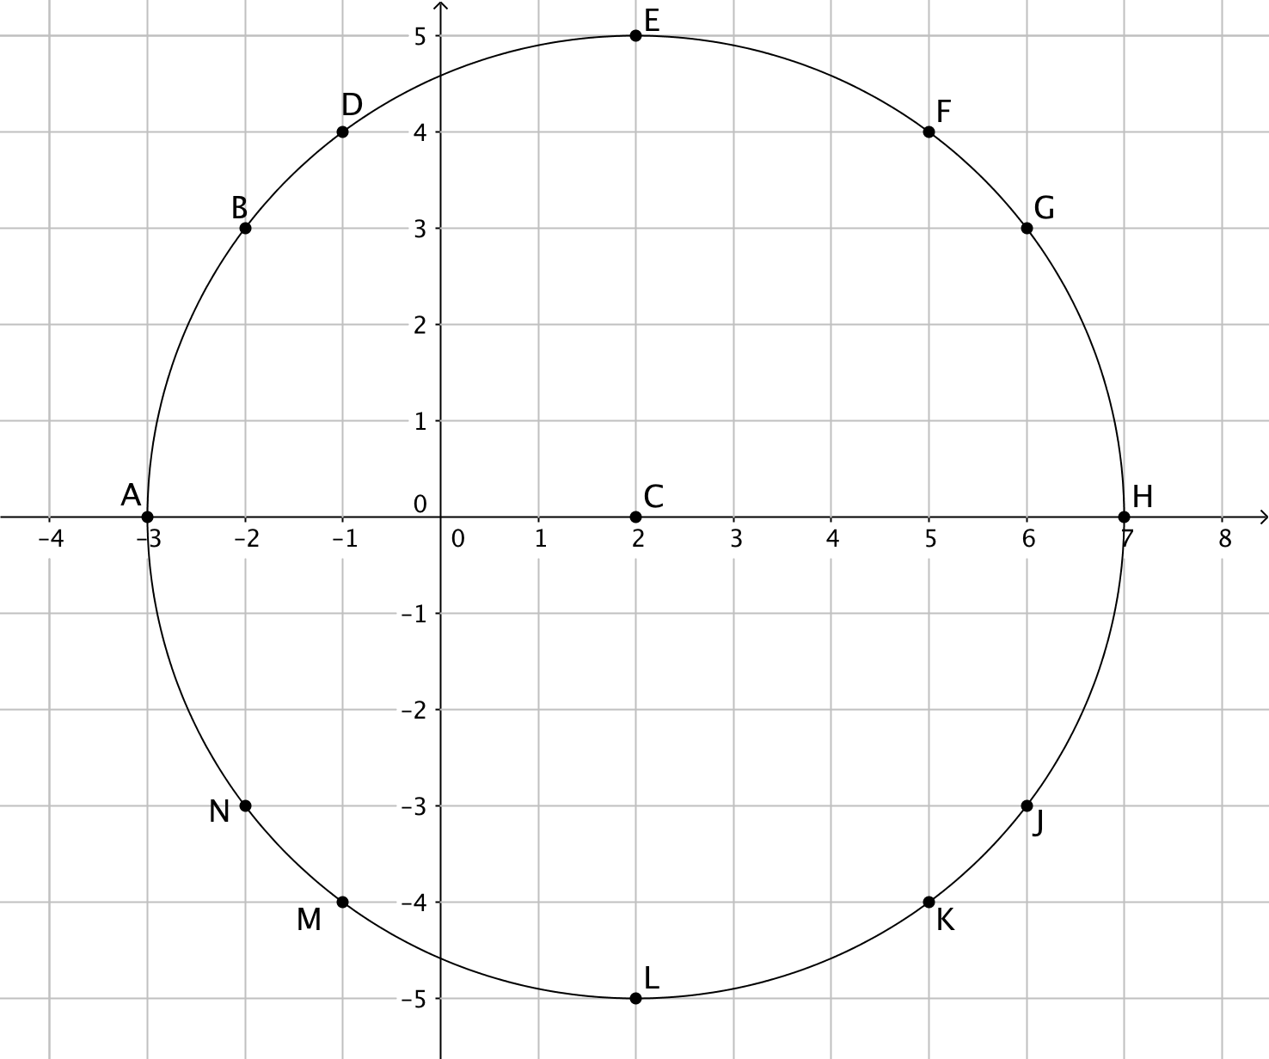 | Point X Y Point X Y  C 2 0 G 6 3  H 7 0  A -3 0 J 6 -3  B -2 3 K 5 -4  D -1 4 L 2 -5  E 2 5 M -1 -4  F 5 4 N -2 -3
- What is the center of this circle?
- Draw the segment from the center of the circle to the same point (letter) you used in
question 5. Use the distance formula to calculate the radius of the circle.
- Brandon says that an equation for this circle is (x – 2)² + y² = 25. Do you think he is correct? Select a couple of points in the table to check Brandon's equation.
For questions 10 through 12, consider the graph and table below.
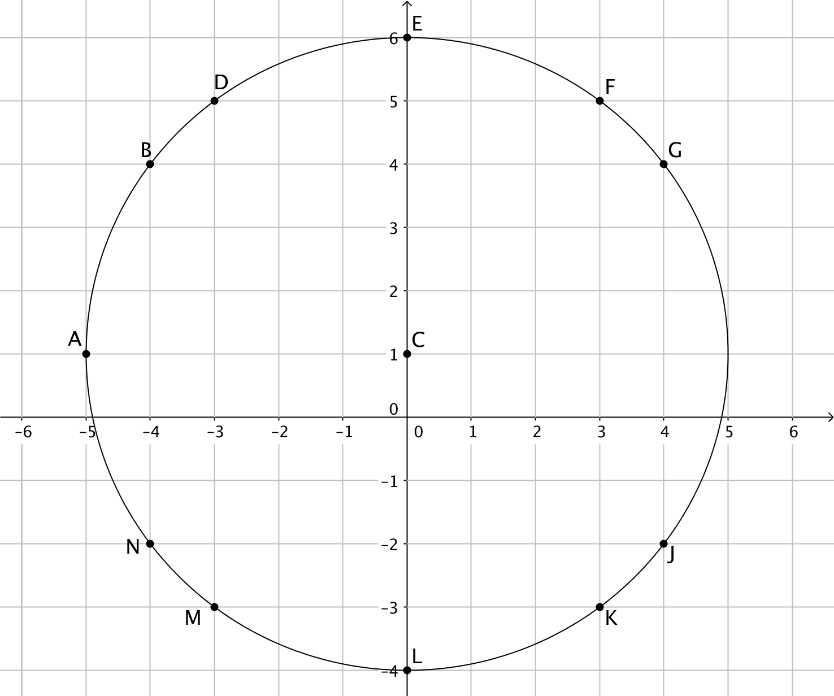 | Point X Y Point X Y  C 0 1 G 4 4  H 5 1  A -5 1 J 4 -2  B -4 4 K 3 -3  D -3 5 L 0 -4  E 0 6 M -3 -3  F 3 5 N -4 -2
- What is the center of this circle?
- Draw the segment from the center of the circle to the same point (letter) you used in
question 5. Use the distance formula to calculate the radius of the circle.
- Arianna says that the equation for this circle is x² + (y – 1)² = 25. Do you think she is correct? Select a couple of points in the table to check Arianna's equation.
For questions 13 through 15, consider the graph and table below.
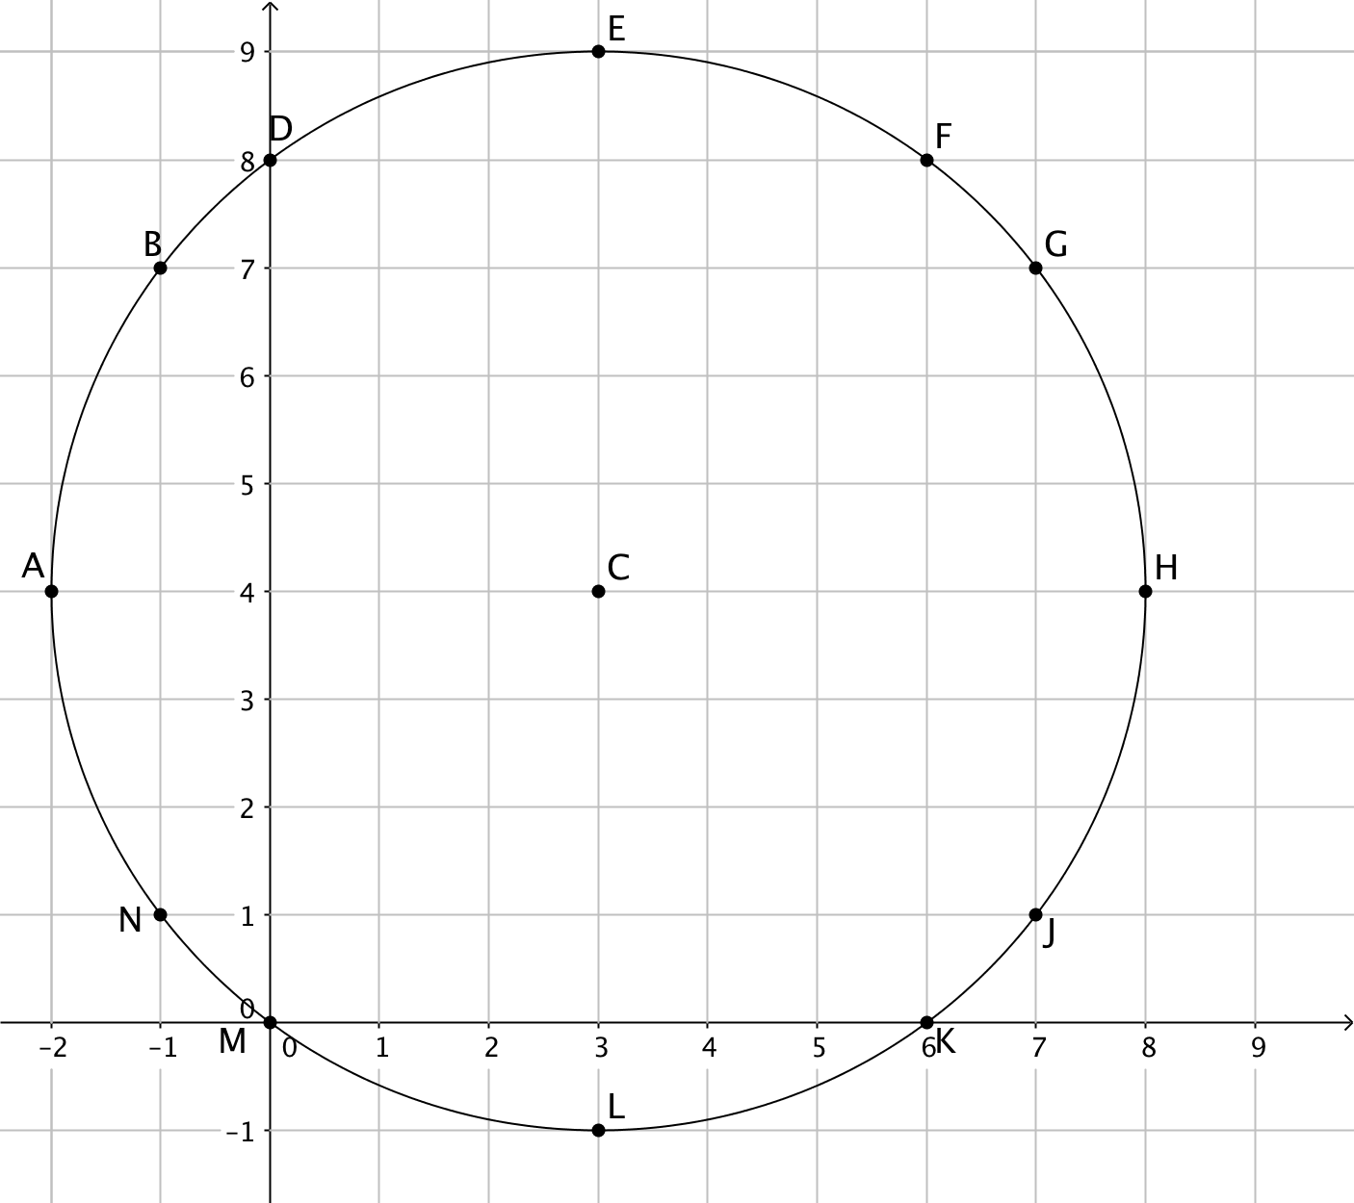 | Point X Y Point X Y  C 3 4 G 7 7  H 8 4  A -2 4 J 7 1  B -1 7 K 6 0  D 0 8 L 3 -1  E 3 9 M 0 0  F 6 8 N -1 1
- What is the center of this circle?
- Draw the segment from the center of the circle to the same point (letter) you used in
question 5. Use the distance formula to calculate the radius of the circle.
- Jacob says that the equation for this circle is (x – 4)² + (y – 3)² = 25. Select a point in the table and use it to show that Jacob's equation is incorrect. Correct Jacob's equation.
- Suppose the center of a circle has coordinates (h, k) and radius = r. Write an equation for this circle.
- Show that the general equation you found in question 16 works for the circle you studied in questions 13 through 15.
- The coordinates h and k do not have to be positive numbers. Find an equation for each of these circles:
a. center (–4,5), radius = 3
b. center (–2, –6), radius = 8
c. center (0, –5), radius = 5
- Find the center and radius of the circle with equation ${(x-2)}^{2}+ {(y+7)}^{2}=81.$

