**Activity 2.1.3 Stretch It! Part Two**

As we continue exploring the transformations that can be imposed upon quadratic functions, let us stress the importance of *understanding*, not memorizing, what graphical changes happen when we change certain parameters of the function.

1. Again, we will start with the parent function, .

|  |  |
| --- | --- |
|  | |
| ***x*** | ***y*** |
| –3 |  |
| –2 |  |
| 0 |  |
| 2 |  |
| 3 |  |

2.  Where *k* is “outside” of the function.

Using a graphing utility, create a table of values for the 4 given values of *k*. Then plot your values and draw a smooth curve to approximate the transformed quadratic function. On each graph, include the graph of the parent function. Label the two functions on your graph  and  respectively.

|  |  |
| --- | --- |
|  | |
| ***x*** | ***y*** |
| –2 |  |
| –1 |  |
| 0 |  |
| 1 |  |
| 2 |  |

|  |  |
| --- | --- |
|  | |
| ***x*** | ***y*** |
| –2 |  |
| –1 |  |
| 0 |  |
| 1 |  |
| 2 |  |

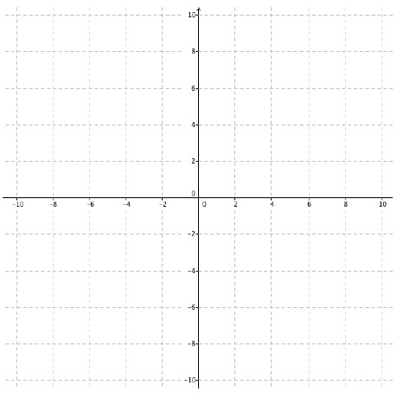

|  |  |
| --- | --- |
|  | |
| ***x*** | ***y*** |
| –4 |  |
| –2 |  |
| 0 |  |
| 2 |  |
| 4 |  |

|  |  |
| --- | --- |
|  | |
| ***x*** | ***y*** |
| –4 |  |
| –2 |  |
| 0 |  |
| 2 |  |
| 4 |  |

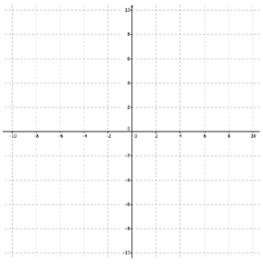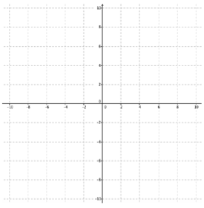

|  |  |
| --- | --- |
|  | |
| ***x*** | ***y*** |
| –2 |  |
| –1 |  |
| 0 |  |
| 1 |  |
| 2 |  |

|  |  |
| --- | --- |
|  | |
| ***x*** | ***y*** |
| –2 |  |
| –1 |  |
| 0 |  |
| 1 |  |
| 2 |  |

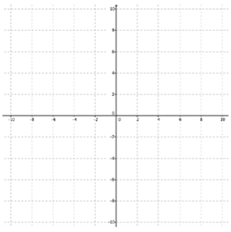

|  |  |
| --- | --- |
|  | |
| ***x*** | ***y*** |
| –10 |  |
| –5 |  |
| 0 |  |
| 5 |  |
| 10 |  |

|  |  |
| --- | --- |
|  | |
| ***x*** | ***y*** |
| –3 |  |
| –2 |  |
| 0 |  |
| 2 |  |
| 3 |  |



3. What do all of the transformations have in common?

4. As a general rule, what two things can you say about the effect on the parabola for given values of “*k*” when *k* is a value producing an outside change?

5.  Where *k* is “inside” of the function.

Using a graphing utility, create a table of values for the 4 given values of *k*. Then plot your values and draw a smooth curve to approximate the transformed quadratic function. On each graph, include the graph of the parent function. Label the two functions on your graph  and  respectively.

|  |  |
| --- | --- |
|  | |
| ***x*** | ***y*** |
| –2 |  |
| –1 |  |
| 0 |  |
| 1 |  |
| 2 |  |

|  |  |
| --- | --- |
|  | |
| ***x*** | ***y*** |
| –2 |  |
| –1 |  |
| 0 |  |
| 1 |  |
| 2 |  |



|  |  |
| --- | --- |
|  | |
| ***x*** | ***y*** |
| –6 |  |
| –4 |  |
| 0 |  |
| 4 |  |
| 6 |  |

|  |  |
| --- | --- |
|  | |
| ***x*** | ***y*** |
| –8 |  |
| –4 |  |
| 0 |  |
| 4 |  |
| 8 |  |



|  |  |
| --- | --- |
|  | |
| ***x*** | ***y*** |
| –2 |  |
| –1 |  |
| 0 |  |
| 1 |  |
| 2 |  |

|  |  |
| --- | --- |
|  | |
| ***x*** | ***y*** |
| –2 |  |
| –1 |  |
| 0 |  |
| 1 |  |
| 2 |  |



|  |  |
| --- | --- |
|  | |
| *x* | *y* |
| –6 |  |
| –3 |  |
| 0 |  |
| 3 |  |
| 6 |  |

|  |  |
| --- | --- |
|  | |
| *x* | *y* |
| –6 |  |
| –3 |  |
| 0 |  |
| 3 |  |
| 6 |  |



6. What do all of the transformations have in common?

7. As a general rule, what can you say about the effect on the parabola for given values of “*k*” when k is a value producing an inside change?

8. Does the sign value of *k* make any difference on your answer from #7? Clearly explain why or why not. Can *k* be zero?