Unit 3: Investigation 5 (3 Days)

Properties of Quadrilaterals

Common Core State Standards

- G-CO.11. Prove theorems about parallelograms. Theorems include: opposite sides are congruent, opposite angles are congruent, the diagonals of a parallelogram bisect each other, and conversely, rectangles are parallelograms with congruent diagonals.

Overview

Students are introduced to a hierarchy of convex quadrilaterals as a means to classify them by their properties. They then discover properties of diagonals and symmetries of special quadrilaterals. They prove theorems involving both necessary and sufficient conditions for parallelograms, rectangles, and rhombuses. Finally they establish formulas for the areas of parallelograms, triangles, trapezoids and kites.

Assessment Activities

Evidence of Success: What Will Students Be Able to Do?

- Understand relationships among special quadrilaterals
- Prove theorems related to quadrilaterals
- Derive formulas for the areas of parallelograms, triangles, trapezoids and kites.

Assessment Strategies: How Will They Show What They Know?

  - Exit Slip 3.5.1 assesses their understanding of the quadrilateral hierarchy
  - In Exit Slip 3.5.2 they provide justifications for steps in a proof of a theorem related to parallelograms
  - Exit Slip 3.5.3 involves the application of area formulas.
  - Journal Entry asks students to explore the difference between necessary and sufficient conditions.

Launch Notes

Paulus Gerdes describes two methods used by peasants in Mozambique to construct rectangular houses. (Gerdes, p. 94-95). The first method is to lay on the floor two bamboo sticks of equal length then connect them with two other sticks of equal length to form a quadrilateral. The figure is further adjusted until the diagonals, measured with a rope, are equal. The second method starts with two ropes of equal length tied together at their midpoints. A bamboo stick whose length is equal to the desired length of the house is used to pin down two of the ropes’ endpoints. The ropes are then stretched to find the other two vertices of the rectangle.

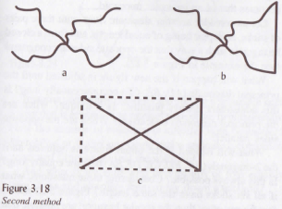
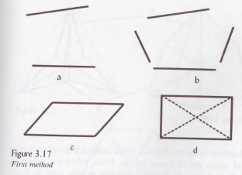

From Gerdes (1999, p. 95)

Illustrate these methods preferably with concrete models. Pose the question, how can we be sure that the figures formed are rectangles?

Teaching Strategies

Activity 3.5.1 Classifying Quadrilaterals introduces students to the hierarchy of quadrilaterals (Craine and Rubenstein, 1993). Students are given 12 figures and asked to identify which figures share certain properties. On the basis of their discoveries they are able to understand relationships such as “a square is a special rhombus,” “a rhombus is both a parallelogram and a kite,” etc. One consequence of this system of classification is that once a property is proved for a particular type of quadrilateral (say a parallelogram) it also applies to all subcategories of that type (e.g. rectangle, rhombus, and square). These relationships are shown in the form of the chart shown on the next page and on page 4 of the activity sheet.

Differentiated Instruction (Enrichment)
Have students create their own chart similar to the one on the next page.

Note to teacher: Two definitions of trapezoid are commonly found in textbooks: (1) A trapezoid is a quadrilateral with exactly one pair of parallel sides, and (2) A trapezoid is a quadrilateral with at least one pair of parallel sides. In the activity above we have adopted the second definition since it facilitates constructing the hierarchy of quadrilaterals, by allowing rectangles to be considered special isosceles trapezoids.

Following this activity you may use Exit Slip 3.5.1.

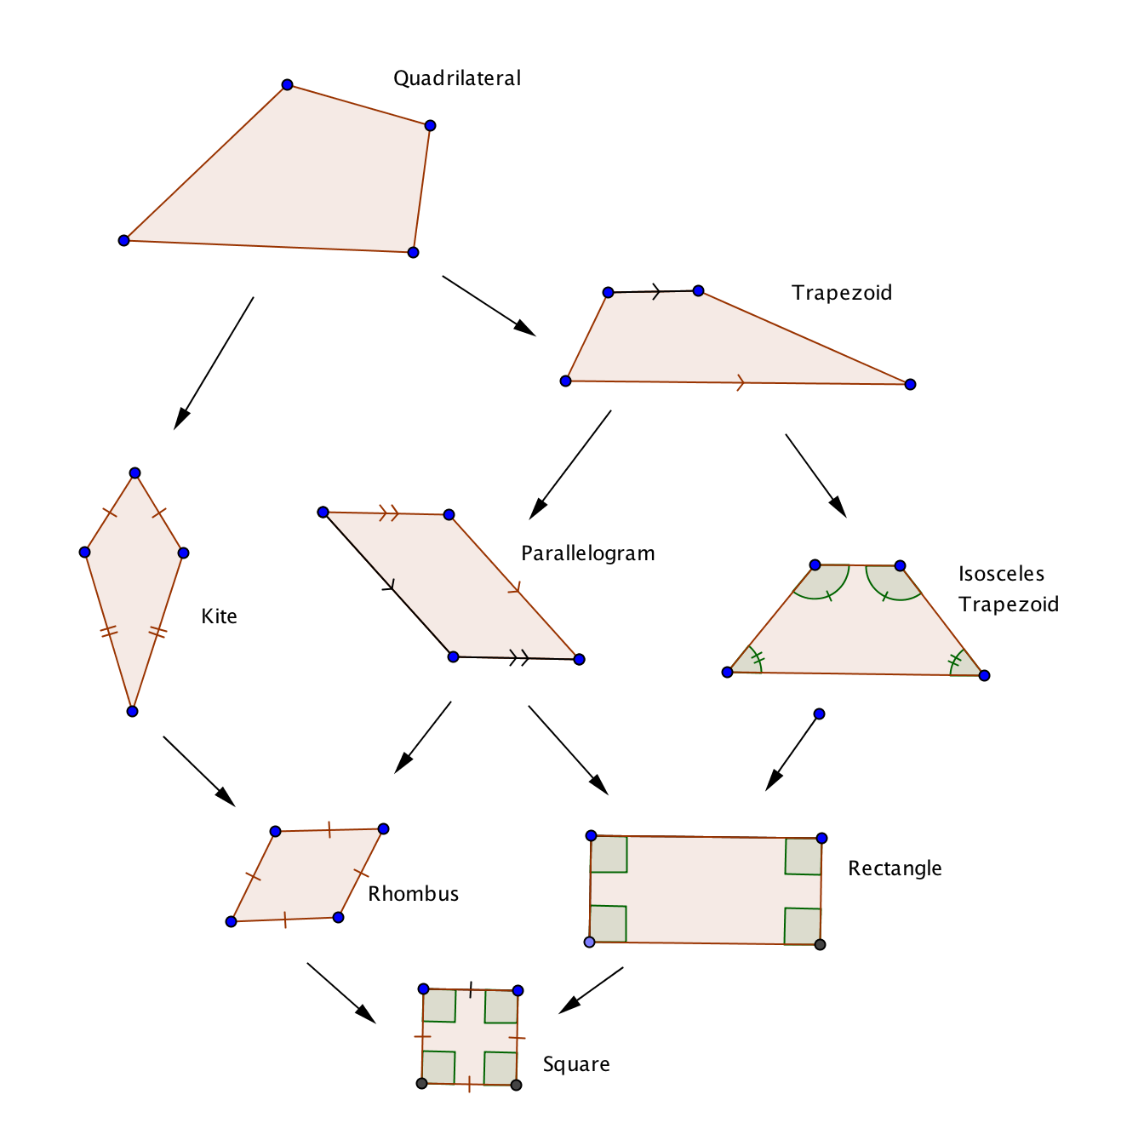

In Activity 3.5.2 Diagonals of Quadrilaterals students will use software or other tools to discover which special quadrilaterals have (1) congruent diagonals (isosceles trapezoids, rectangles, and squares), (2) perpendicular diagonals (kites, rhombuses, and squares), and (3) diagonals which bisect each other (parallelograms, rectangles, rhombuses and squares). The conjectures thus generated will be proved as theorems later in this investigation and in Investigation 6. The findings from this activity are summarized on the chart shown above and on page 4 of the activity sheet. Activity 3.5.2a has students cut out shapes, and use rulers and protractors. In Activity 3.5.2b students use premade Geogebra files for each of the eight types of quadrilateral.

Differentiated Instruction (For Learners Needing More Help)
Some students may have difficulty unpacking the phrase “bisect each other.” Break it down into two sentences: “Diagonal $\overline{AC }$bisects diagonal $\overline{BD}$,” and “Diagonal$\overline{BD}$ bisects diagonal $\overline{AC }$.” An alternative wording is “$\overline{AC }$ and $\overline{BD}$ have the same midpoint.”

Activity 3.5.3 Symmetry in Quadrilaterals is based on these open ended questions: In Investigation 4 you learned that a regular quadrilateral has four lines of symmetry as well as 90° rotational symmetry. What other special quadrilaterals have lines of symmetry? How many? Where are they located? What special quadrilaterals have rotational symmetry? What is the angle of rotation?

Students may work in groups to make these discoveries: Isosceles trapezoids have at least one line of symmetry through the midpoints of opposite sides, and rectangles have two lines of symmetry through both pairs of midpoints. Kites have at least one line of symmetry through opposite vertices, and rhombuses have two lines of symmetry through both pairs of midpoints. Parallelograms have 180° rotational symmetry (as do rectangles, rhombuses, and squares since they are all special parallelograms). The findings from this activity are summarized on the chart on page 3.

Group Activity
Activity 3.5.3 lends itself to group investigation. Form heterogeneous groups so that the stronger students may help other members of the group articulate their findings.

In Activity 3.5.4 Properties of Parallelograms students start with a definition of parallelogram as a quadrilateral with two pairs of parallel sides. From that they prove that (1) the opposite sides are congruent (2) the diagonals bisect each other, and (3) the opposite angles are congruent.

Activity 3.5.5 Sufficient Conditions for Parallelograms introduces converses of the previous theorems. The theorems of the previous activity had the form: if a quadrilateral is a parallelogram then a certain condition holds. That condition is necessary since all parallelograms must have that condition. In this activity theorems take the form: if a certain conditions holds, then the quadrilateral is a parallelogram. The condition is sufficient since it provides enough information to ensure that the quadrilateral is a parallelogram. The sufficient conditions introduced in this activity are (1) two pairs of opposite sides and congruent, (2) one pair of opposite sides is both parallel and congruent, (3) the diagonals bisect each other, and (4) both pairs of opposite angles are congruent. These properties are first discovered by hands-on experiments with linguine.

Following this activity you may use Exit Slip 2.

In Activity 3.5.6 Rectangles and Rhombuses students start with these definitions: a rectangle is a quadrilateral with four congruent angles and a rhombus is a rectangle with four congruent sides. From these definitions they prove that all rectangles and all rhombuses are parallelograms. They also prove the properties of diagonals discovered in Activity 3.5.2: that the diagonals of a rectangle are congruent and that the diagonals of a rhombus are perpendicular. Conversely a parallelogram with congruent diagonals is a rectangle and a parallelogram with perpendicular diagonals is a rhombus. There are two versions of this activity. Activity 3.5.6a has more scaffolding for questions 4 and 6 than does Activity 3.5.6b.

Activity 3.5.7 Areas of Quadrilaterals begins with the Rectangle Area Postulate. From that postulate students derive formulas for the areas of parallelograms, triangles, kites, and trapezoids. Several different approaches may be taken for each derivation. See Flores article under resources. You may want to do this as a class activity with hands-on materials in addition to, or instead of, using the animations.

Following this activity you may use Exit Slip 3.5.3

Caution: Many theorems are proved in this investigation. Rather than asking students to memorize the theorems, have them refer to the charts constructed in the first three activities. The most important theorems are indicated with asterisks in the appendix of this investigation overview.

Differentiated Instruction (Enrichment)
Students who wish to explore further, may want to prove theorems related to kites and isosceles trapezoids.

Journal Entry
Explain these statements: Having diagonals that bisect each other is a necessary condition for a quadrilateral to be a rectangle. However, it is not a sufficient condition. Look for students to recognize that having mutually bisecting diagonals is a property of all parallelograms, not just rectangles.

Closure Notes

Return to the questions posed in the launch. Both methods depend upon the fact that a parallelogram with congruent diagonals is a rectangle. In the first case we use the fact that if the opposite sides of a quadrilateral are congruent, then it is a parallelogram. In the second case we use the fact that if the diagonals of a quadrilateral bisect each other, then we have a parallelogram.

Vocabulary

Quadrilateral
Trapezoid
Kite
Parallelogram
Isosceles Trapezoid
Rhombus
Rectangle
Square

“Bisect each other”

Necessary condition
Sufficient condition

Resources and Materials
Activity 3.5.1 Classifying Quadrilaterals
Activity 3.2.3 Diagonals of Quadrilaterals
Activity 3.5.3 Symmetry in Quadrilaterals
Activity 3.5.4 Properties of Parallelograms
Activity 3.5.5 Sufficient Conditions for Parallelograms
Activity 3.5.6 Rectangles and Rhombuses
Activity 3.5.7 Areas of Quadrilaterals

Linguine for Activity 3.5.4

Craine, Timothy V. and Rheta N. Rubenstein. A Quadrilateral Hierarchy to Facilitate Learning in Geometry. Mathematics Teacher 86 (1993), 30-36.

Flores, Alfinio. Area Formulas with Hinged Figures. In Understanding Geometry for a Changing World, NCTM, 2009.

Gerdes, Paulus. Geometry from Africa: Mathematical and Educational Explorations. Mathematical Association of America, 1999.

http://people.wku.edu/tom.richmond/area.html for Activity 3.5.7.

Theorems

Parallelogram Opposite Sides Theorem: If a quadrilateral is a parallelogram, then both pairs of opposite sides are congruent.

Parallelogram Opposite Sides Converse: If both pairs of opposite sides of a quadrilateral are congruent, then the quadrilateral is a parallelogram.

Parallelogram Diagonals Theorem: If a quadrilateral is a parallelogram, then the diagonals bisect each other.

Parallelogram Diagonals Converse: If the diagonals of a quadrilateral bisect each other, then the quadrilateral is a parallelogram.

Rectangle Diagonals Theorem: If a parallelogram is a rectangle, then the diagonals are congruent.

Rectangle Diagonals Converse: If the diagonals of a parallelogram are congruent, then the parallelogram is a rectangle.

One Pair Congruent and Parallel Theorem: If two sides of a quadrilateral are parallel and congruent, then the quadrilateral is a parallelogram.

Parallelogram Opposite Angles Theorem: If a quadrilateral is a parallelogram, then both pairs of opposite angles are congruent.

Parallelogram Opposite Angles Converse: If both pairs of opposite angles of a quadrilateral are congruent, then the quadrilateral is a parallelogram.

Rhombus Diagonals Theorem: If a parallelogram is a rhombus, then the diagonals are perpendicular.

Rhombus Diagonals Converse: If the diagonals of a parallelogram are perpendicular, then the parallelogram is a rhombus.

Area Formulas

Rectangle Area Postulate If b is the base and h is the height of a rectangle, then Area = bh.
Parallelogram Area Formula If b is the base and h is the height of a parallelogram,
then Area = bh.
Triangle Area Formula - If b is the base and h is the height of a triangle, then Area = $\frac{1}{2}$bh.
Trapezoid Area Formula – If b₁ and b₂ are the lengths of the two bases of a trapezoid and h is the height, then Area = $\frac{1}{2}$h(b₁+ b₂).
Kite Area Formula – If d₁ and d₂ are the diagonals of a kite, then Area = $\frac{1}{2}$d₁d₂.

