Unit 3: Investigation 2 (2 Days)

Inequalities in Triangles

Common Core State Standards

- G-CO.10. Prove theorems about triangles. Theorems include: measures of interior angles of a triangle sum to 180°; base angles of isosceles triangles are congruent; the segment joining midpoints of two sides of a triangle is parallel to the third side and half the length; the medians of a triangle meet at a point.

Overview

Students will prove and apply four theorems involving inequalities in triangles. These include the Exterior Angle of a Triangle Theorem (and its corollary), the Angle Opposite Longer Side Theorem, the Side Opposite Larger Angle Theorem, and the Triangle Inequality.

Assessment Activities

Evidence of Success: What Will Students Be Able to Do?

- Understand and explain Proofs of theorems involving inequalities in triangles.
- Apply theorems involving inequalities in triangles.

Assessment Strategies: How Will They Show What They Know?

- Exit Slip 3.2.1 asks students to find exterior angles and/or interior angles in a triangle given sufficient information.
- Exit Slip 3.2.2 asks students to identify the greater side or the greater angle in a triangle given sufficient information.
- In the Journal Entry students will summarize what they have learned about inequalities in a triangle.

Launch Notes

Begin by discussing how GPS devices are used in navigation and how helpful they are in planning routes and finding destinations with which one is unfamiliar. Then pose this question: when you type in an address, the GPS will give a distance to that location, let’s say 10 miles. But once you pull out of your driveway onto the street, it may give you a longer distance, say 15 miles. Why is that? Elicit from students the distinction between distance that is “straight as the crow flies” and the actual distance traveled on the streets. From that we have the general principle that the path along a straight line segment is the shortest distance between two points. In this investigation we will prove the case where this principle is applied to triangles. The Triangle Inequality states that the sum of the lengths of any two sides of a triangle is greater than the length of the third side.

The Triangle Inequality Theorem will be the last of several theorems we will prove in this investigation since its proof depends upon the previous ones.

Teaching Strategies

First have students discover some of the inequalities associated with triangles. Activity 3.2.1 Discovering Inequalities in Triangles will lead students to make conjectures. Students will use rulers and protractors to measure sides and interior angles in a variety of triangles. They will be asked to observe the relationships among the sides and among the angles. This should lead them to conjecture that in any triangle the longest side is opposite the largest angle, and that the shortest side is opposite the smallest angle. They will also verify that the sum of the lengths of two sides of a triangle is greater than the length of the third side.

Differentiated Instruction (For Learners Needing More Help)
There are two versions of Activity 3.2.1. Activity 3.2.1a has more scaffolding on page 5 to lead students to the appropriate conjecture for students and is appropriate for students who feel overwhelmed by open-ended questions.

In Activity 3.2.2 Exterior Angles of Polygons students learn the definition of an exterior angle of a [convex] polygon and use the fact that an exterior angle and its non-adjacent interior angle form a linear pair to solve problems similar to those in Activity 3.1.5. They should then be able to prove a special property for exterior angles of triangles. The Exterior Angle of a Triangle Theorem states that the measure of an exterior angle of any triangle is equal the sum of the measures of the two non-adjacent interior angles. A corollary to that theorem is that an exterior angle of a triangle is greater than either non-adjacent interior angle. Be sure to point that out since the corollary will be used in Activity 3.2.3.

You should be able to finish Activity 3.2.2 and start on Activity 3.2.3 on the first day.

Exit Slip 3.2.1 asks students to find exterior angles and/or interior angles in a triangle given sufficient information.

Activity 3.2.3 Sides and Angles in a Triangle leads students through the proofs of two theorems. First they show that in a triangle if two sides are unequal, the angle opposite the longer side is greater than the angle opposite the shorter side. The proof is very similar to the one Euclid used in his Proposition I.18. The converse states that if two angles are unequal, the side opposite the larger angle is longer than the side opposite the smaller angle. Here an indirect proof is used, based on the principle of trichotomy: Given two quantities a and b one of three relations holds: a > b, a = b, or a < c. Eliminate two of the possibilities and the third one must be true.

Activity 3.2.4 The Triangle Inequality leads students through a proof. Again this very closely follows Euclid’s proof in Proposition I.20 of the Elements. Point out that this theorem is related to the fact that the shortest path between two points is the straight line segment joining them.

Differentiated Instruction (Enrichment)
Students may be asked to investigate extensions of these theorems to quadrilaterals.

Activity 3.2.5 Possible or Impossible? Presents students with measures of certain sides and angles in a triangle. Students are asked to apply the theorems of this investigation to determine whether not such a triangle is possible.

Activity 3.2.6 Design a Triangle. See Group Activity below.

Group Activity
This is a follow up to Activity 3.2.5. Students start with a triangle ABC for which no measurements are given. They take turns specifying the measure of an angle or the length of a side. For each choice the other students must decide if it is possible or impossible, based on the measurements previously established and the theorems introduced in this investigation.

Exit Slip 3.2.2 asks students to identify the longer side or the larger angle in a triangle given sufficient information.

Journal Entry
Summarize what you have learned about inequalities in a triangle. Look for students to cite at least 2 of the four theorems related to inequalities in triangles.

Closure Notes
Close by having students examine the relationship among the theorems proved in this investigation. Draw a chart similar to the one on the next page, showing which theorems are used in the proofs of subsequent theorems. The theorems in this investigation can all be traced back to the Isosceles Triangle Theorem (Investigation 2-3) and the Triangle Sum Theorem (Investigation 3-1).

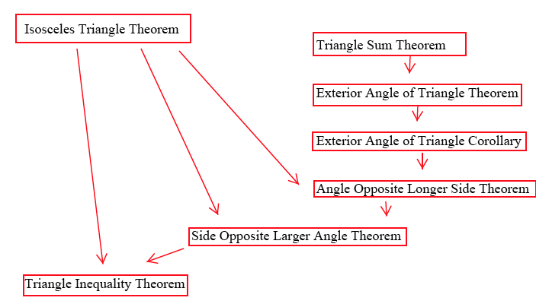

Vocabulary

Exterior angle of a polygon
Non-adjacent interior angle of a triangle
(Note: These are sometimes called “remote” interior angles)
Transitive Property for >.
Trichotomy principle

Theorems

Exterior Angle of a Triangle Theorem: The measure of an exterior angle of any triangle is equal the sum of the measures of the two non-adjacent interior angles.

Exterior Angle of a Triangle Corollary: The measure of an exterior angle of any triangle is greater than the measure of either non-adjacent interior angle.*

Angle Opposite Longer Side Theorem: If two sides of a triangle are not equal, the angle opposite the longer side is greater than the angle opposite the smaller side.

Side Opposite Larger Angle Theorem: If two angle of a triangle are not equal, the side opposite the larger angle is longer than the side opposite the smaller angle.

Triangle Inequality Theorem: The sum of the lengths of any two sides of a triangle is greater than the third side.

* Note for Teachers. Euclid’s proof of what we call the Exterior Angle of a Triangle Corollary does not depend upon the Triangle Sum Theorem. See Proposition 16 in Book I of the elements for his proof. Consequently the theorem holds in hyperbolic geometry as well as Euclidean geometry.

Resources and Materials

Activity 3.2.1 Discovering Inequalities in Triangles
Activity 3.2.2 Exterior Angles of Polygons
Activity 3.2.3 Sides and Angles in a Triangle
Activity 3.2.4 The Triangle Inequality
Activity 3.2.5 Possible or Impossible?
Activity 3.2.6 Design a Triangle
Tools: Rulers and protractors for Activity 3.2.1

