Activity 4.7.3 Special Right Triangles and Trigonometric Ratios

Please complete this activity without the use of a calculator. Now that you know the relationships among the sides in special right triangles, you can use those patterns to solve any special right triangle without a calculator.
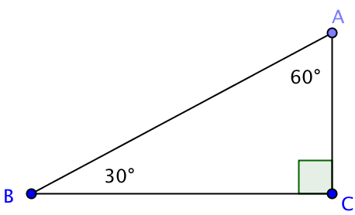
For example suppose we want to evaluate $\sin\left(30°\right)$. This means to find, in a right triangle, the ratio of the side length opposite the $30°$ angle to the length of the hypotenuse.

Since all 30°-60°-90° triangles are similar by the AA Similarity Theorem, it doesn’t matter which length you choose to represent a side. Let’s begin with finding a length for the hypotenuse since the length of the short leg is ½ the length of the hypotenuse and the long leg is $√3$ multiplied by the length of the short leg.

1. Suppose the length of the hypotenuse is 2 (which is a nice even number).

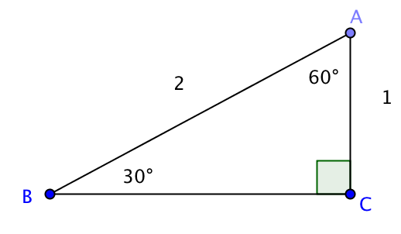
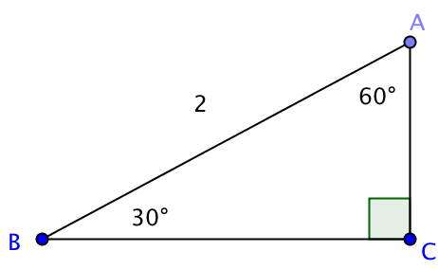

That now gives us

We now have enough information to see that $\sin\left(30°\right)=_____$ .

2. Suppose had chosen 4 to represent your hypotenuse. What value would you have calculated for the short leg _______? Is the ratio of that value to 4 equivalent to $\frac{1}{2}$ ?

3. Continuing to solve for the legs in the triangle will allow you to find other trigonometric ratios or sine ratios of a different acute angle. What is the length of the long leg in this triangle? _______

4. Use the length found in question 3 to find $\cos\left(30°\right)=\frac{}{}$

5. Use the length found in question 3 to find tan(30°) =

6. Rationalize the denominator to your answer in question 5.

7. Use the length found in question 3 to find $\sin\left(60°\right)=\frac{}{}$

8. Use the length found in question 3 to find tan(60°) =

9. Now let’s look at our other special right triangle. Draw a 45°- 45°- 90° triangle.

10. Give a length for one of the legs. Then use your understanding of the relationship among the sides in a 45°-45°-90° triangle to determine the length of the hypotenuse and the other leg. Label your figure.

11. Use your triangle to find the values of three trigonometric ratios.

12. Summarize what you have learned about the trigonometric ratios in the special right triangles: In each case write the answer in simple radical form (as an exact quantity) and also use a calculator to find a decimal to the nearest 0.001.

a. $\sin\left(30°\right)$ b. cos($30°)$ c. tan($30°)$

d. sin($45°)$ e. cos($45°)$ f. tan($45°)$

g. sin($60°)$ h. cos($60°)$ i. tan($60°)$

13. In Investigation 6 you learned about a special relationship between the sine and cosine of complementary angles. Apply this relationship to the angles studied in this activity and fill in the blanks:

a. sin(30°) = cos(____) b. sin(45°) = cos (____) c. sin(____) = cos(30°)

