Activity 4.7.2 Special Right Triangles Discovery
- Warm up: Find the missing side lengths in the right triangles below. Leave your answer as a simplified square root.
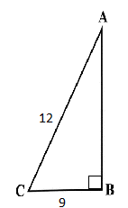

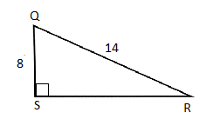
a. b.

2. 45 º - 45 º - 90 º Right Triangles
- Use the square dot paper to draw an isosceles right triangle with legs that are 3 units long. Find the length of the hypotenuse. Then simplify the square root.

- Draw an isosceles right triangle with different leg lengths than above and find the length of the hypotenuse. Then simplify the square root.

- Compare your answer in (b) to a classmate. What do you notice about the relationship of the legs of an isosceles right triangle to its hypotenuse?

- Label each side length of the 45º- 45 º- 90º triangles below.
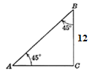
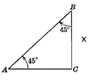

In the previous activity you learned there is a special ratio relationship of the legs to the hypotenuse in a 45º - 45 º- 90 º triangle. We are now going to explore another special relationship with 30 º- 60 º- 90 º triangles.

30 º - 60 º - 90 º Right Triangles

3. Use the isometric dot paper to draw an equilateral triangle with side lengths of 4-4-4.

- What do you know about the angles of an equilateral triangle?

- Draw an altitude from a vertex to one side. Label all of the angles and the side lengths of your triangle(s).

- You now have two congruent triangles. What are the angles of the triangles?

- Find the missing leg of the triangle and leave as a simplified square root.

- Repeat the above steps for a 6-6-6 triangle.

- What conjecture can you make about the hypotenuse of a 30º - 60 º - 90 º triangle when compared to the short leg?

- What conjecture can you make about the long leg of a 30º - 60 º - 90 º triangle when compared to the short leg?

- Find the missing side lengths. Leave the missing side in simplified form where applicable.
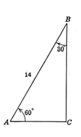
a. b. c.
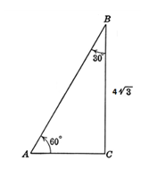
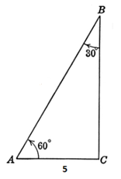

6. In the figure at the right, A is on and AB = 10 cm. Find each length as an exact value.
Show all your steps and explain your reasoning.

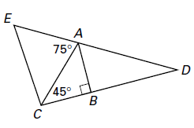
  - BC = ________
  - AC = ________

  - BD = ________

  - AD = ________

