Activity 4.7.1 Irrational Square Roots in Standard Form

Recall if x² = 25 then $x=±\sqrt{25} or ±5$ since ${(-5)}^{2}=25$ and $(5)^{2}=25$. In geometry, we often only use the positive square root or principal square root. For this reason when talk about “square root” in this activity we are referring to the principal square root.

Part I:
1. Evaluate each expression

a. $\sqrt{25}-\sqrt{9}$ b.$\sqrt{25-9}$

c. $\sqrt{16}+\sqrt{9}$ d. $\sqrt{16+9}$

e. $\frac{\sqrt{36}}{\sqrt{9}}$ f. $\sqrt{\frac{36}{9}}$

g. $\sqrt{4}⋅\sqrt{9}$ h. $\sqrt{4⋅9}$

2. Suppose a and b are any positive numbers. Which of these statements are always true? Sometimes true? Never true? (Look at the examples in question 1 and test with other values for a and b.)
a. $\sqrt{a}+\sqrt{b}=\sqrt{a+b}$. b. $\sqrt{a}-\sqrt{b}=\sqrt{a-b}$ whenever a≥ b.

c. $\frac{\sqrt{a}}{\sqrt{b}}=\sqrt{\frac{a}{b}}$. d. Does $\sqrt{a}⋅\sqrt{b}=\sqrt{a⋅b}.$

Part II:
Many times in mathematics we simplify square roots to make them simpler to approximate or to put it in a form that is helpful to finding patterns. For example, $\sqrt{40}$ can be rewritten as $\sqrt{4}⋅\sqrt{10}$ or $\sqrt{5}⋅\sqrt{8}$.
3. Find another equivalent expression of $\sqrt{40}$as the product of two square roots. ______
In the case of the two factors where one is a perfect square, $\sqrt{4}⋅\sqrt{10},$you can now simplify this expression and write it as $2⋅\sqrt{10}$.

4. Verify that $\sqrt{40}$ = $2⋅\sqrt{10}$ by finding a decimal approximation for each on your calculator.

5. Simplify each of the following square roots:
a. $\sqrt{12}$ b. $\sqrt{56}$ c. $\sqrt{75}$

d. $\sqrt{27}$ e. $\sqrt{15}⋅\sqrt{6}$

Part III: Applying Simplified Square Roots

6. Solve for the missing side length of each right triangle and write your answer in simplified square root form.

a. b. c.

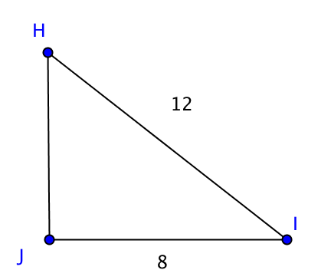
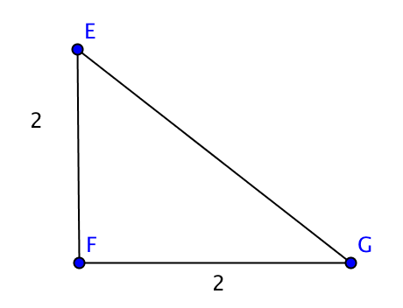
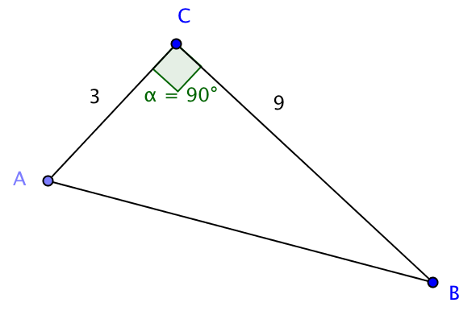

Part IV: Rationalizing a denominator.

Often we prefer not to have an expression with a square root in the denominator. We can often eliminate the square root by multiplying both numerator and denominator by the same number so that the denominator is “rationalized”

For example, $\frac{4}{\sqrt{5}}$ = $\frac{4}{\sqrt{5}}∙\frac{\sqrt{5}}{\sqrt{5}}$ = $\frac{4\sqrt{5}}{5}$

7. Verify that$\frac{4}{\sqrt{5}}$ = $\frac{4\sqrt{5}}{5}$ by finding a decimal approximation for each on your calculator.

8. Simplify each of the following fractions by rationalizing the denominator:

a. $\frac{1}{\sqrt{2}}$ b. $\frac{3}{\sqrt{10}}$ c. $\frac{1}{\sqrt{3}}$ d. $\frac{\sqrt{5}}{\sqrt{2}}$ e. $\frac{\sqrt{6}}{\sqrt{3}}$

