Activity 4.6.4 Complementary Angles and Cofunctions

Part I: Investigating a relationship between Sine and Cosine through tables.

1. Using your calculator, complete the following table.
$$θ$$ | $$sin⁡(θ)$$ | $$cos⁡(θ)$$
$$9^{°}$$
$${15}^{°}$$
$${30}^{°}$$
$${45}^{°}$$
$${60}^{°}$$
$${75}^{°}$$
$${81}^{°}$$

2. Look for numbers that appear twice in the table and describe any patterns you see.

3. Two angles are complementary if the sum of their measures is 90°. Name three pairs of complementary angles in the table above.

Part II: Investigating a relationship between Sine and Cosine through a right triangle.
4. Using the diagram below, determine each of the following.
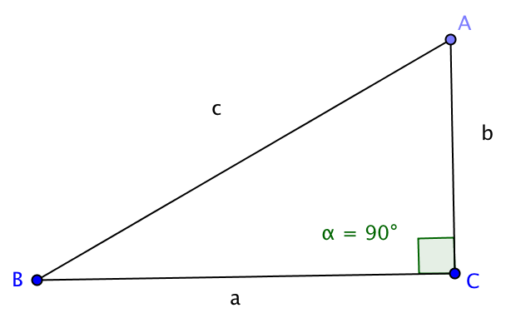
a. $\sin\left(A\right)=\frac{}{}$ b. $\cos\left(B\right)=\frac{}{}$

c. $\sin\left(B\right)=\frac{}{}$ d. $\cos\left(A\right)=\frac{}{}$

5. What do you notice about your answers to 3a and 3b?

6. What do you notice about your answers to 3c and 3d?

7. Complete each of the following equations.

a. m $∠$A + m $∠B= __________$ b. m $∠$A = ___ – m $∠B$

c. m $∠$B = ___ – m $∠$A d. $∠$A and $∠B$ are called ______________ angles.

8. Using your work from Parts I and II, complete the following identities:
Suppose $0<θ<90^{°}$ , where $θ$ is the measure of an acute angle in a right triangle.

$$\sin\left(θ\right)=cos⁡(___________)$$

$$\cos\left(θ\right)=sin⁡(___________)$$

9. Are there any angle measures for which $\sin\left(θ\right)=cos⁡(θ)$. Explain.

10. Complete each of the following identities.

a. $\sin\left({42}^{∘}\right)=cos⁡(___________)$ b. $\cos\left({28}^{∘}\right)=sin⁡(___________)$

c. $\sin\left({84}^{∘}\right)=cos⁡(___________)$ d. $\cos\left({67}^{∘}\right)=sin⁡(___________)$

11. Looking back at the names sine and COsine, why do you think they were given these names?

