Activity 4.5.4a Similar Triangles and the Pythagorean Theorem

In Unit 1 you saw an informal proof of the Pythagorean Theorem. We can now use the Right Triangle Similarity Theorem to give a formal proof.

Pythagorean Theorem: In a right triangle the square of the length of the hypotenuse is equal to the sum of the squares of the lengths of the legs.
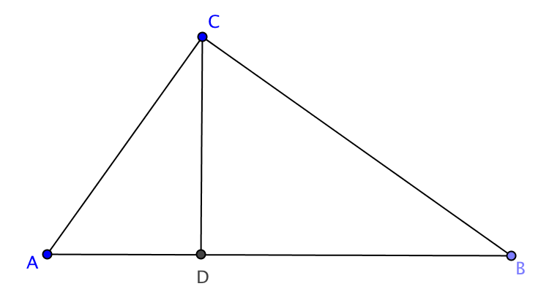
Given: ∆ABC with $∠$ACB a right angle
$\overline{CD}$ is the altitude to $\overline{AB.}$

Prove ${AC}^{2}+{BC}^{2}={AB}^{2}$

Hint: use the fact that each of the smaller triangles is similar to the large one to show that
AD$∙$ AB = AC² and that BD$∙$ AB = BC².

1. Write your proof here:

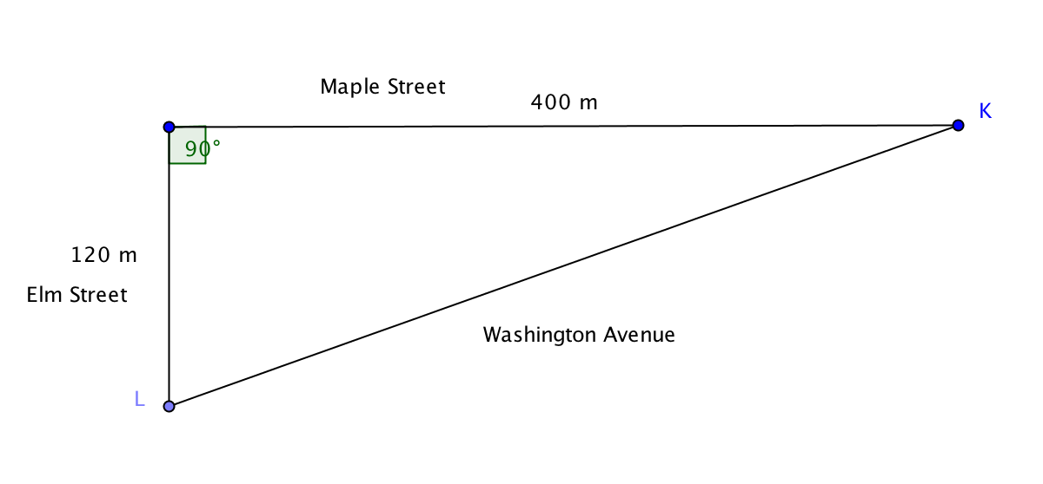
Applications of the Pythagorean Theorem

2. How much distance is saved going from K to L if you travel along Washington Avenue instead of using Maple Street and Elm Street?

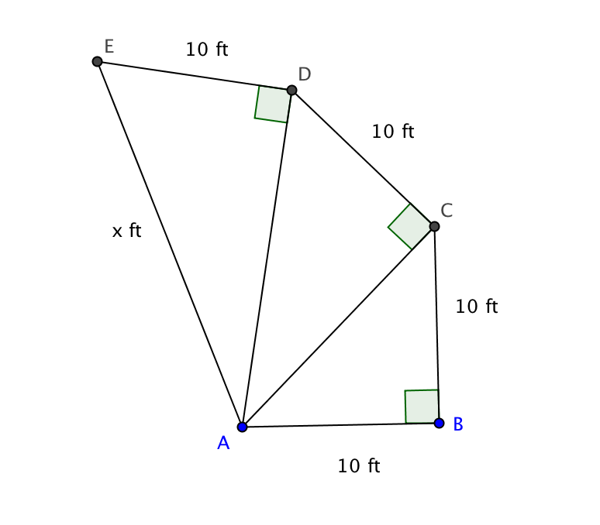

3. In the figure right angles at B, C, and D are shown.
AB = BC = CD = DE = 10 ft. Find AE.

4. A baseball diamond is in the shape of a square, 90 ft on one side.
a. How far is it from second base to home plate?
b. If the second baseman can throw the ball at a speed of 80 miles per hour, how long will it take the ball to reach the catcher? Assume the second baseman is near second base and the catcher is at home plate. (Useful information for this problem: 5280 ft = 1 mile; 60 seconds = 1 minute; 60 min = 1 hour.)

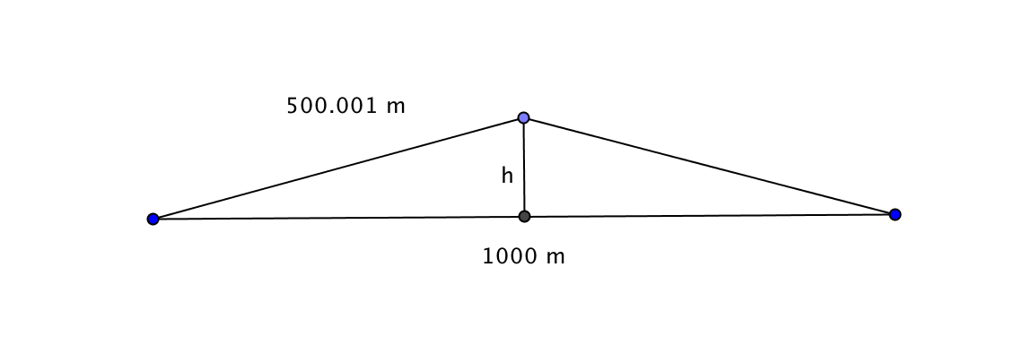
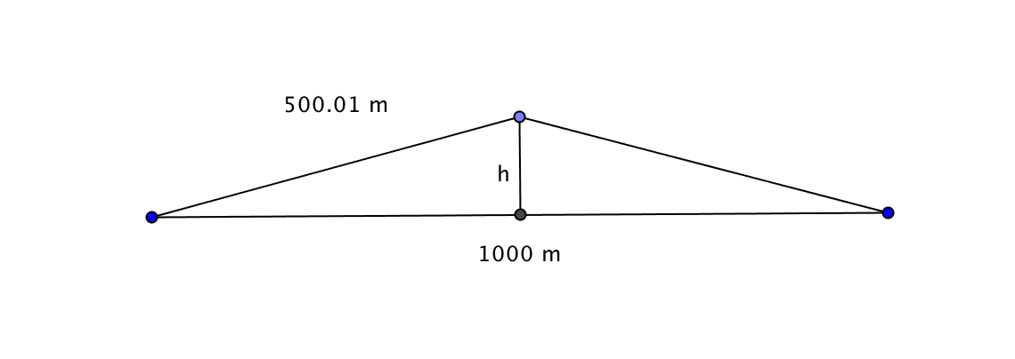
5. A rail track is constructed during the winter using steel rails that are 1000 meters long. In the summer, due to the heat, the rail expands by 0.002 meter (That’s only 2 mm) and buckles at the midpoint, forming an isosceles triangle.

- Find h, the height of this triangle.

- Based on this result, if you were a consultant to an engineering firm, what advice would you give regarding how long to make the rails?

7. Make up your own problem that requires application of the Pythagorean Theorem.

8. Solve the problem you created in question 7.

