Activity 4.5.2b Proving The Right Triangle Similarity Theorem

In Activity 4.5.1 you may have noticed that the altitude is drawn to the hypotenuse of a right triangle forms similar triangle. We can now state that conjecture as theorem.

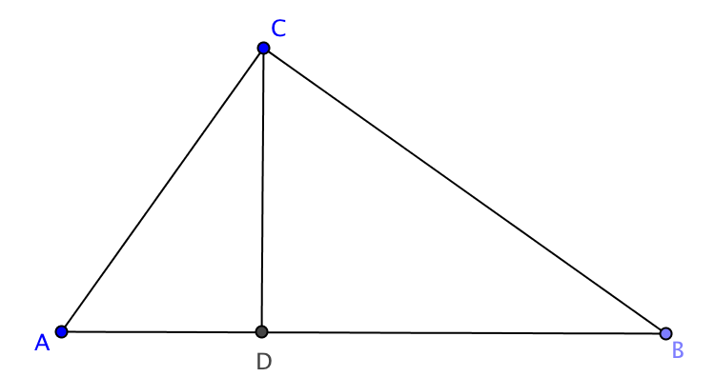
Right Triangle Similarity Theorem: If the altitude is drawn to the hypotenuse of a right triangle, then the two triangles formed are similar to the original triangle and to each other.

Given: ∆ABC with $∠$ACB a right angle
$\overline{CD}$ is the altitude to $\overline{AB}$ (and therefore $\overline{CD}⊥\overline{AB})$

Part I: Prove $ΔACB∼ΔADC$

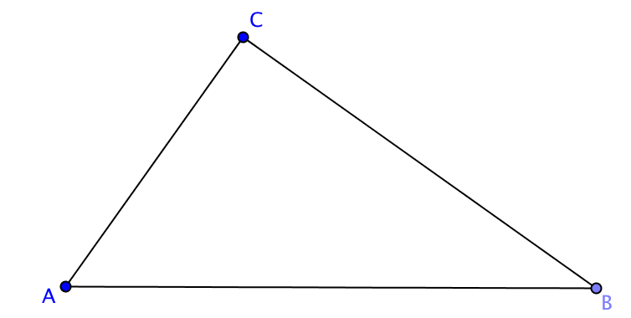
$∠$____ $≅∠$____ because of the reflexive property
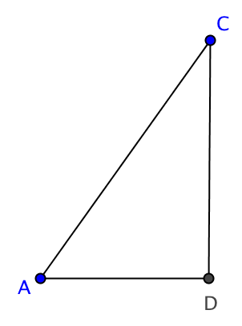
$∠$____ is a right angle because_____________

$∠$____ $≅∠$____ because________________

$ΔACB∼ΔADC$ because __________________________

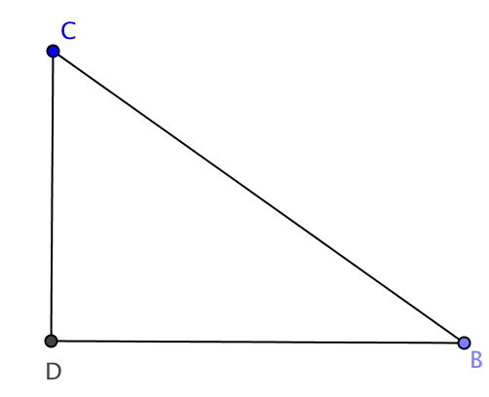
Part II: Prove $ΔACB∼ΔCDB$

$∠$____ $≅∠$____ because______________

$∠$____ is a right angle because__________

$∠$____ $≅∠$____ because_______________

$ΔACB∼ΔCDB$because __________________________
Part III: Prove $ΔADC∼ΔCDB$

E1.$m∠$ACD + m$∠$BCD = 90º because____________
E2. $m∠ ACD$ + m$∠$A = 90º because____________
Use E1 and E2 to show that $m∠$A=$m∠$____

$∠$____ and $∠$____ are right angles because________

$∠$____ $≅∠$____ because________

$ΔADC∼ΔCBD$ because __________________________

