Activity 4.5.2a Proving The Right Triangle Similarity Theorem

In Activity 4.5.1 you may have noticed that the altitude is drawn to the hypotenuse of a right triangle forms similar triangle. We can now state that conjecture as theorem.

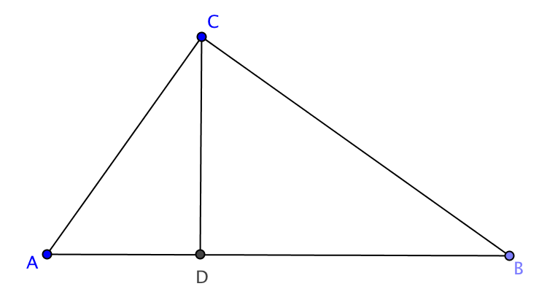
Right Triangle Similarity Theorem: If the altitude is drawn to the hypotenuse of a right triangle, then the two triangles formed are similar to the original triangle and to each other.

Given: ∆ABC with $∠$ACB a right angle
$\overline{CD}$ is the altitude to $\overline{AB}$ (and therefore $\overline{CD}⊥\overline{AB})$

Part I: Prove $ΔACB∼ΔADC$

Part II: Prove $ΔACB∼ΔCDB$

Part III: Prove $ΔADC∼ΔCDB$

