Activity 4.5.1 Right Triangles
Part 1 – Notecard Investigation

You will be given at 3 in, by 5 in. notecard and a pair of scissors.

- Cut a diagonal on your notecard to create two right scalene triangles. On each note card label the vertices, A, B, and C with C as the vertex of the right angle. Set one notecard aside to use in question 7.

- Draw the altitude from C perpendicular to hypotenuse $\overline{AB}$. Label the point where the altitude meets the hypotenuse as D. (D is called the foot of the altitude.) Notice that two smaller triangles, have been created: ∆ACD and ∆CBD.
- Make a sketch of ∆ABC and altitude $\overline{CD}$ in the space below:

- Record the length in mm for each side of the triangles.
 | $$∆ABC$$ | $$∆ACD$$ | $$∆CBD$$
Short Leg
Long Leg
Hypotenuse

- Find the ratio of the sides of the triangles, to the nearest 0.01.
 | $$∆ABC$$ | $$∆ACD$$ | $$∆CBD$$
Short Leg
Long Leg
Short Leg
Hypotenuse
Long Leg
Hypotenuse

- What patterns do you notice in the chart in question 5? Discuss this with other students in your class.

- Now cut the first note card along altitude $\overline{CD}$. Take the two small triangles you have created and show how the angles match with the angles of the large triangle you set aside in question 1. What do you notice?

Part II – GeoGebra Investigation

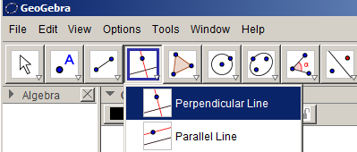
Step 1 - Open GeoGebra and make a line segment $\overline{ AC}$ and then draw a line perpendicular to $\overline{AC}$ at C using the ‘perpendicular line’ tool and label this point on the perpendicular line ‘B’.

Step 2 - Your triangle should look something like the one below and you should be able to move point ‘B’ around so that $∠$ ACB remains a right angle.

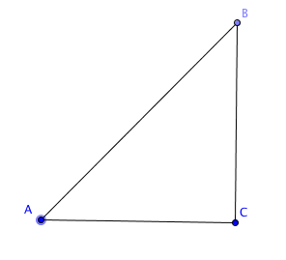

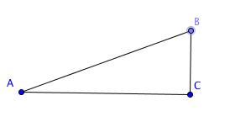

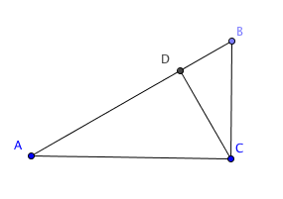
Step 3 - Construct a perpendicular line from vertex C to segment $\overline{AB}$. Label the point of intersection D. Once again you should be able to move point B around and observe that $\overline{ AC}$remains perpendicular to $\overline{BC}$ and $\overline{CD}$ remains perpendicular to $\overline{AB}$.

Step 4 – Using the ‘Distance or length’ tool measure each side length of the three triangles, ∆ABC, ∆ACD, and ∆CBD.

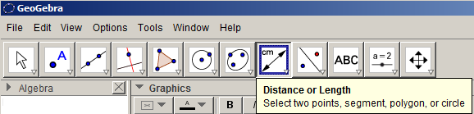

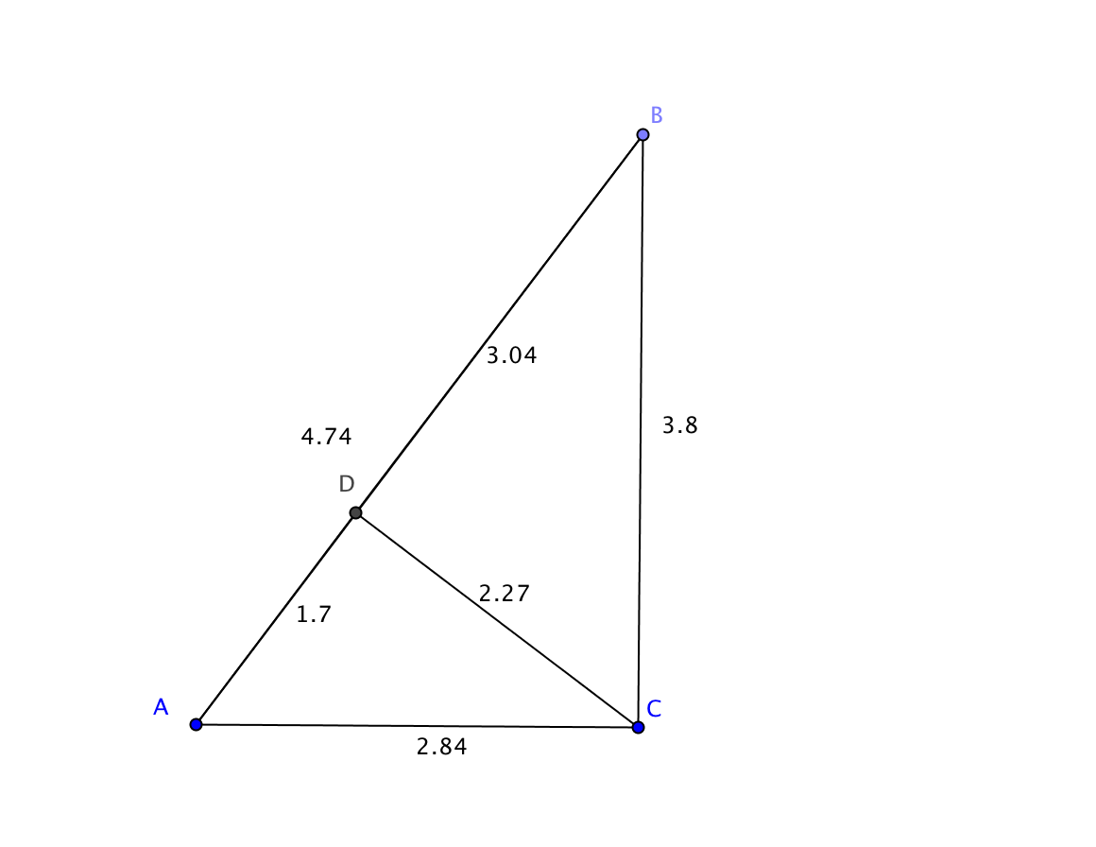
Your triangle will look something like the one to the right. When you move around point B you will notice that the numbers will change to reflect the new segment lengths.

Step 5 – At the bottom of your screen you have an input bar which will do calculations for you. Type the ratio of two distances as shown and then hit Return. The ratio will appear in the Algebra window.

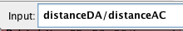

 | $$∆ABC$$ | $$∆ACD$$ | $$∆CBD$$
Short Leg
Long Leg
Short Leg
Hypotenuse
Long Leg
Hypotenuse

Step 6 – Use the Angle measurement tool to measure these angles and record the results in the space below:
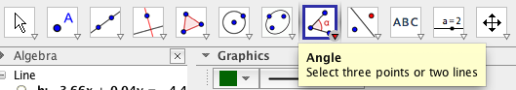

m $∠$ CAB = ___________ m $∠$ CDA = ___________
m $∠$ CBA = ___________ m $∠$ CDB = ___________

m $∠$ ACD =____________ m $∠$ ACB = ___________
Investigation Questions:

- What do you notice about the ratios in the each row of the table in Step 5?
- What do you notice about the angle measures?

- Move point B around and record your observations of what happens to your ratios. Does your observations still hold true?

- Find two pairs of triangles that appear to be similar and explain why you think they are similar.

- In your own words describe what you have discovered from this investigation.

