Activity 4.4.4 Dividing Segments into Parts

Materials: Compass and straightedge

After doing so well on your last unit test your teacher has given you and your group a bar of chocolate to share. However, there’s a problem. After purchasing the bars of chocolate your teacher left them in the car for a day and they melted. This has caused the chocolate bar to lose all of its divisions but not it’s rectangular shape. Your task is to find a way to divide the chocolate into three congruent pieces using only a compass and straightedge. Oh, by the way, you don’t have a ruler to measure with.

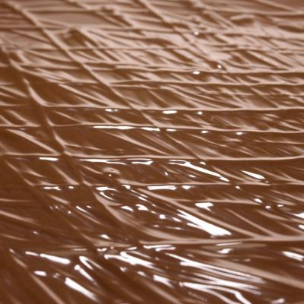

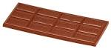

+ =

Photo1 Credit: http://www.wikiwand.com/en/Hershey_bar
Photo2 Credit: https://myvirtualsongbook.wordpress.com/guide/campfire-planning/
Photo3 Credit http://Jupiterimages/Comstock/Getty Images

1. Perform these steps to divide the chocolate bar.

Step 1: Focus on one side of the chocolate bar by focusing on just a segment, $\overline{AB}$. If we divide the segment or one side of the bar into three congruent parts then we can divide the bar into three congruent parts.

Step 2: Construct $\vec{AC}$.
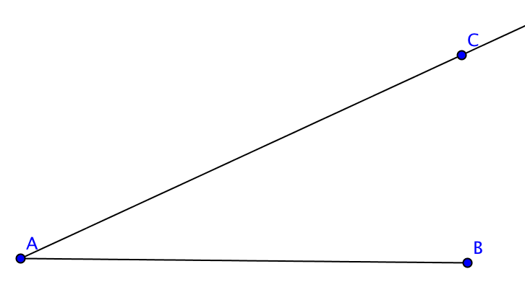

Step 3: Open your compass so that you can create three (any length) congruent segments along $\vec{AC}$. Name the congruent segments $\overline{AP}, \overline{PM},$and $\overline{MN}$.

Step 4: Construct $\overline{NB}$.

Step 5: Construct parallel lines to $\overline{NB}$ through points P and M. Name the points of intersection with $\overline{AB}$ points Q and R.

2. Explain why $\overline{AQ}≅\overline{QR}≅\overline{RB}$ in the construction above.

3. What would you do differently in the construction if you wanted to divide the segment into a different number of congruent parts? For example, dividing the candy bar or segment into 5 congruent segments.

4. Open GeoGebra and create a segment $\overline{AB}$. Using the method shown above, divide $\overline{AB}$ into 7 congruent segments. You may use any tool available including the one that draws parallel lines.

5. Take a sheet of lined notebook paper and a note card. Position a longer edge of the card so that the corners lie on two parallel lines and the edge intersects 8 other lines. Mark the card where it meets these lines to divide the edge of the card into 9 congruent parts.

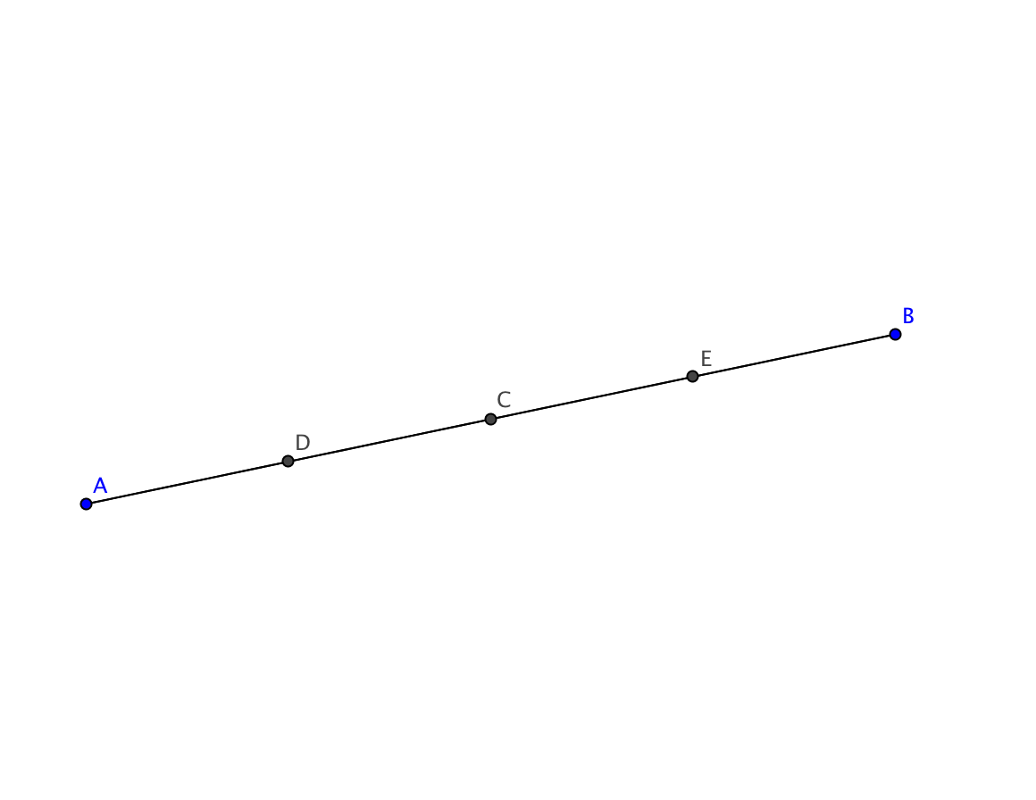
6. Keisha says she can divide a segment into 4 congruent parts. “First I find C, the midpoint of the segment $\overline{AB}$, using the construction we learned in Unit 2. Then I find midpoints D and E of each of segments $\overline{AC}$ and $\overline{CB}$. I have now divided $\overline{AB}$ in four congruent segments.”

- Does Keisha’s method work? Explain.
- Could Keisha’s method be used to divide a segment into three congruent parts? Explain.

