Activity 4.4.3 Manhattan Sidewalk Construction Project

In Manhattan, the numbered avenues are perpendicular to numbered streets. For example, 7th avenue is perpendicular to 45th street. Having organized roadways like this makes it easy for people to travel in the city and for city planners to take measurements for construction purposes, etc. However, there is one famous intersection that is unlike most intersections in Manhattan. In Times Square, Broadway and 7th avenue are not perpendicular to each other (See image below).

You are the owner of a construction company and have been asked to submit a quote to replace the sidewalks along a portion of Broadway. The city planners have given you an old drawing that once included all of the roadway measurements. However, two of the measurements, DF and FG, are no longer legible.
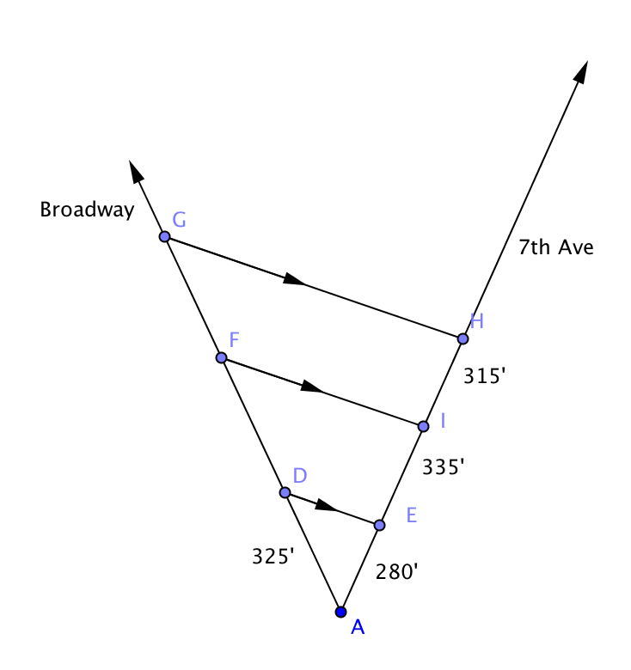
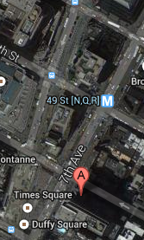

1. Find the distances FD and FG to the nearest foot.

2. The sidewalks to be replaced are 9 ft wide, 5 in. thick, and AG feet long. How many cubic yards of concrete will you need to order to replace the section in question?

3. If concrete costs you $85.00 per cubic yard from the manufacturer and you want to charge 10% more than your cost of the concrete, how much should the concrete cost in your quote to the city?

4. Each concrete truck can hold 18 yd³ of concrete. How many trucks will you need to deliver concrete to the work site?

5. What additional information might affect the answer to questions 2–4?

