Activity 4.3.5 Similarity in Equilateral Triangles

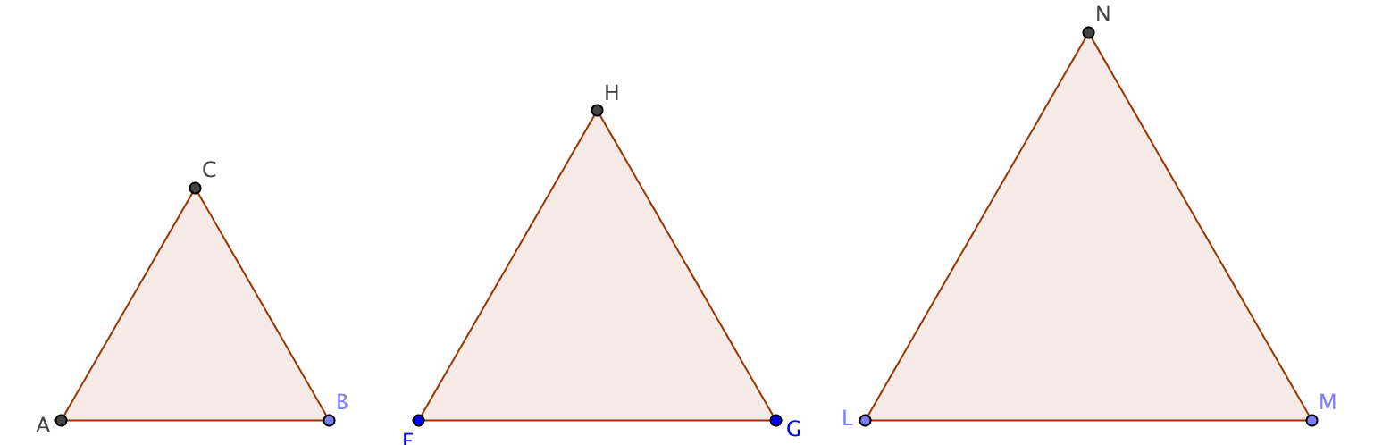
- Measure the sides of the three triangles below (to the nearest 0.1 cm). Verify that the triangles are equilateral.

AB = ______ FG = __________ LM = ____________
BC = ______ GH = __________ MN = ____________
CA = ______ HF = __________ NL = ____________
- Take two of the triangles, say ∆ABC and ∆FGH. Are the pairs of corresponding sides proportional? Explain.
- Without measuring them, what can you say about the angles of these triangles? Which theorem or theorems from Units 2 and 3 justify your conclusion?

- Make a conjecture: All equilateral triangles are ___________________.
- Prove your conjecture.

- Are all squares similar? Explain your reasoning.

