Activity 4.3.3 The SSS Similarity Theorem
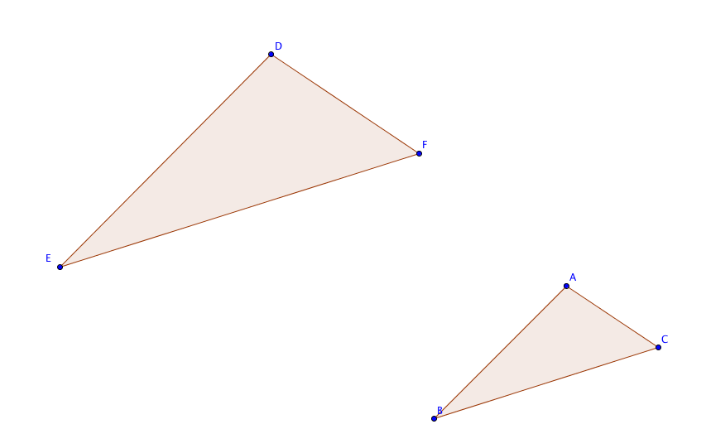
Prove the SSS Similarity Theorem: If three sides of one triangle are proportional to three sides of another triangle, then the two triangles are similar.

Given ∆ABC and ∆DEF
with $\frac{DF}{AC}=\frac{EF}{BC}=\frac{DE}{AB}$.

Prove ∆ABC$\sim$∆DEF.

Construction steps:
- Draw a circle with center F and radius CA to intersect $\vec{DF}$ at point G.
- Draw a circle with center F and radius CB to intersect $\vec{DE}$ at point H.
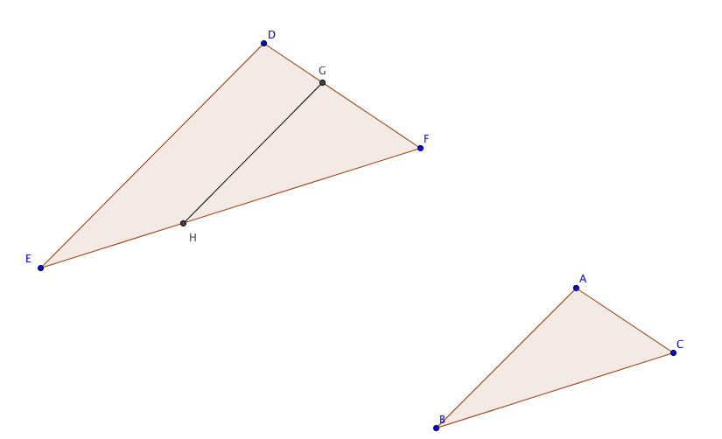
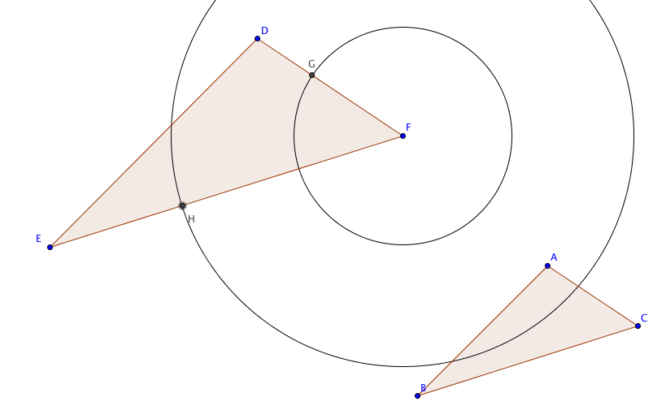
- Draw segment $\overline{FG}$ and hide the circles.

Proof steps:

- Prove that ∆GHF ~ ∆DEF using one of the similarity theorems we have already proved. Show steps here:

- Prove that GH = AB using the given information. Show steps here:

- Prove that ∆GHF $≅$ ∆ABC and consequently m$∠GFE$= m$∠ACB$. Show steps here:

- Now show that ∆ABC ~ ∆DEF.

