Activity 4.2.4b Similarity and Circles

- Open the file ctcoregeomACT424.
a. Translate the circle with center A so that the center of its image is at point C.
b. Dilate the translated circle so that the new image has a radius equal to CD.
c. Describe the relationship between the two original circles.

d. In Unit 2 you proved that if two circles have the same radius, then they are congruent. If two circles do not have the same radius, they cannot be congruent, but they are ___________.

- Prove that circle 1 with center P and radius r₁ is similar to circle 2 with center Q and radius r_{2.}
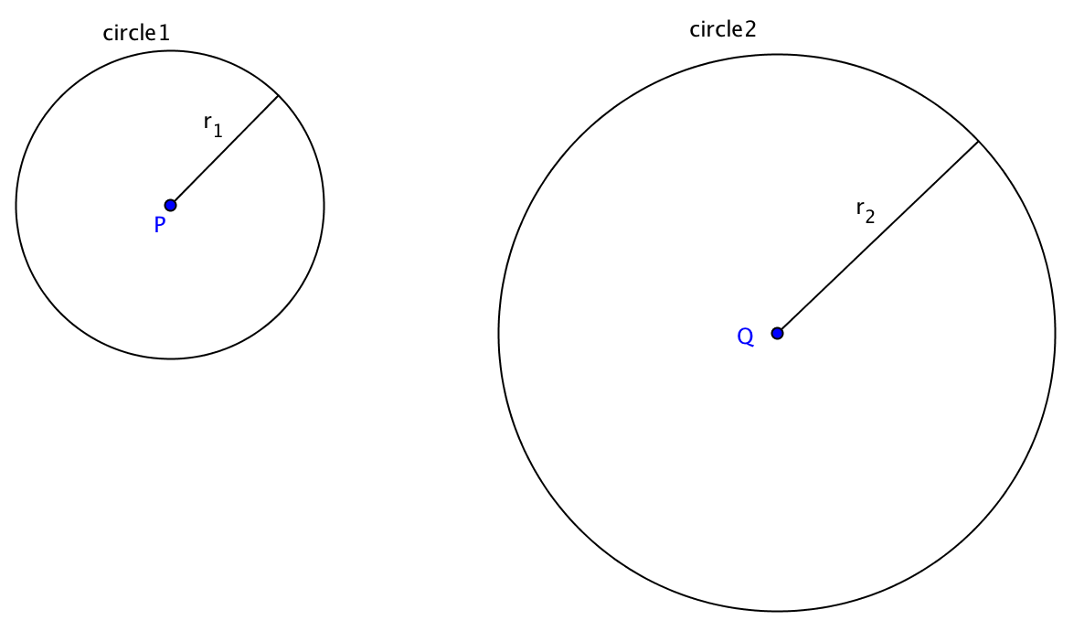

Step 1. Translate circle1 by the vector from ____ to _______.
Step 2. Dilate the translated circle from center ______by the scale factor =$\frac{r_{2}}{}$.
Step 3. The new circle will coincide with circle 2. Why?
Step 4. This shows that the circle 2 is the image of circle 1 under _____________ followed by _______________. Since both of these are _______________ transformations, circle 2 must be _____________ to circle 1.

- Would you say that any two circles are similar? Explain.

- Would you say that any two triangles are similar? Explain.

- Are congruent circles also similar circles? Why or why not?

- Recall that $π=\frac{C}{d}$ , where C is the circumference and d is the diameter of a circle. Explain why $π$ is the same for all circles.

