Activity 4.2.2 Similar Figures
In the previous investigation we learned that dilations preserve angle measures but not the side lengths if the scale factor (k) was not equal to 1. In Activity 4.2.1 we learned that similar figures are figures where one is the image of the other under a similarity transformation. Consequently corresponding angles of similar polygons are congruent corresponding side lengths are in a common ratio. The symbol for similarity is (~).
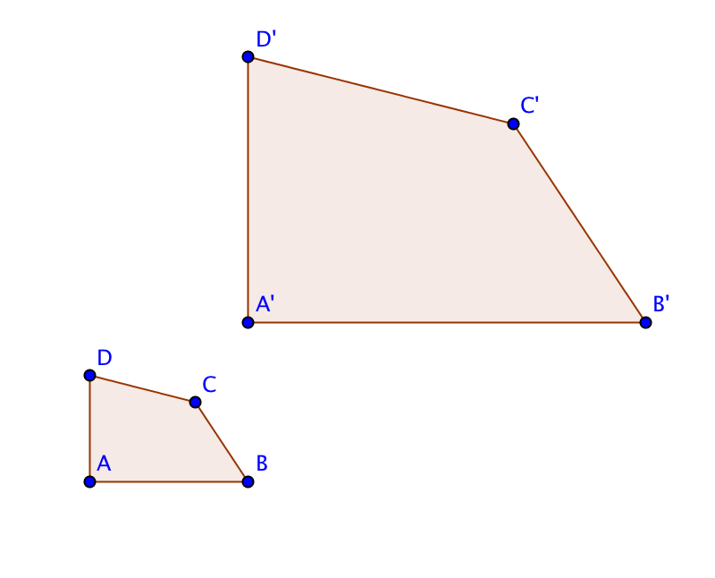
1. Use a protractor and a ruler to measure the angles and side lengths and determine if Quadrilateral ABCD ~ Quadrilateral A’B’C’D’. Then fill in the table below.

Side Lengths  (use mm) | Angle Measures
$$AB= \\ A^{'}B^{'}=$$ | $$m∠A= \\ m∠A^{'}=$$
$$BC= \\ B^{'}C^{'}=$$ | $$m∠B= \\ m∠B^{'}=$$
$$CD= \\ C^{'}D^{'}=$$ | $$m∠C= \\ m∠C^{'}=$$
$$AD= \\ A^{'}D^{'}=$$ | $$m∠D= \\ m∠D^{'}=$$

a. Are the measures of the corresponding angles equal?

b. Are the ratios of the corresponding side lengths equal?

2. Is Pentagon ABCDE ~ Pentagon GHIJK? Measure the sides and angles to determine the relationship.
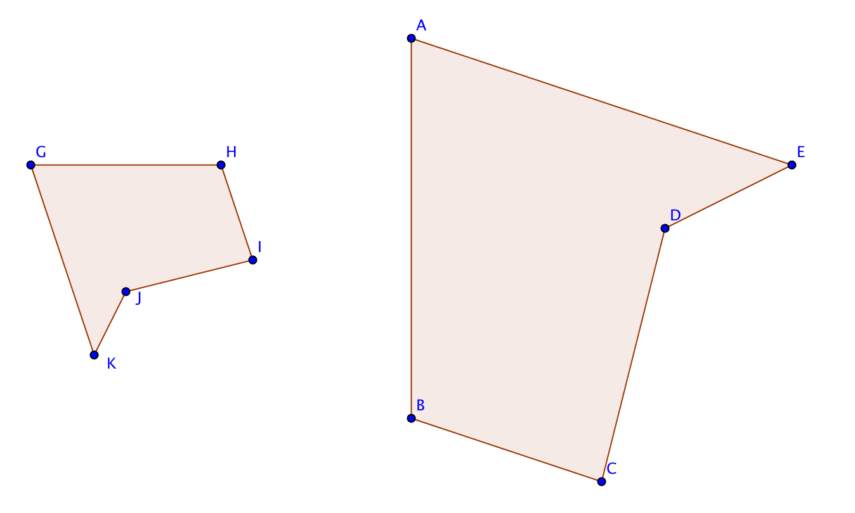

Side Lengths  (use mm) | Angle Measures
$$AB= \\ GH=$$ | $$m∠A= \\ m∠G=$$
$$BC= \\ HI=$$ | $$m∠B= \\ m∠H=$$
$$CD= \\ IJ=$$ | $$m∠C= \\ m∠I=$$
$$DE= \\ JK=$$ | $$m∠D= \\ m∠J=$$
EA =  KG = | $m∠E= m∠K$=

a. Are the measures of the corresponding angles equal?

b. Are the ratios of the corresponding side lengths equal?

3. Is Quadrilateral FGHI ~ Quadrilateral PQRS? The side lengths have been measured. Find the missing angle measures with your protractor and then decide if the two quadrilaterals are similar. Then explain why or why not.
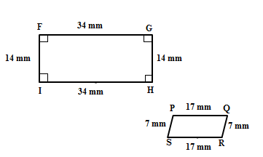

4. Draw a quadrilateral that is similar (but not congruent) to the one given below. Measure and label all sides and angles of quadrilaterals $MATH$ and$M'A'T'H'$. Write a similarity statement.
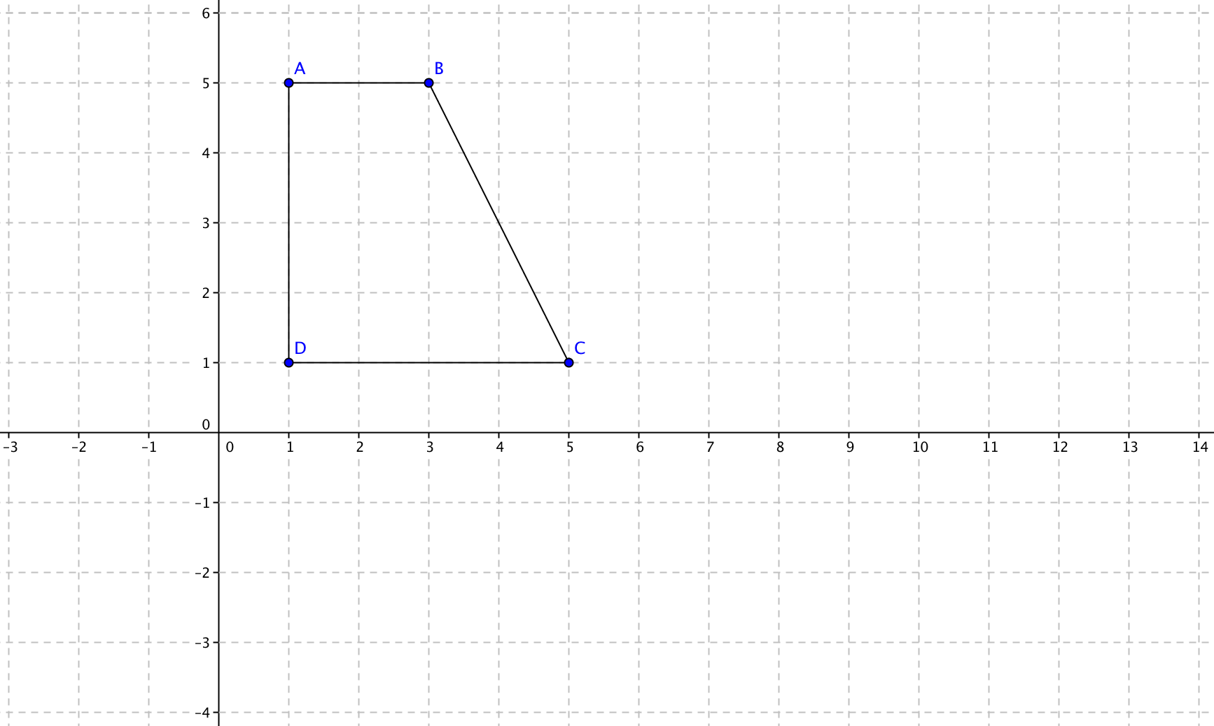

5. Three students are debating about whether Quadrilateral ABCD is similar to Quadrilateral EFGH. Read each statement below and decide who has the best argument. Justify you reasoning.
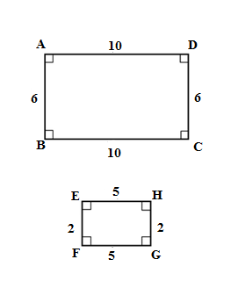
- Justin says “they are definitely similar because they both have 90º angles, so all the corresponding angles are congruent”.
- CeCe says “the corresponding angles are congruent and both bases are in the ratio of 2:1 and both altitudes are in the ratio of 3:1 so the quadrilaterals must be similar”.

- Maria says “The angles are congruent, but the ratio of the bases must be in the same as the ratio of the altitudes. Since one pair is in the ratio of 2:1 and the other pair is in the ratio of 3:1, the quadrilaterals cannot be similar”.

