Activity 4.1.1 Properties of Dilations
1. On your own, list some examples of real life objects that have had an enlargement or a reduction applied to them.

2. Now share your list with a partner or group and include any additional examples to your list:

3. Dilate the figure below about the center, P, by a scale factor of 2.
Follow these steps:
- Draw a ray from point P through vertex G, making sure that the ray extends past the vertex.
- Repeat the process in (a) to form rays $\vec{PH}$ and $\vec{PJ}$ .
- Using a compass, mark off the distance from point P to vertex G.
- Without changing the distance on the compass, place the pointer of the compass on vertex G and mark the distance of the radius along the ray. Label this image point G’.
- Repeat this for vertices H and J
- Connect the three image points to form the image triangle.

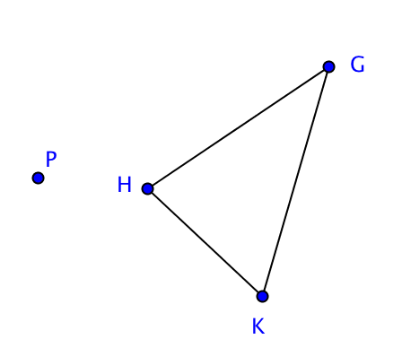

4. Dilate quadrilateral ABCD about the center point, P, by a scale factor of 1/2 .
Follow these steps.
- Draw a ray from point P through vertex C in the figure making sure that the ray extends beyond the vertex point.
- Find the midpoint of segment $\overline{PC}$. (Hint: see Activity 2.7.6 for compass and straightedge construction, or use the Midpoint Formula.) Name this midpoint C′.
- Repeat this for all vertices in the pre-image.
- Connect the image points found to form a quadrilateral.

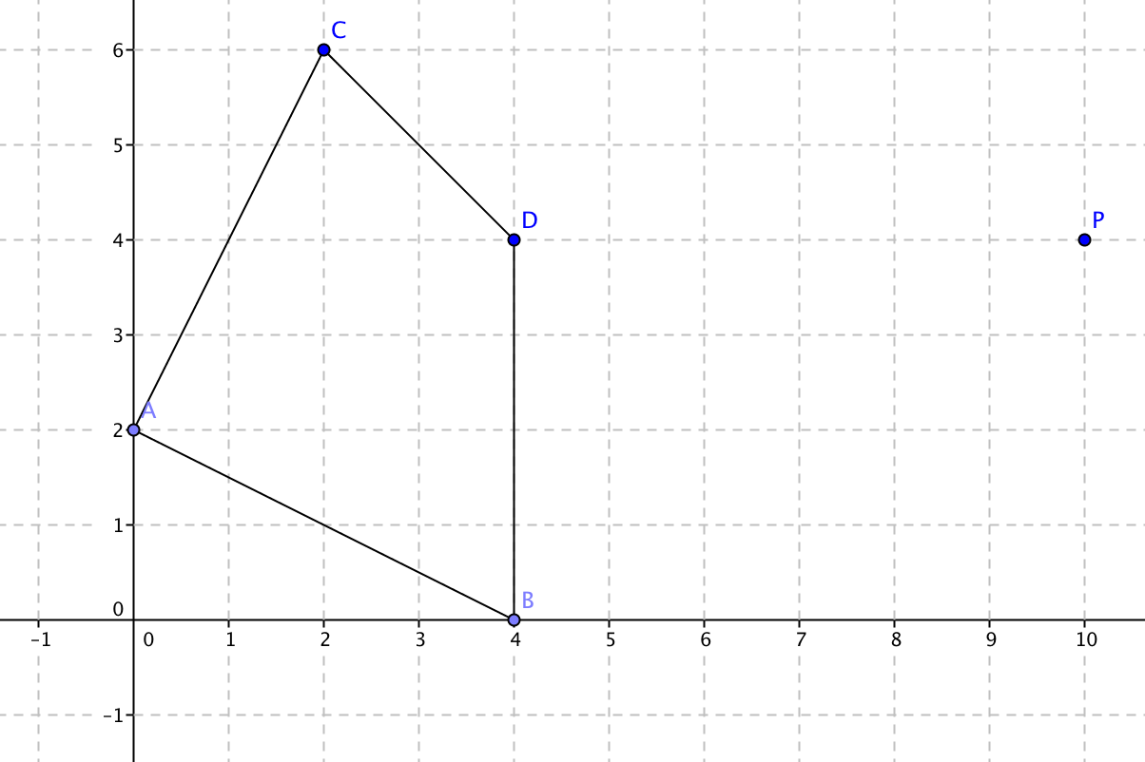

5. Based on what you observe in questions 3 and 4.

- How are the pre-image and image alike?

- How are the pre-image and image different?

- What happens when the scale factor is greater than 1?

- What happens when the scale factor is a positive number less than 1?

6. In the coordinate plane a dilation with center at the origin has the mapping rule:
(x, y) (kx, ky) where where k is the scale factor.

a. On the graph below draw the image of $∆ABC$ under a dilation with center at the origin and scale factor $\frac{1}{4}$.

b. Find the coordinates of the image vertices

Pre-image Image

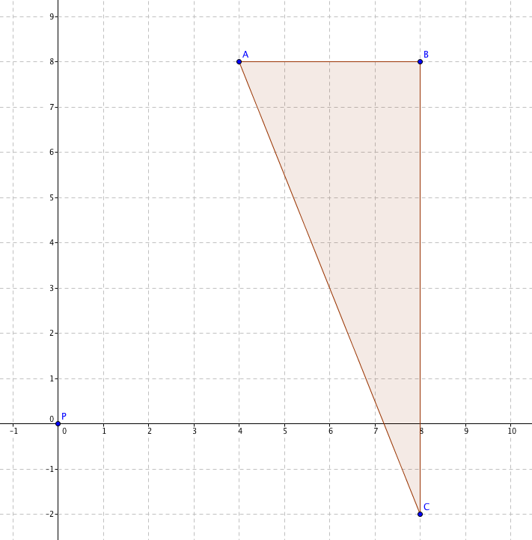
A (4, 8) A’(____,____)

B (8, 8) B’(____,____)

C (8, –2) C’(____,____)

c. Find these distances:

AB = _________ A’B’ = _______

BC = _________ B’C’ = _______

AC = _________ A’C’ = _______

Leave answers in radical form for AC and A’C’. Then find AC and A’C’ to the nearest 0.01.

AC ≈ _________ A’C’ ≈ _______

d. How does the length of a side in the image triangle compare to the length of its pre-image?
7. a. In the space below, dilate the figure around its center point P with a scale factor of 3 using a compass and a straightedge.

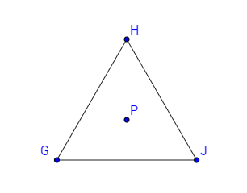

b. What relationship do you notice between the lines containing the sides of the pre-image triangle and their images (that is between $\overset{⃡}{GH}$ and $\overset{⃡}{G'H'}$, etc.)

8. Summing up what you have learned:

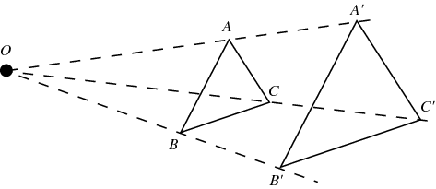
- True or false? Dilations only go from small sizes to big sizes.
- True of false? Dilations always look like this:

- What is a scale factor?

- When a figure is dilated, what stays the same?

- When a figure is dilated, what changes proportionally?

- When a figure is dilated, what happens to lines that pass through the center of dilation?

- When a figure is dilated, what happens to lines that do not pass through the center of dilation?

- What point remains unchanged under a dilation?

