Activity 3.7.4 Tessellating Quadrilaterals

Show that any quadrilateral may tile the plane.
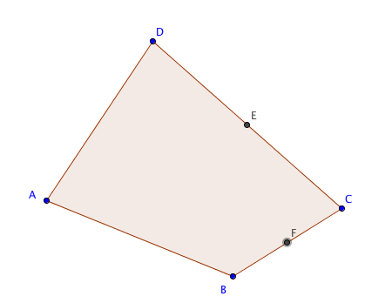
- Pick four points and create quadrilateral ABCD.
- Place four copies of the quadrilateral at point C.
Hint: Find the midpoints of $\overline{BC}$ and $\overline{CD}$ and rotate ABCD by 180° around these points.
Then translate ABCD by the vector from A to C to fill in the remaining gap.

- Show that you may now fill the plane by translating these four quadrilaterals as many times as you like. Keep translating until you have at least 20 copies of the original quadrilateral.

- How many quadrilaterals are there at each vertex?

- What is the sum of the angles at each vertex?

- Now change the shape of quadrilateral ABCD and observe what happens.

- Is it possible for a non-convex quadrilateral to tile the plane? Explain.

