Activity 3.7.1 Noticing Tilings

Across time and culture people have tried to create beautiful environments and materials for themselves, often with repeating elements. In this investigation you will study some ways that surfaces are tiled to create repeating designs. Tiling designs, also called tessellations, cover a flat surface entirely without gaps or overlaps. They can be extended infinitely and the design looks essentially the same everywhere. We say tessellations ‘tile a plane.’ The word “tessellation” is derived from “tessella,” which is a small piece of stone or glass used in a mosaic. Tiling designs appear on floors walls, wrapping papers, wallpapers, fabrics, rugs, weavings, and elsewhere. On page 3 there are eight tiling designs that have some special features.

- What do the tessellations (tiling designs) appear to have in common?

- In what ways are the tessellations distinct from one another? [Hint: Think about what types of shapes are used, how the shapes fit, and how corners compare.]

- Recall that a regular polygon has all sides congruent and all angles congruent. Which design(s) are made entirely of one regular polygon?

- Which design(s) are made entirely of more than one regular polygon?

- Notice that in all the examples, vertices meet at points with other vertices. In this activity a pattern like the following is not being considered.

What must be true in a tiling about the angles that meet at a vertex?

6. One way to symbolize tilings is to represent what shapes meet at each vertex. For example, tiling (c) can be symbolized as 3.6.3.6. Each number tells the number of sides for one regular polygon at that corner. So each 3 represents an equilateral triangle and each 6 represents a regular hexagon. The order of the numbers tells you the order in which they are arranged at each vertex.

- Explain to your partners how this symbol system works.

- What is the symbolization for (b)?

- What is the symbolization for (d)?

- Notice that tiling (f) has two different vertex configurations. Write the symbolization for each.

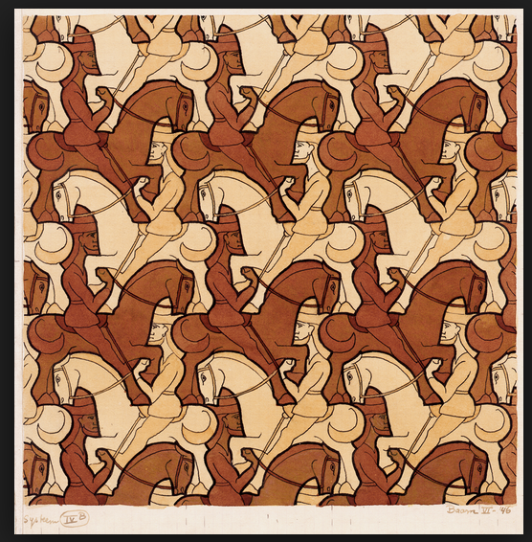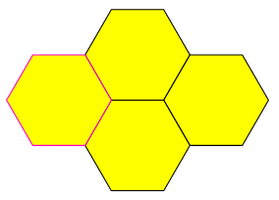
a. b.

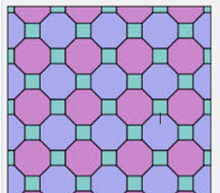
c. d.

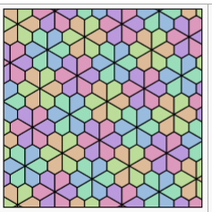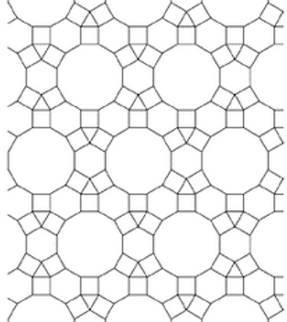
e. f.

