Activity 3.6.6 Medians and Centroids

Recall the Midpoint Formula from Unit 1 Investigation 2:

The coordinates of the midpoint of a line segment are the average of the coordinates of the two endpoints of the segment, that is

If the endpoints of the segment are (x₁, y₁) and (x₂, y₂), then the midpoint has coordinates $(\frac{x_{1}+x_{2}}{2},\frac{y_{1}+y_{2}}{2}$).

1. Plot ∆PQR on graph paper or using GeoGebra with P(0,0), Q(18,0), and R(12,24).
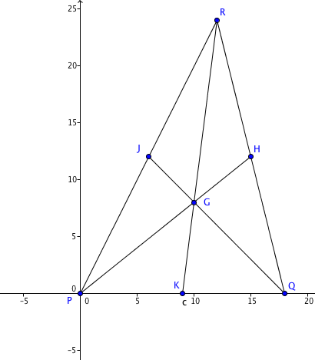
2. Find the midpoint of each side

The midpoint of $\overline{QR}$ is H(_____,_____)
The midpoint of $\overline{RP}$ is J(_____,_____)
The midpoint of $\overline{PQ}$ is K(_____,_____)

3. Now join each vertex to the midpoint of the opposite side; that is, draw segments $\overline{PH}$, $\overline{QJ}$ and $\overline{RK}$. What do you notice?

4. $\overline{PH}$, $\overline{QJ}$ and $\overline{RK}$ are the medians of ∆PQR. In your own words, give a definition for “median of a triangle.”

5. The centroid of a triangle may be described as the point whose coordinates are the average of the coordinates of the three vertices of the triangle. For ∆PQR find

the average of the x-coordinates of P, Q, and R: ________________

the average of the y-coordinates of P, Q, and R: ________________

The Coordinates of G the centroid of ∆PQR are G(________, ________)

6. What connection do you see between the answers to questions 3 and 5?

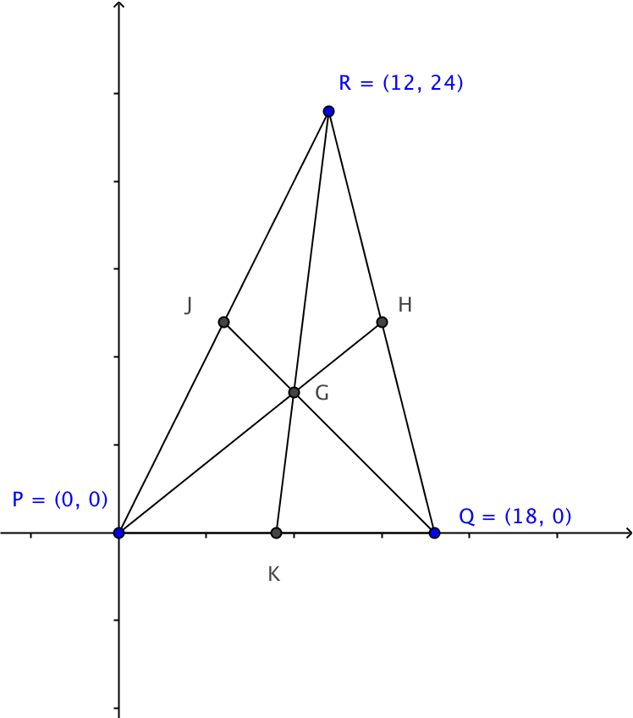
7. We can show that G lies on each of the medians by finding the equations of the lines containing the medians.

Recall the point-slope form of the equation of a line: $y-y_{1}=m\left(x-x_{1}\right)$

For each median, find the slope and the equation:

Slope of $\overset{⃡}{PH}$ = ___________ Equation of $\overset{⃡}{PH}$: ______________________________(1) Slope of $\overset{⃡}{QJ}$ = ___________ Equation of $\overset{⃡}{QJ}$: _______________________________(2)
Slope of $\overset{⃡}{RK}$ = ___________ Equation of $\overset{⃡}{RK}$: ______________________________(3)
8. Show that the coordinates of G satisfy each of the three equations above:
Show that they satisfy equation (1):

Show that they satisfy equation (2):

Show that they satisfy equation (3):

9. You have shown that the coordinates of G satisfy each of the equations. Geometrically this means that the ______________ of a triangle is the point where the three ______________ intersect each other.
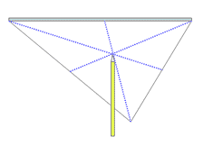
10. The centroid of a triangle is also known as the center of gravity.
You can illustrate this property by drawing a triangle on heavy paper or card stock. Use a ruler to locate the midpoint of each side and draw the medians. Cut out the triangle and try balancing it on the tip of pencil at the centroid, as shown.

Figure from http://www.mathopenref.com/trianglecentroid.html
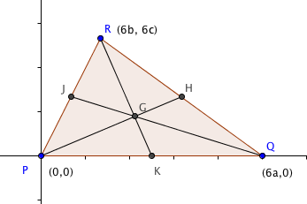
11. Prove the Centroid Theorem: The medians of a triangle intersect in one point. This point is the centroid of the triangle.

Fill in the blanks for this proof.
Let the vertices of the triangle be P(0,0), Q (6a, 0) and R(6b, 6c).

Then the coordinates of the centroid G are the averages of the coordinates of the vertices so we have G(______,_______).

The midpoints of the three sides are,

H(________, ________) for $\overline{QR}$,
J(________, ________) for $\overline{RP}$, and
K(________, ________) for $\overline{PQ}$.

We now find the equations of the medians:

Slope of $\overset{⃡}{PH}$ = ___________ Equation of $\overset{⃡}{PH}$: ______________________________(1)
Slope of $\overset{⃡}{QJ}$ = ___________ Equation of $\overset{⃡}{QJ}$: ______________________________ (2)
Slope of $\overset{⃡}{RK}$ = ___________ Equation of $\overset{⃡}{RK}$: ______________________________(3)
The coordinates of G into each of these equations to verify that G lies on all three lines:

Equation (1):

Equation (2):

Equation (3):

