Activity 3.6.5 Midsegments
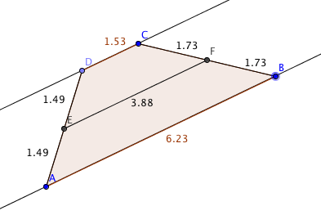
Open the file ctcoregeomACT365.ggb. The vertices of quadrilateral ABCD lie on two parallel lines as shown.

Move point C to demonstrate that DC is always parallel to $\overline{AB}$.

Move point D to show that D always lies on the line through C parallel to $\overline{AB}$. (However, don’t move D beyond C—we’ll do that later.)

1. Classify ABCD as a special quadrilateral. ABCD must be a _________________. Why?

2. The lengths of segment $\overline{ED}$, $\overline{EA}$, $\overline{FC}$, and $\overline{FB}$ are shown. As you move any of the vertices of the quadrilateral these quantities may change, but what always stays the same?

3. Therefore E is the __________ of $\overline{AD}$ and F is the ___________ of$\overline{ BC}$.

4. In a trapezoid the two parallel sides are called bases and the other two sides are called legs. In ABCD the bases are _____ and ____. The legs are ______ and ______.

5. The midsegment of a trapezoid is the segment joining the midpoints of the legs. Name the midsegment of ABCD: _________

6. Compare the length of the midsegment of ABCD with the sum of the two bases. What do you notice? Does this relationship still hold when you move the vertices?

7. Find the slope of the midsegment of ABCD and compare it to the slopes of the bases. What do you notice? Does this relationship still hold when you move the vertices?

8. Based on your observations make a conjecture:

9. Now move D so that it coincides with C. What type of figure do you have now?

10. Continuing moving D so that it is on the other side of C from where it started. What happens? Is ABCD still a quadrilateral? Justify your answer.

Here are two theorems based on what we have observed:
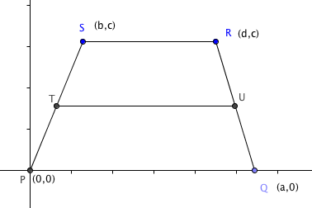
Trapezoid Midsegment Theorem: The segment joining the two midpoints of the legs of a trapezoid is parallel to the bases and equal in length to the average of the lengths of the two bases.

Triangle Midsegment Theorem: The segment joining the midpoints of two sides of a triangle is parallel to the third side and equal in length to half the third side.

11-12. Prove the Trapezoid Midsegment Theorem. Recall that a trapezoid may be represented in the coordinate plane by P(0,0), Q(a, 0), R(d, c) and S(b, c). Let T be the midpoint of $\overline{PS}$ and U the midpoint of $\overline{QR}$.

11. Start with the specific case where a = 10, b = 4, c = 6, and d = 8, that is the coordinates are P(0,0), Q(10, 0), R(8,6) and S(4,6).
a. Find coordinates of T(___,____) and U(_____, _____)

b. Find these lengths: PQ = _____ SR = _____ TU =______

c. Find the slopes of $\overline{PQ}$, $\overline{SR}$, and $\overline{TU}:$
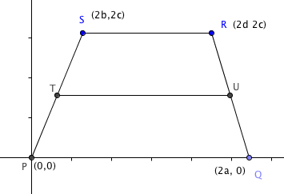

d. Now complete the proof.

12. Now prove the theorem in the general case. To make the calculations simpler we can double each variable coordinate so we have P(0,0), Q(2a, 0), R(2d, 2c) and S(2b, 2c).

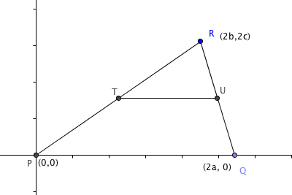

13. Prove the Triangle Midsegment Theorem. Use the coordinates shown in the figure at the right.

