Activity 3.6.2 Variables for Coordinates
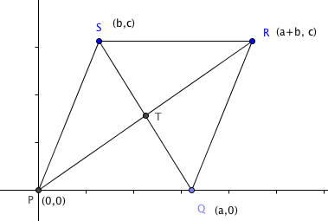
In this activity you will use variable coordinates to prove theorems using coordinate geometry.

1. Prove the Parallelogram Opposite Sides Theorem: The opposite sides of a parallelogram are congruent. (If a quadrilateral is a parallelogram, then the opposite sides are congruent.)

Here is a quadrilateral in the coordinate plane with vertices P(0, 0), Q(a, 0), R(a +b, c), and S(b, c).

First show that the opposite sides are parallel (using the slope formula):

a. Show that $\overline{PQ}$ || $\overline{RS}$

b. Show that $\overline{QR}$ || $\overline{SP}$

c. Since both pairs of opposite sides are parallel, by definition PQRS is a __________________.

Now show that the opposite sides are congruent (using the distance formula):

d. Show that PQ = RS

e. Show that QR = SP

f. Since PQ = RS and QR = SP, the opposite sides of PQRS are __________________.

2. Prove the Parallelogram Diagonals Theorem: The diagonals of a parallelogram bisect each other. (If a quadrilateral is a parallelogram, the diagonals bisect each other.)

You already showed in question 1 that quadrilateral in the coordinate plane with vertices P(0, 0), Q(a, 0), R(a +b, c), and S(b, c) is a parallelogram.

- Find the midpoint of $\overline{PR}$: (_________, __________)

b. Find the midpoint of $\overline{QS}$: (_________, __________)

c. Since diagonals $\overline{PR}$ and $\overline{QS}$ have the same __________, they__________ each other.

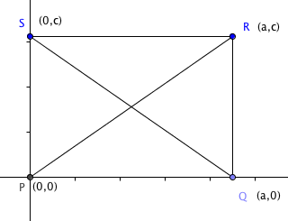
3. Prove the Rectangle Diagonals Theorem: The diagonals of a rectangle are congruent. (If a quadrilateral is a rectangle, then its diagonals are congruent.)

Here is a quadrilateral in the coordinate plane with vertices P(0, 0), Q(a, 0), R(a, c), and S(0, c).

- Which sides have zero slopes?

- Which sides have undefined slopes?

- Explain, using slope why $\overline{PS }⊥$ $\overline{PQ}$.

- Name the other pair of perpendicular sides.

- Explain why PQRS must be a rectangle.

Now find the length of each diagonal:

- PR = ________________

g. QS = _______________

h. Since PR = QS, the diagonals of PQRS are _____________________.

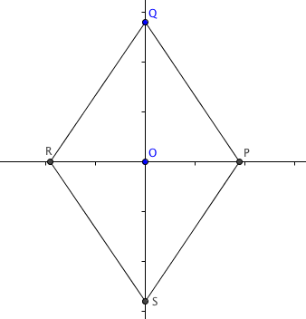
4. Prove the Rhombus Diagonals Theorem: The diagonals of a rhombus are perpendicular. (If a quadrilateral is a rhombus, then its diagonals are perpendicular.)

Here is a quadrilateral in the coordinate plane with vertices P(a, 0), Q(0, c), R(–a, 0), and S(0, –c).

Show that PQRS is a rhombus (use the distance formula):

a. PQ = _________

b. QR = _________

c. RS = _________

d. SP = _________

e. Because all four sides are congruent, PQRS is a _______________.

f. Find the slope of diagonal $\overline{PR}$.

g. Find the slope of diagonal $\overline{QS}$.

h. Explain using slopes why $\overline{PR}$ $⊥$ $\overline{QS}$.

