Activity 3.5.7Areas of Quadrilaterals

The purpose of this activity is to derive the formulas for the area of a rectangle, parallelogram, triangle, trapezoid, and kite. Throughout this activity, the base may refer to any side of a polygon and the height is perpendicular to the base.

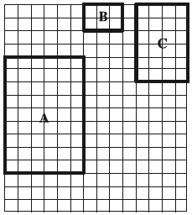
1. Rectangle Area Postulate
Assign each student in your group one of the rectangles at the right.

A: How many rows? _____ How many columns? _____
Area? ________

B: How many rows? _____ How many columns? _____
Area? ________

C: How many rows? _____ How many columns? _____
Area? ________

Rectangle Area Postulate - If b is the base and h is the height of a rectangle, then
Area = ________________. Explain by referring to the rectangles above.

2. Parallelogram Area Formula
Go to http://people.wku.edu/tom.richmond/area.html and click parallelogram. Watch the animation and explain below what kind of transformations you saw. Does the base change? Does the height change? Does the area change? What is the area formula for the area of a parallelogram? Make a sketch of the animation.

Parallelogram Area Formula - If b is the base and h is the height of a parallelogram, then
Area = ________________.

3. Triangle Area Formula
Use the same website and click triangle1. Watch the animation and explain below what kind of transformations you saw. Does the base change from the triangle to the parallelogram? Does the height change? Does the area change? What is the formula for the area of a triangle? Make a sketch of the animation.

Use the same website and click triangle2. Watch the animation and explain below what kind of transformations you saw. Does the base change from the triangle to the parallelogram? Does the height change? Does the area change? What is the formula for the area of a triangle? Make a sketch of the animation. Which animation do you like better?

Triangle Area Formula - If b is the base and h is the height of a triangle, then
Area = ________________.
4. Trapezoid Area Formula
Use the same website and click trapezoid1. Watch the animation and explain below how the figure was divided. Show the algebraic steps in the animation. What is the formula for the area of a trapezoid? Make a sketch of the animation.

Use the same website and click trapezoid2. Watch the animation and explain below what kind of transformations you saw. Does the base change from the trapezoid to the parallelogram? Does the height change? Does the area change? What is the formula for the area of a trapezoid? Make a sketch of the animation. Which derivation do you like better for the trapezoid?

Trapezoid Area Formula – If b₁ and b₂ are the measures of the two bases of a trapezoid and h is the height, then Area = ___________________.

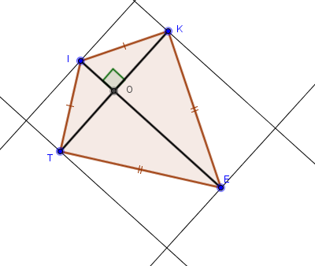
5. Kite Area Formula
For any kite, a rectangle can constructed around it such that the base and height of the rectangle are parallel to the diagonals of the kite. See picture to the right.
Label the diagonals d₁ and d₂. Then label the parallel sides of the rectangle d₁ and d_{2.} What is the area of the rectangle in terms of d₁ and d₂? How does the area of the kite compare to the area of the rectangle?

Kite Area Formula – If d₁ and d₂ are the diagonals of a kite, then Area = __________________.

6. What formula(s) would you use to calculate the area of a rhombus? Explain your options.

