**Activity 3.5.5 Sufficient Conditions for Parallelograms**

We know that if a quadrilateral has two pairs of parallel sides, then it is a parallelogram by definition. In this activity, you will explore what conditions are sufficient to prove that a quadrilateral has to be a parallelogram, without already knowing that both pairs of opposite sides are parallel.

**1.** Have each person in your group take one piece of linguine and break it so that you have two pairs of equal segments. Form a quadrilateral with your pieces. Depending on how you arrange the pieces you might get a kite, but you should be able to get a parallelogram. Was everyone in your group able to do that?   
  
Now fill in the blanks.

**Parallelogram Opposite Sides Converse:**

If the __________________sides of a quadrilateral are ______________________, then the quadrilateral is a _________________________.

**2.** Have each person in your group take another piece of linguine and break into two unequal pieces. Let the pieces intersect at their midpoints but not be perpendicular. Either use your pencil or pieces of linguine to outline a quadrilateral around the diagonals. Did everyone in your group successfully make a parallelogram? Now, fill in the blanks.

**Parallelogram Diagonals Converse:**

If the diagonals of a quadrilateral ______________ each other, then the quadrilateral is a ______________________.

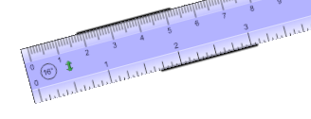**3.** What if you only know that one pair of opposite sides of a quadrilateral are congruent and parallel, but knew nothing about the other pair of sides? Is that sufficient evidence that the quadrilateral must be a parallelogram? Have each person in your group take a piece of linguine and break off two pieces of equal length. Place them somewhere on opposite sides of a ruler. Take the ruler away and connect the end points with two segments. Did you form a parallelogram? What about the rest of your group? Fill in the blanks.

**Opposite Sides Congruent and Parallel Theorem:** If one pair of opposite sides of a quadrilateral is ________________ and ________________, then the quadrilateral is a _____________________.

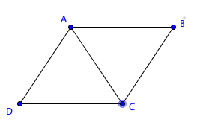**4. Proof of Parallelogram Opposite Sides Converse:**

**Given:** In quadrilateral *ABCD***,**and 

**Prove:** *ABCD* is a parallelogram.

Start by drawing .   
In ∆*ABC* and ∆*ADC*,  is congruent to ________ because it is a shared side.

We are also given that and _____________________.

We apply the _______ triangle congruence theorem to conclude that $∆$____________. Since corresponding parts of congruent triangles are congruent, we can say that   
__________ which makes _____ ||  by the alternate interior angle converse.

We can also conclude that ______ by CPCTC.

Thus, _______ || _______ by the alternate interior angle converse.

Therefore, *ABCD* is a ________________ by the definition of _____________________.

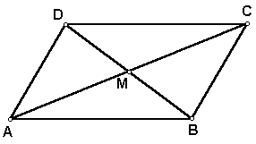**5.** **Proof of Parallelogram Diagonals Converse:**

**Given:** In quadrilateral *ABCD*,   
diagonals and  bisect each other at M.

**Prove:** *ABCD* is a parallelogram.

Since, and bisect each other at M, then it follows that _______ and ______ by the definition of bisect.

and are _____________ angles, so they must be congruent.

So, $∆$____________ by the __________ triangle congruence theorem.

Then,  by CPCTC. Complete the proof to show the other pair of opposite sides is congruent:

Since both pairs of opposite sides are congruent, the quadrilateral is a _____________________ by the Parallelogram Opposite Sides Converse.

**6.** **Proof of Opposite Sides Congruent and Parallel Theorem**

**Given:** In quadrilateral *ABCD*,and 

**Prove:** *ABCD* is a parallelogram.

Start by drawing .

Since , _________ by _____________________ theorem.

In ∆*ABC* and ∆*ADC*,  is congruent to ________ since it is a shared side.

Since it is also given that , we can conclude that $∆ABC ≅$ $∆ _______$

by ____________ triangle congruence.

It then follows that by ___________________.

Since both pairs of sides are congruent, and we just proved the __________________ Converse, *ABCD* must be a _______________________.

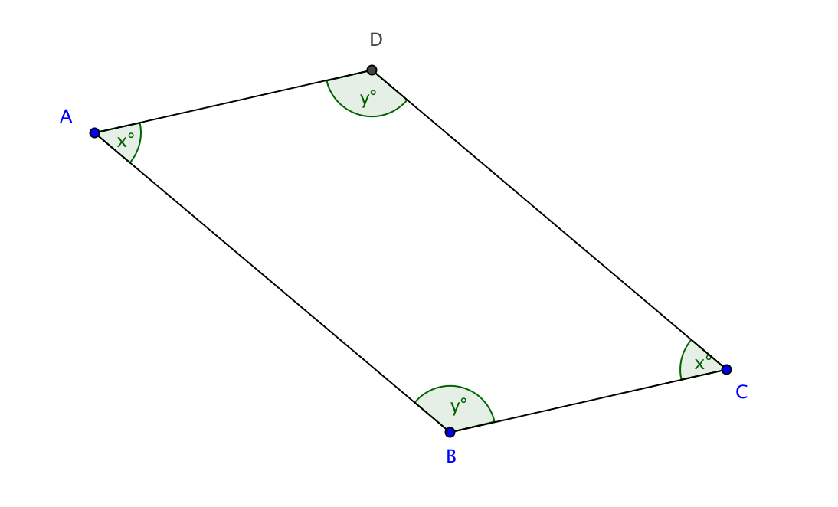**7.** **If a quadrilateral has two pairs of opposite angles that are congruent, then the quadrilateral is a parallelogram.**

Use the diagram to the right to help prove that *ABCD* is a parallelogram.

y

x

|  |  |
| --- | --- |
| Statements | Reasons |
| 2*x* + 2*y* = 360 |  |
|  | Divide both sides of equation by 2. |
| $∠$*A* and $∠$*B* are supplementary. Also $∠$*A* and $∠$*D* are supplementary. |  |
|  | Same Side Interior Angles Supplementary 🡪Parallel Lines |
|  | Definition of Parallelogram |

**8.** Circle the quadrilaterals that have sufficient evidence to be a parallelogram, based on the markings on the figures.

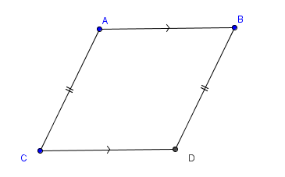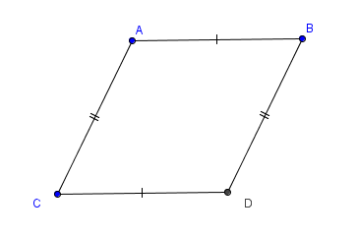

A) B)

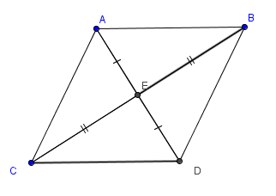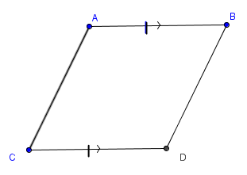

C) D)

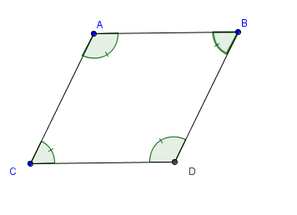

E)