Activity 3.5.3 Symmetry in Quadrilaterals

1. Your teacher will assign you to one or two of the quadrilaterals. Cut out the corresponding quadrilaterals below for your group.

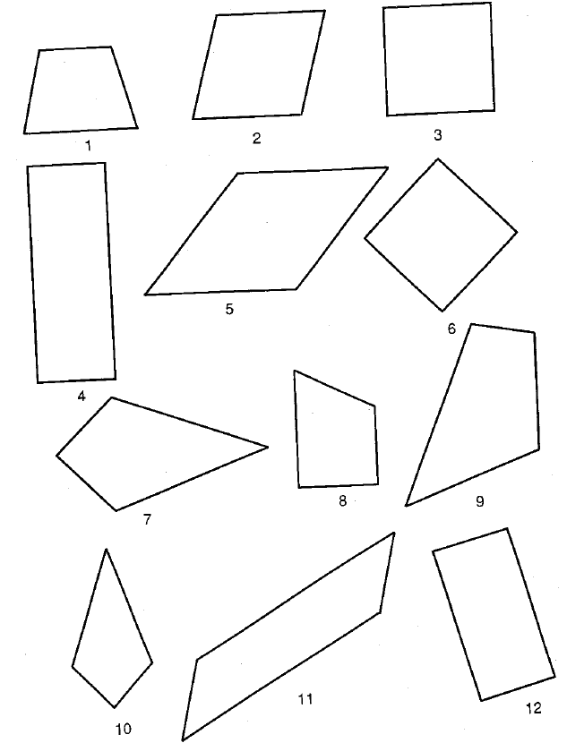

This page intentionally left blank to cut out quadrilaterals.

2. Investigate your quadrilateral(s) by filling in the following table. Use paper folding to help you.
 | Sketch with lines of symmetry. | Degrees of Rotational Symmetry | Do the diagonals always bisect interior angles?
Quadrilateral
Trapezoid
Isosceles Trapezoid
Kite
Parallelogram
Rhombus
Rectangle
Square

3. Assign one person from your group to be the rotator. When your teacher says to rotate, the rotator from each group will move to another group. During this time, explain what you learned with the new group member(s). Fill in the chart on the previous page with the information that you learned. You will keep rotating until your chart is completed. Then return to your original group.

4. Which quadrilaterals have diagonals that bisect the interior angles?

5. Which quadrilaterals have exactly one line of symmetry?

6. Which quadrilaterals have two lines of symmetry?

7. Which quadrilaterals have four lines of symmetry?

8. Which quadrilaterals have 180 degree rotational symmetry?

9. Which quadrilaterals have 90 degree rotational symmetry?

10. Complete the following statements with “True” or “False.”
a. A parallelogram’s diagonals are always lines of symmetry. ____________
b. The diagonals of a rectangle bisect the interior angles. _____________
c. An isosceles trapezoid’s line of symmetry is the perpendicular bisector of the bases. ________
d. A kite always has two lines of symmetry. __________
e. A rhombus’s diagonals are always lines of symmetry. _____________

