Activity 3.5.1 Classifying Quadrilaterals

Use these 12 quadrilaterals for this activity. You may assume that things are the way they appear. For example if two sides appear to be equal you may assume that they are. If two sides appear to be parallel you may assume that they are; etc. You may also use rulers or protractors to check.

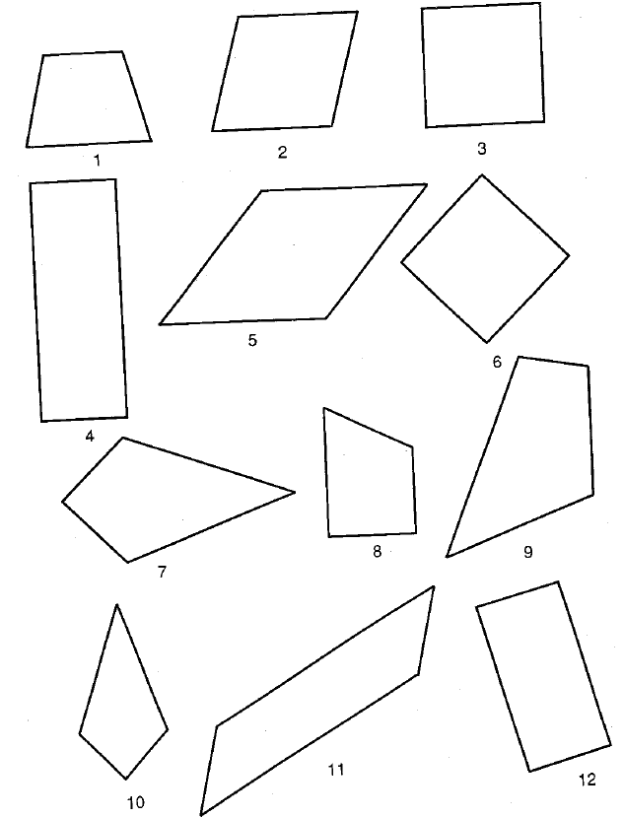
Figures from Craine and Rubenstein, 1993
Answer questions on page 3 of this activity.

This page left intentionally blank.
You may tear off the first page to use when answering questions on page 3.

- Which quadrilaterals have at least one pair of parallel sides?

- Which quadrilaterals have two pairs of parallel sides?

- Which quadrilaterals have at least two pairs of congruent adjacent sides?

- Which quadrilaterals have at least two pairs of congruent adjacent angles?

- Which quadrilaterals have four congruent sides?

- Which quadrilaterals have four congruent angles?

- Which quadrilaterals appeared in every answer to questions 1 through 6? What are these quadrilaterals called?

- In this course we will use this definition of trapezoid: A trapezoid is a quadrilateral with at least one pair of parallel sides. Using this definition, which of the quadrilaterals are trapezoids?

- In this course we will use this definition of isosceles trapezoid: An isosceles trapezoid is a quadrilateral with at least two non-overlapping pairs of congruent adjacent angles. Using this definition, which of the quadrilaterals are isosceles trapezoids?

- A parallelogram is a quadrilateral with two pairs of parallel sides. Which of the quadrilaterals are parallelograms?

- A kite is a quadrilateral with two at least two non-overlapping pairs of congruent adjacent sides. Which of the quadrilaterals are kites?

- A rectangle is a quadrilateral with four congruent angles. Which of the quadrilaterals are rectangles?

- A rhombus is a quadrilateral with four congruent sides. Which of the quadrilaterals rhombuses?

The Hierarchy of Quadrilaterals
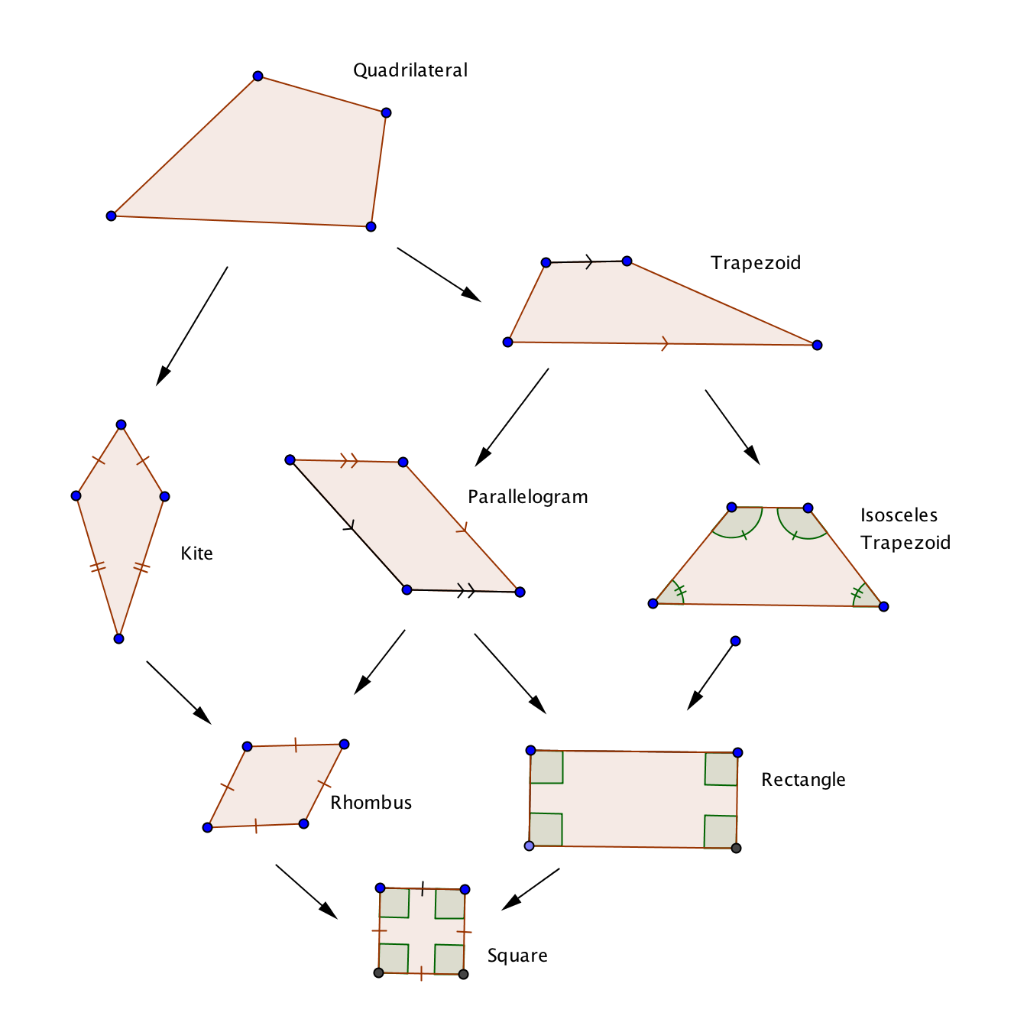
The chart at the right shows the hierarchy of quadrilaterals. As you go down the chart each type of quadrilateral has more properties than the one above it.

14-19. Fill in the blanks:

14. If a quadrilateral is both a rectangle and a rhombus, then it is a ____________.
15. If a quadrilateral is both a kite and a parallelogram, then it is a _____________.
16. If a quadrilateral is both a parallelogram and an isosceles trapezoid, then it is a _________.
17. Every isosceles trapezoid is also a ___________ and a ________.
18. Every parallelogram is also a _____________ and a ___________.
19. Every square is also a _________________, a _________________, a ______________,
a ______________, a ___________________, a ____________________, and
a __________________.

