Activity 3.4.6 Lines of Symmetry in Regular Polygons

Use the template that comes with this activity.

1. Cut out the six regular polygons and fold along their lines of symmetry. You may want to work with a partner, each taking three polygons.

2. Sketch the lines of symmetry you found on the figures below.

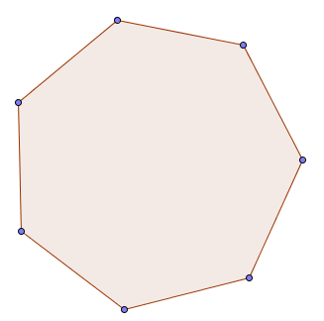
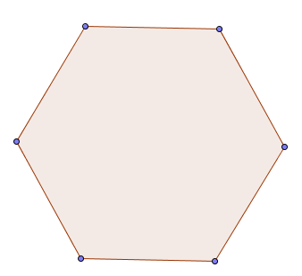
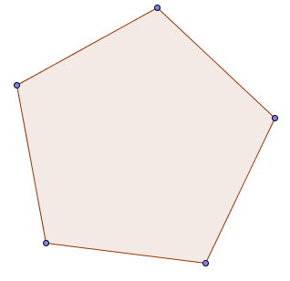
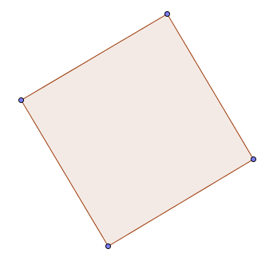
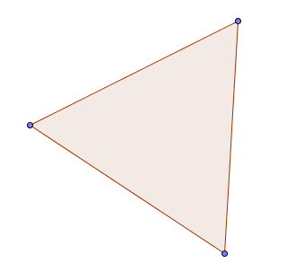
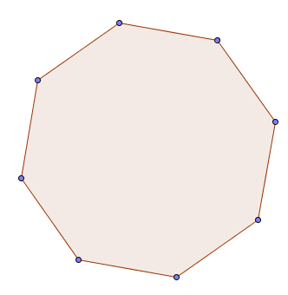
3. Make conjectures about how many lines of symmetry a polygon with n sides has and where those lines are located. Also record any other patterns you notice.

