Activity 3.4.5 Constructing Regular Polygons with Other Tools

In the previous activity you were limited to using the Euclidean tools—compass and straightedge. Now we will allow other tools such as protractors, rulers, and the transformation tools of Geogebra or Geometer’s Sketchpad.
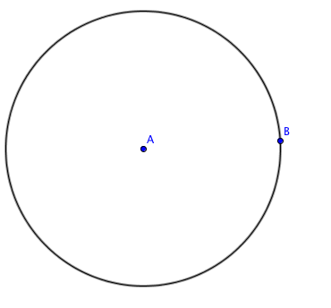
- Construct a regular polygon with any number of sides (n) inscribed in a given circle.
- First divide 360° by the number of sides. For example if n = 5, $\frac{360°}{n}=\frac{360°}{5}$ = 72°.
- Draw a circle with center A and radius $\overline{AB}$.
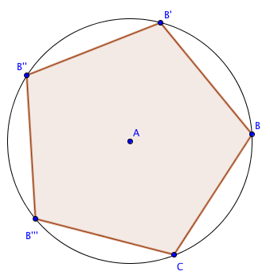
- Rotate B about point A with angle $\frac{360°}{n}$. In this case the angle is 72°.
- Rotate B’ about point A with the same angle.
- Continue rotating until you have n equally spaced points on the circle.
- Join the points on the circle to form a polygon.
- Measure the sides and the interior angles to verify that your polygon is regular.
Sides = ____________ Angles = ___________
- Now try this with n = 10, n = 9, and n = 7.
2. Explore the rotational symmetry of a regular polygon.
a. Start with the regular pentagon inscribed in a circle as shown above. Use the rotate tool.
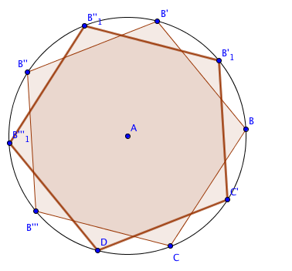
b. Select the pentagon, point A, and 36° for the angle of rotation. Observe that the rotated pentagon does not coincide with the original pentagon as shown.
c. Undo the rotation so that only the original pentagon is showing.
d. Now rotate the pentagon again about point A this time with 72° for the angle of rotation. What happens?

e. Rotate the pentagon 144°. Observe what happens.

f. Find one more angle of rotation that will map the pentagon onto itself.

g. Make a conjecture about which angles of rotation will map the pentagon onto itself.

- Suppose you start with a regular nonagon (n = 9), which you constructed in question 1h. What angle(s) of rotation will map the nonagon onto itself? Test your conjecture.

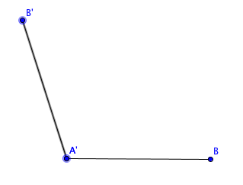
3. Constructing a regular polygon given one side. Again suppose n = 5, so we will be constructing a regular pentagon.
a. Start with a line segment $\overline{AB}$.
b. Find the measure of an interior angle of your regular polygon. Recall how to do this from Activity 3.4.2.
Show your calculation here:

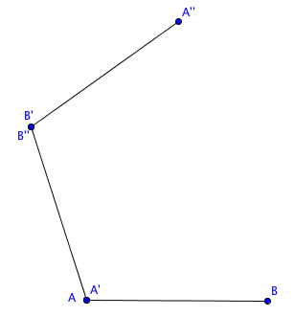
c. Rotate segment $\overline{AB}$ about point A through the angle found in step (b).
d. Now rotate segment $\overline{A’B’ }$about point B’ through the same angle.
e. Continue the process until the regular polygon is completely formed.
f. Measure the sides and angles of the figure you have created to verify that this polygon is indeed regular.
Sides = _________ Angle measures = __________
g. Repeat this process for some other value of n of your choosing.

