Activity 3.3.4a Constructing Parallel Lines

Our goal is to create parallel lines using a straight edge and a compass. We are given only a line m and a point P. We will create a line parallel to line m through point P. Try this construction on another sheet of paper or on the computer.

Note: If you use GeoGebra, it is easier to draw complete circles rather than arcs. If you use a compass and straightedge, you may prefer to draw only an arc that passes through or locates the named points.
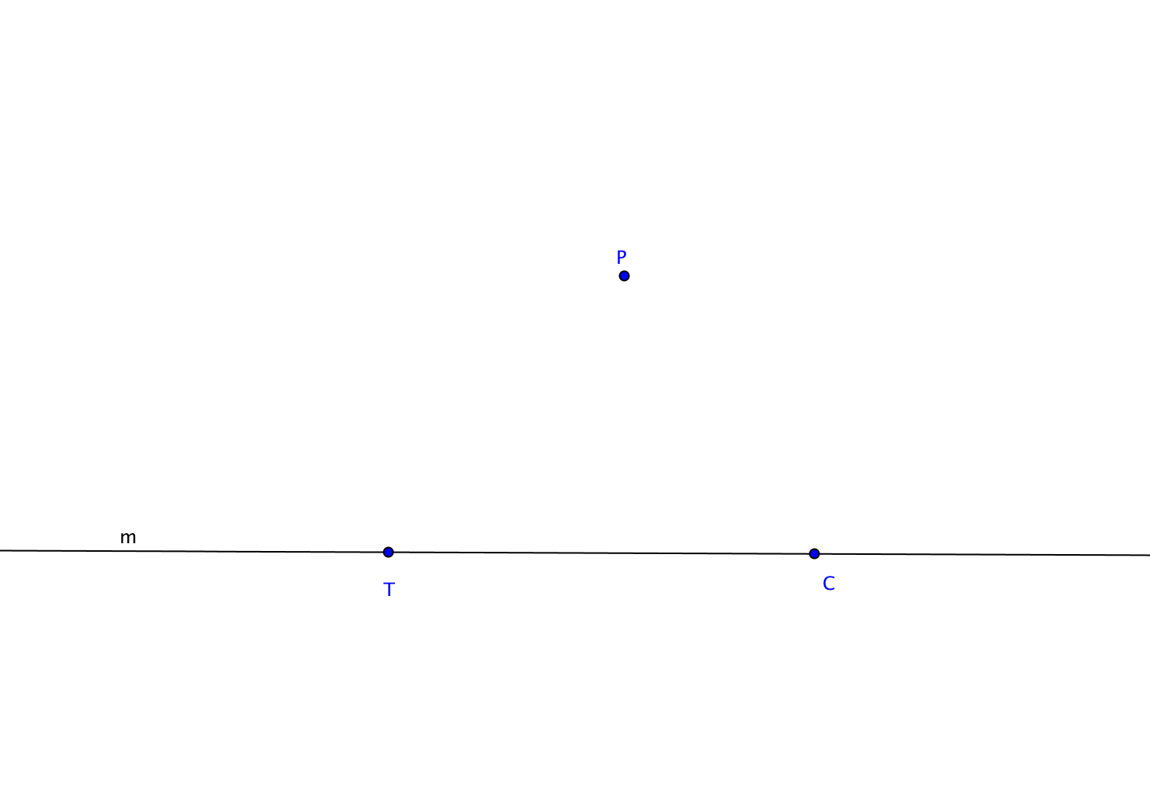
- Given line m and point P.

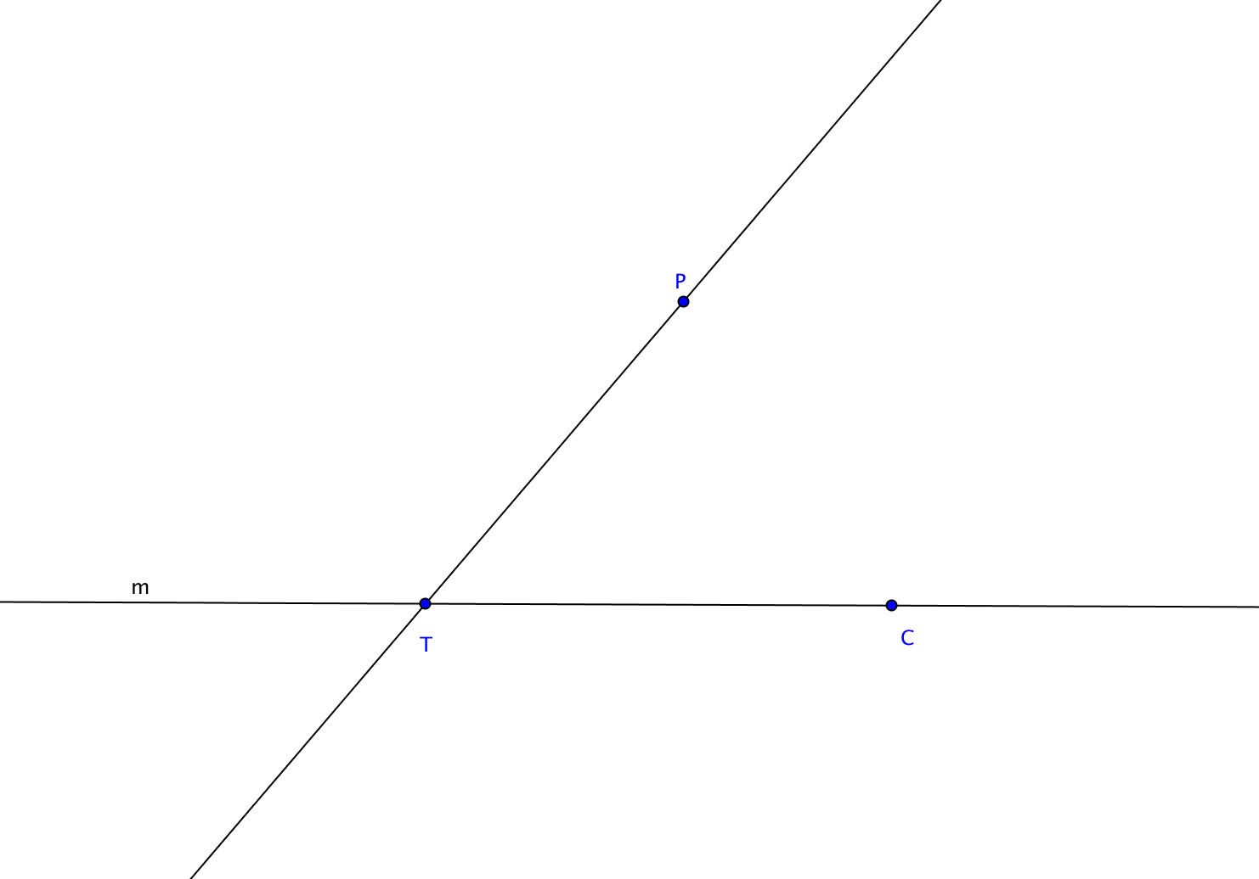
- Choose any point T on line m. Draw line $\overset{⃡}{TP}$. Let C be another point on m.

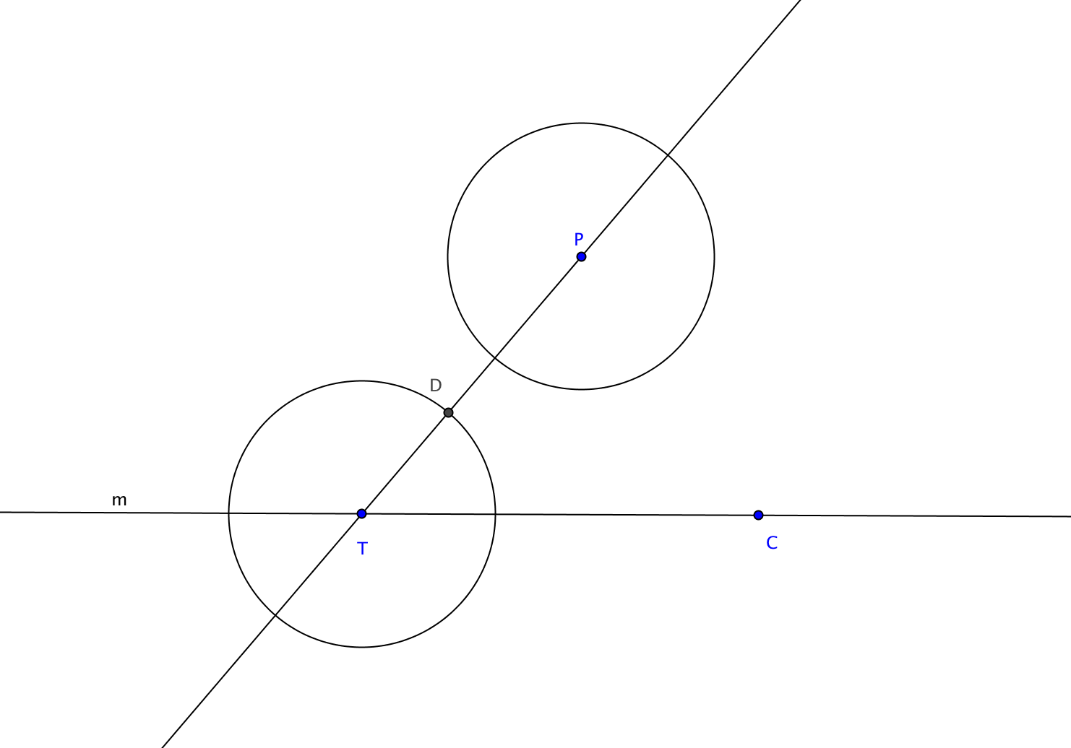
- We will now copy $∠PTC$ and form that angle with P as its vertex and one side along $\vec{TP}$.
Choose any point on line $\overset{⃡}{TP}$ between points T and P. Call that point D. Draw the circle (or an arc) with center T through point D. Then draw the circle (or an arc) with center P with radius = DT.

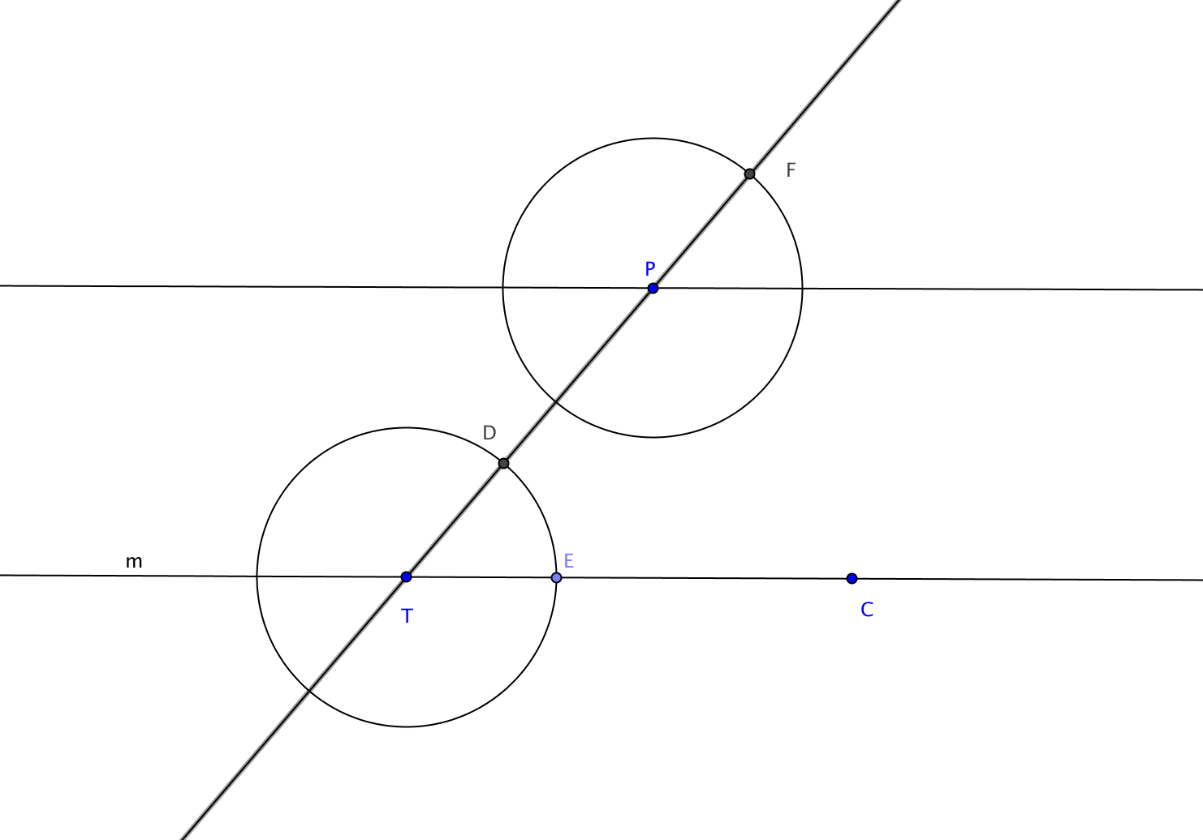
- Name the intersection of circle T and line m, point E. Name the intersection of circle P with line TP, point F.

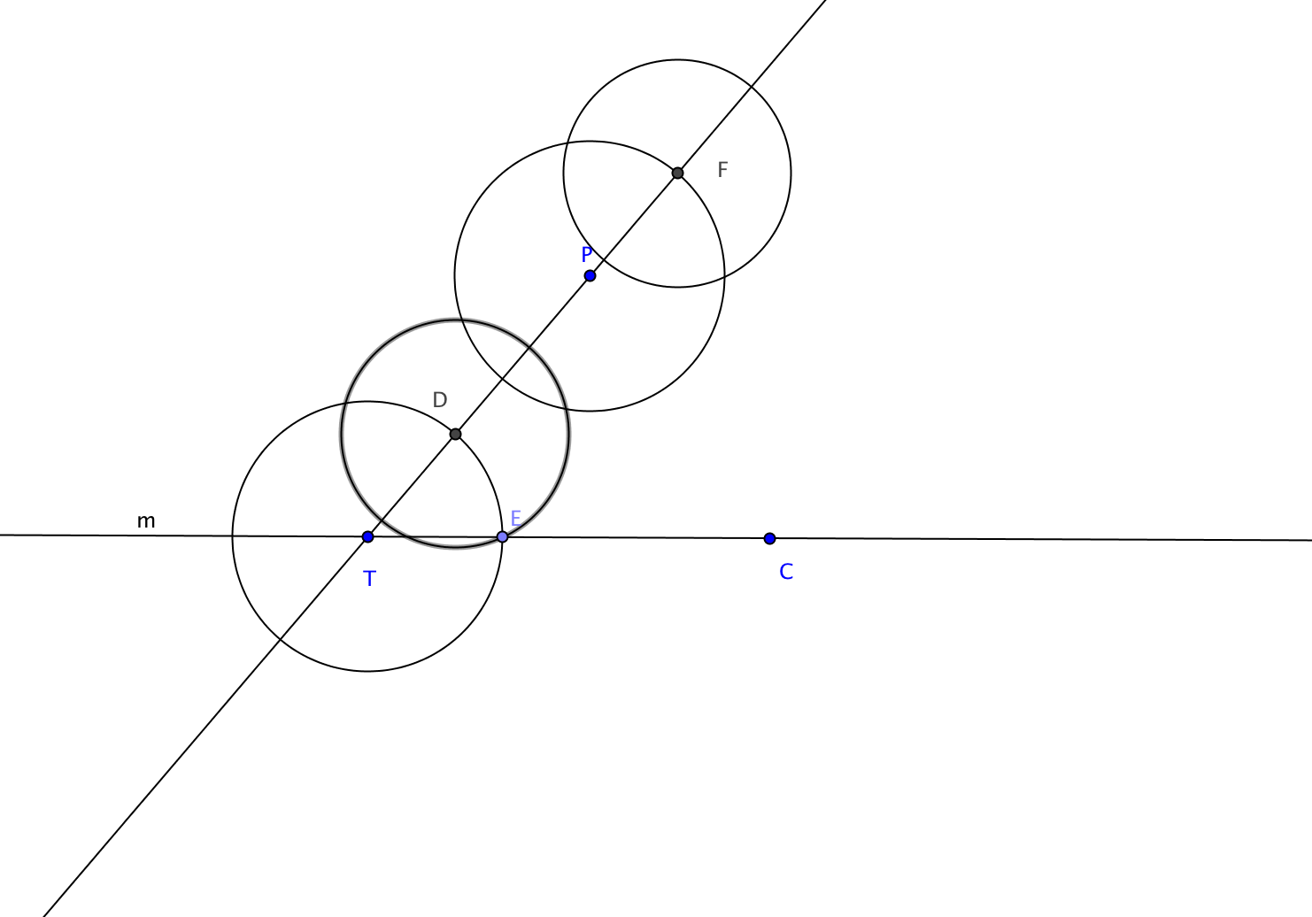
- Draw the circle (or an arc) with center D through point E. Draw the circle (or an arc) with center F and radius = DE.

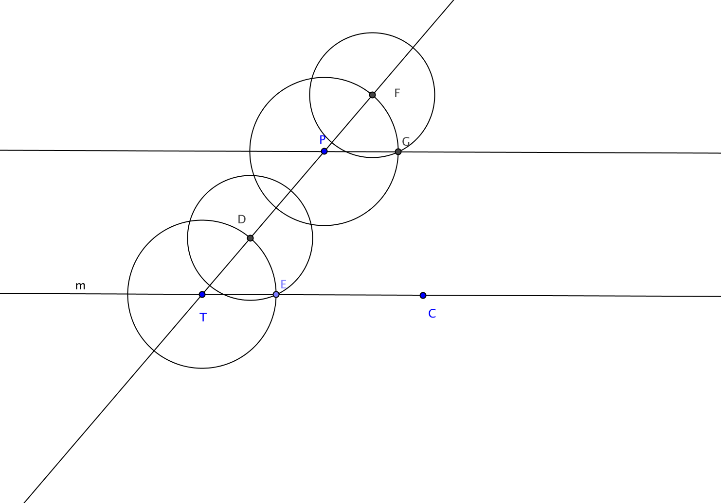
- Label the intersection of circle F and circle P, point G as in the diagram below. Draw line $\overset{⃡}{PG}$. $\overset{⃡}{PG }$has now been constructed to be parallel to line m.

- Prove that this construction produces a line parallel to line m through point P.

