Activity 3.2.6 Design a Triangle
Group members:

1. _________________ 2. _______________ 3. ________________ 4. _______________

Take turns choosing the length of a side or the measure of an angle of ∆ABC Then other members of the group must decide whether a triangle with the given measurements is possible or impossible. Keep track of which parts have been chosen in the column on the right.

1. First student’s choice:
______ = ________
Possible or impossible?
Explain:

2. Next student’s choice:
______ = ________
Possible or impossible?
Explain:

3. Next student’s choice:
______ = ________
Possible or impossible?
Explain:

4. Next student’s choice:
______ = ________
Possible or impossible?
Explain:

5. Next student’s choice:
______ = ________
Possible or impossible?
Explain:

6. Next student’s choice:
______ = ________
Possible or impossible?
Explain:

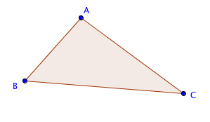

m$∠A$ = ____________

m$∠B$ = ____________

m$∠C$ = ____________

AB = ____________

BC = ____________

CA = ____________

