Activity 3.1.6 Angle-Angle-Side Congruency

- Determine the measure of A. m$∠A$ = ______.

- Determine the measure of D. m$∠D$ = ______.

- Determine the measure of I. m$∠I$ = ______.
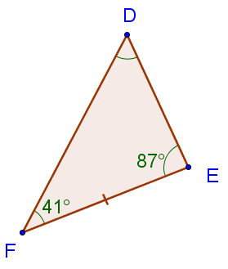
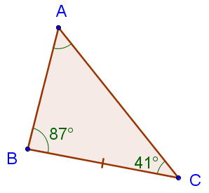
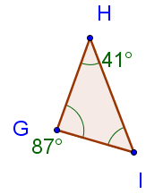

- Can you make any conclusions? Write your thoughts down about the relationships between the triangles and the given information.

- Discuss your ideas with a classmate and try to formalize your ideas into a theorem that can be communicated with the rest of the class.

- If _____ angles from one triangle are equal to _____ angles from another triangle, then their third angles are ______.

7. Using this new theorem formed in question 6, how can we prove congruence between the following triangles?

Prove: $∆ABC≅∆DEF$

Given: $∠A=∠D$, $∠B=∠E,$ $BC=EF$

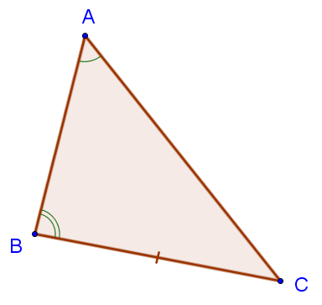
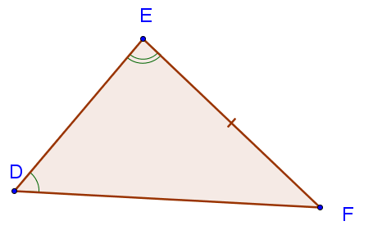

{HINT: Use the theorem on the previous page to help you obtain the information necessary for a previously proven method of congruence}

You have now proved the AAS Congruence Theorem: It two angles and a non-included _____ of one triangle are congruent to two ______ and the corresponding non-included ______of a second triangle, then the two triangles are congruent.
Proving Congruency using SAS, ASA, SSS, and AAS

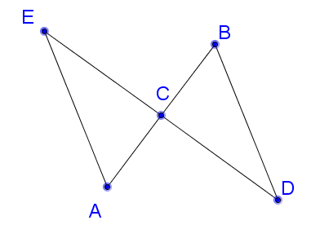
- Can the following congruence statement be proved using the given information and the diagram? If so, prove the congruence statement. If not, state why not.

Prove: $∆CBD≅∆CAE$

Given: $∠A=∠B$ and C is the midpoint of segment $\overline{AB}.$

- Can the following congruence statement be proved using the given information and the diagram? If so, prove the congruence statement. If not, state why not.
Prove: $∆CBD≅∆CAE$

Given: $∠A=∠B$ and $BD=AE$

- Can the following congruence statement be proved using the given information and the diagram? If so, prove the congruence statement. If not, state why not

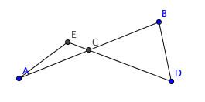
Prove: $∆CBD≅∆CAE$

Given: C is the midpoint of segment $\overline{AB}$ and $BD=AE$

- Can the following congruence statement be proved using the given information and the diagram? If so, prove the congruence statement. If not, state why not

Prove: $∆ABF≅∆EHG$

Given: m $∠H=m ∠B$ and $FG=AE;$ angles HEG and FAB are right angles.
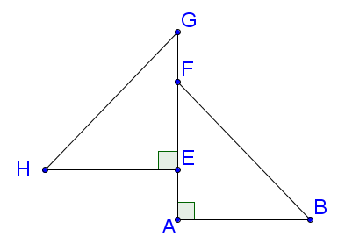

- Can the following congruence statement be proved using the given information and the diagram? If so, prove the congruence statement. If not, state why not.

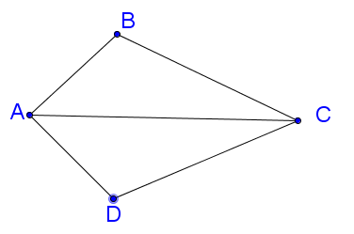
Prove: $∆ABC≅∆ADC$

Given: Segment $\overline{AC}$ bisects $∠BAD$ and
Segment $\overline{AC}$ bisects $∠BCD$

- Can the following congruence statement be proved using the given information and the diagram? If so, prove the congruence statement. If not, state why not.
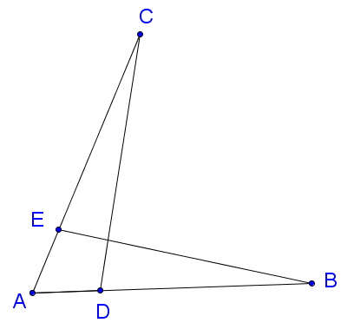

Prove: $∠B$ $≅$ $∠C$

Given: $AC=AB$ and $EA=DA$

- Can the following congruence statement be proved using the given information and the diagram? If so, prove the congruence statement. If not, state why not.
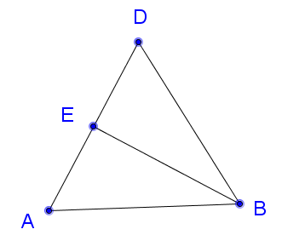

Given: $∆ABD$ is an equilateral triangle and E is the midpoint of segment $\overline{AD}$

Prove: $\overline{EB}$ bisects $∠DBA.$

15. In question 14 above prove that $\overline{EB}$ $⊥\overline{AD}$.

