**Activity 3.1.5 Applications of the Triangle, Quadrilateral and   
Polygon Angle Sum Theorems**

**Part I -- Triangles**

Determine the missing degree measure for each diagram. m $∠B$

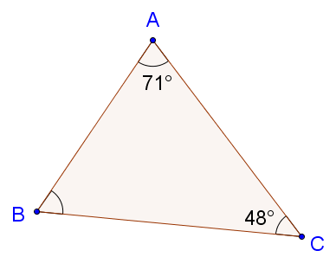

1. m $∠B$ = _______

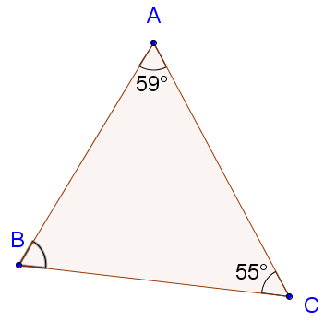

1. m $∠B$ = _______

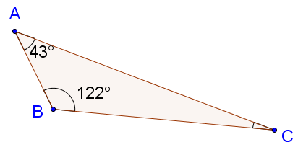

1. m $∠C$ = _______

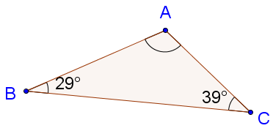

1. m $∠A$ = _______

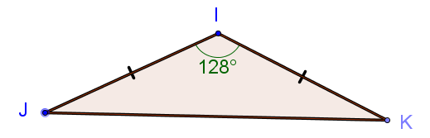

1. m $∠J$ = _______

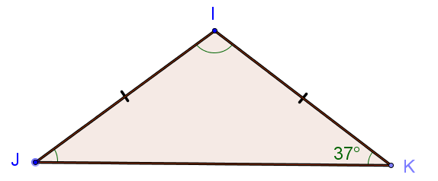

1. m $∠I$ = _______

Use the diagram at the right for questions 7 and 8.

1. m $∠GEH$ 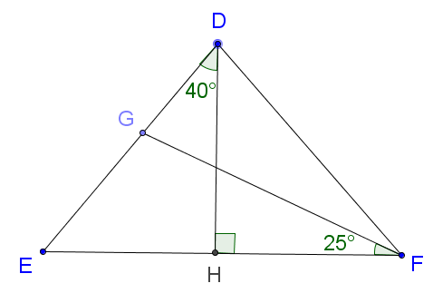 = _______
2. m $∠DGF$ = _______
3. Use the diagram below to determine the measures of the angles.



m $∠1$ = _______

m $∠2$ = _______

m $∠3$ = _______

m $∠4$ = _______

m $∠5$ = _______

m $∠6$ = _______

m $∠7$ = _______

m $∠8$ = _______

m $∠9$ = _______

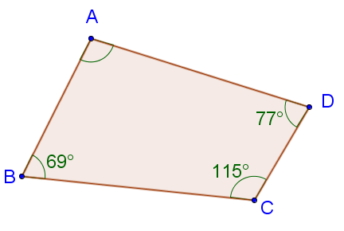**Part II -- Quadrilaterals and Other Polygons**

1. Determine the measure of $∠A$.

m $∠A$ = _______

1. Determine the value of *x*. Then determine the measures of all of the angles in the figure.

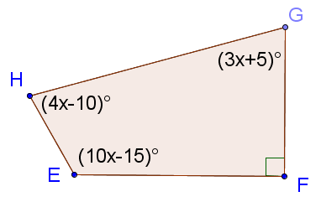

*x* = _______

m $∠E$ = _______

m $∠F$ = _______

m $∠G$ = _______

m $∠H$ = _______

1. Determine the measure of $∠E$.

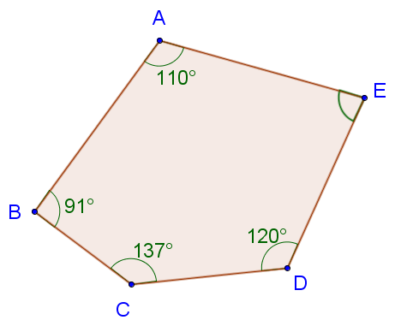m $∠E$ = _______

1. Determine the value of *x.* Then determine the measures of all of the angles in the figure.

*x* = _______

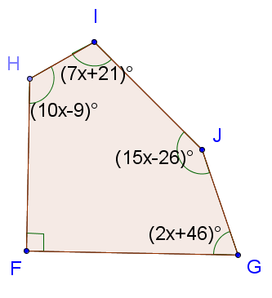

m $∠F$ = _______

m $∠G$ = _______

m $∠H$ = _______

m $∠I$ = _______

m $∠J$ = _______