**Activity 1.5.2 Domains and Graphs of Composite FUNctions**

In this Activity, we will explore the domain and range of composite functions.

1. If f(x) = 2x – 1 and g(x) = , find the following:

a) The domain of f(x): e) The domain of g(x):

b) (f $∘$ g)(x) = f) (g $∘$ f)(x) =

c) the domain of (f $∘$ g)(x): g) the domain of (g $∘$ f)(x):

d) Graph f(x), g(x) and (f g)(x) on the same h) Graph f(x), g(x) and (g f)(x) on

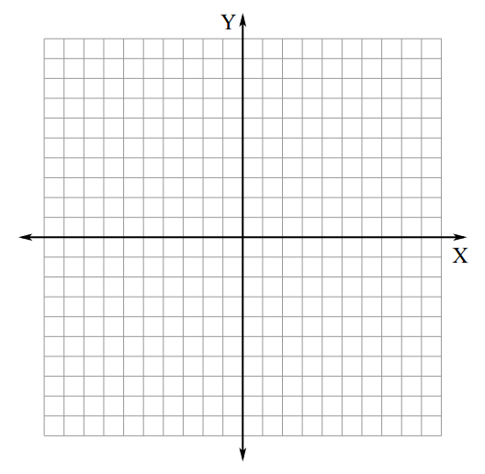 coordinate plane. (Use different colors the same coordinate plane.

if possible.) (Use different colors if possible.)

1. (f $∘$ f)(x) = l) (g $∘$ g)(x) =

j) the domain of (f $∘$ f)(x): m) the domain of (g $∘$ g)(x):

k) Graph f(x), g(x) and (f $∘$ f)(x) on the same n) Graph f(x), g(x) and (g $∘$ g)(x) on

 coordinate plane. (Use different colors the same coordinate plane.

if possible.) (Use different colors if possible.)

1. If f(x) = 3x – 2 and g(x) = , find the following:

a) The domain of f(x): e) The domain of g(x):

b) (f $∘$ g)(x) = f) (g $∘$ f)(x) =

c) the domain of (f $∘$ g)(x): g) the domain of (g $∘$ f)(x):

d) Graph f(x), g(x) and (f g)(x) on the same h) Graph f(x), g(x) and (g f)(x) on

 coordinate plane. (Use different colors the same coordinate plane.

if possible.) (Use different colors if possible.)

i) (f f)(x) = l) (g g)(x) =

j) the domain of (f f)(x): m) the domain of (g g)(x):

k) Graph f(x), g(x) and (f f)(x) on the same n) Graph f(x), g(x) and (g g)(x) on

 coordinate plane. (Use different colors the same coordinate plane.

if possible.) (Use different colors if possible.)

1. If f(x) = x2 +1 and g(x) = , find the following:

a) The domain of f(x): e) The domain of g(x):

b) (f g)(x) = f) (g f)(x) =

c) the domain of (f g)(x): g) the domain of (g f)(x):

d) Graph f(x), g(x) and (f g)(x) on the same h) Graph f(x), g(x) and (g f)(x) on

 coordinate plane. (Use different colors the same coordinate plane.

if possible.) (Use different colors if possible.)

i) (f f)(x) = l) (g g)(x) =

j) the domain of (f f)(x): m) the domain of (g g)(x):

k) Graph f(x), g(x) and (f f)(x) on the same n) Graph f(x), g(x) and (g g)(x) on

 coordinate plane. (Use different colors the same coordinate plane.

if possible.) (Use different colors if possible.)

1. If f(x) = 2x - 5 and g(x) = , find the following:

a) The domain of f(x): e) The domain of g(x):

b) (f $∘$ g)(x) = f) (g $∘$ f)(x) =

c) the domain of (f $∘$ g)(x): g) the domain of (g $∘$ f)(x):

d) Graph f(x), g(x) and (f g)(x) on the same h) Graph f(x), g(x) and (g f)(x) on

 coordinate plane. (Use different colors the same coordinate plane.

if possible.) (Use different colors if possible.)

i) (f f)(x) = l) (g g)(x) =

j) the domain of (f f)(x): m) the domain of (g g)(x):

k) Graph f(x), g(x) and (f f)(x) on the same n) Graph f(x), g(x) and (g g)(x) on

 coordinate plane. (Use different colors the same coordinate plane.

if possible.) (Use different colors if possible.)

1. Given the “composite” function F below, find two functions, f and g, such that F is equal to. (This is called “decomposing the function.”) *Note: For some functions, there is more than one pair of functions f and g that work!*

Example: Given: F(x) = , f(x) = , g(x) = x + 5

|  |  |  |
| --- | --- | --- |
|  |  |  |
|  |  |  |
|  |  |  |

|  |  |  |
| --- | --- | --- |
|  |  |  |
|  |  |  |
|  |  |  |