Unit 3: Investigation 2 (3-4 days)

Polynomial Operations

Common Core State Standards

A.APR.1 Understand that polynomials form a system analogous to the integers, namely, they are closed under the operations of addition, subtraction, and multiplication; add, subtract, and multiply polynomials.
A.APR.2 Know and apply the Remainder Theorem: For a polynomial p(x) and a number a, the remainder on division by x – a is p(a), so p(a) = 0 if and only if (x – a) is a factor of p(x).
Overview
Investigation 2 examines polynomial operations and establishes that polynomials have a similar structure as the set of integers. The activities examine the basic operations involving polynomials by reviewing the operations of addition, subtraction, and multiplication and making the connection between the Division Algorithm for integers and Division for polynomials with integral coefficients. Note that any polynomial with rational coefficients can be written as a rational number times a polynomial with integral coefficients by factoring out the rational number representing the least common denominator of all the rational coefficients. Similar properties between the two structures include 1) prime factorization; 2) closure of addition, subtraction, and multiplication of polynomials; and 3) the zero product property. To launch the activity, students will find the polynomial expressions that compute the surface area and volume of a rectangular solid. Students will then examine the relationship between the annual revenue generated by movie viewing and the general population to establish the amount of money spent per capita on going to theaters. After first examining the relationship numerically, the students will then consider how to come up with an expression that represents this problem in general. This question leads to the need to divide the two polynomials and interpret the quotient and remainder. After developing the procedure to perform long division, students will examine the relationship between the remainder of the quotient P(x) ÷ (x–a) and the value of P(a). Students will note that when the remainder is 0, P(a) = 0, which indicates that (x–a) is a factor of P(x).

Assessment Activities

Evidence of Success: What Will Students Be Able to Do?
- Add, subtract, and multiply polynomials.
- Divide polynomials using long division.
- State the Remainder Theorem and its implications.
- Determine if (x–a) is a factor of P(x) by either calculating the remainder using long division or finding the value of P(a).

Assessment Strategies: How Will They Show What They Know?
- Exit Slip 3.2 asks the students to state the Remainder Theorem in their own words, apply it to find the remainder for a specific division problem, and determine if a binomial is a factor of a polynomial using the theorem.

- Journal Prompt 1 asks students in what ways do the properties of the polynomial operations of addition and multiplication depend on the properties of addition and multiplication of real numbers?
- Journal Prompt 2 asks students to respond to the prompt: How is long division of polynomials like long division with whole numbers?
- Journal Prompt 3 asks the students two questions: 1) What does it mean if the remainder of the division process for integers is equal to 0? and 2) What would it mean if the remainder for polynomial division equals 0?
- Activity 3.2.1 Roller Coasters and Curves will review the basic operations involving polynomials.
- Activity 3.2.2 Roots and Factored Form of Polynomials gives students a problem whose solution will require them to perform some form of division, which can be used to illustrate the long division process and extend the process to polynomial division.
- Activity 3.2.3 Polynomial Long Division and the Remainder Theorem will have students practice performing long division of a polynomial P(x) divided by a binomial of the form (x–a).

Launch Notes
The launch for Investigation 2 establishes a bridge between Geometry and Algebra 2 by asking students to find the surface area and volume of a rectangular solid whose dimensions are expressed as linear expressions. The computations necessary to find the expressions will provide a good review of the basic operations of addition, subtraction, and multiplication of polynomials.

Teaching Strategies

To introduce this investigation, Activity 3.2.1 will review the basic operations involving polynomials. Students first find the surface area and volume of the rectangular solid with width, w = 2x+1, length, l = 3x + 2, and height, h = x+5.

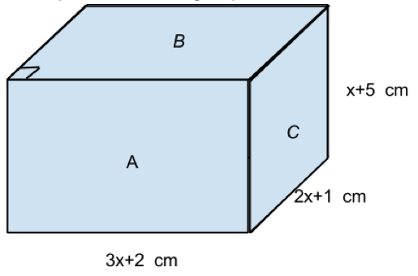

In order to perform those computations, students will need to be able to compute the products and sum of polynomial expressions. This will lead into the parallel structures that exist between the set of integers and the set of polynomial expressions. For students needing more help, it would be beneficial to first perform the operations with integral values for the width, length, and height and then proceed to the computation of the volume and surface area using the polynomial expressions for the length, width, and height. This would help students make the connection between the algebraic structure of the integers and the algebraic structure of polynomials. In the later example from the business world, it can be seen that polynomials with rational number coefficients also follow the same rules for performing the operations. Points to be discussed in this investigation are closure of addition, subtraction, and multiplication of polynomials.

Group Activity:
Place the students in pairs of approximately equal ability to perform the operations necessary to find the surface area and volume of the rectangular solid.

Differentiation:
Make one of the sides of the rectangular solid a monomial in order to simplify the computation or structure the worksheet to indicate the operations necessary to calculate the areas of each face of the rectangular solid. Bring in a rectangular solid to help students visualize the surface area of the figure.

For more advanced students, the revenue problem presents more of a challenge in working with the polynomials and in interpreting how the problem works when x represents hundreds of units and not a single unit.

Journal Prompt 1: Ask students in what ways do the properties of the polynomial operations of addition and multiplication depend on the properties of addition and multiplication of real numbers? Answers should include the fact that since the variables all represent real numbers, the properties of addition and multiplication must still hold.

To begin Activity 3.2.2, students will be given the following problem: How much money per person was spent on movies in the United States and Canada in the year 2013? Students can be given this problem for homework and then have them share their answers in class. It is expected that they will have access to the internet to find the appropriate information. The solution will require students to perform some form of division, which can be used to illustrate the long division process. Once examined in class, the following scenario involving algebra will be given to the students:

The amount M (in hundreds of millions of dollars) spent at movie theaters from 1990 to 1995 can be modeled by the polynomial function M(x) = 2x³ – 11x² +14x +27, where x is the number of years since 1990. The United States population P (in tens of millions) from 1990 to 1995 can be modeled by the function P(x) = 2x + 25. What is the per capita average amount that is spent at the movies in 1990? 1995? x years after 1990?

Students will examine the relationship numerically by creating a table with the numerical values for each year from x=0 to x=5. This can be done with a four-function calculator, with the use of a graphing calculator, or with spreadsheet software such as GeoGebra.

After examining the relationship numerically, students will be asked to consider the relationship algebraically. The website: www.webgraphing.com/polydivision.jsp provides access to an applet that computes the quotient and shows the steps needed to perform the long division. The figure below shows the long division performed by the web applet. (Note that the same computation can be done by the CAS feature of GeoGebra.)

The teacher can then establish the parallel between the process of long division for integers and long division for polynomials by examining the example provided. The division algorithm for integers will lead to the division algorithm for polynomials, that is, when a polynomial P(x) is divided by another polynomial D(x), the result will be the polynomial Q(x) and a remainder polynomial R(x) which satisfy the equations that form the Division Algorithm for polynomials:
$P\left(x\right)=Q\left(x\right)•D\left(x\right)+R(x)$ and $P\left(x\right)÷D\left(x\right)=Q\left(x\right)+\frac{R(x)}{D(x)}$ .

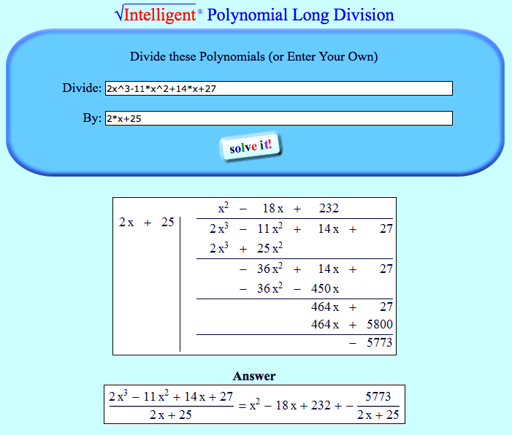

Group Activity:
Place the students in pairs of approximately equal ability to complete the activity describing the numerical solution to the per capita spending on theater going in the U.S. from 1990 to 1995.

Differentiation:
Students will be required to perform some of the computation by hand, but accommodations should be made allowing students to use calculators if necessary.

Journal Prompt 2: Ask the question: “How is long division of whole numbers like long division of polynomials?” Answers should note that the relationship between the dividend, the divisor, the quotient and the remainder still hold, that is, the equation from the division algorithm holds: dividend = divisor • quotient + remainder.

In Activity 3.2.3, students will practice performing long division of a polynomial P(x) divided by a binomial of the form (x–a). The activity will require students to perform the division; find the quotient, Q(x), and remainder, R(x), of the operation; find the value of P(a); and rewrite the polynomial as P(x) = (x–a)•Q(x) + R(x). Problems include examples where the remainder is zero. Students will be asked to make observations about the relationship between the R(x) and P(a) and to generalize what happens when R(x) = 0. Closure for the lesson will include formal statements of the Remainder Theorem and the Factor Theorem as produced by the students. Exit Slip 3.2 can be given at the end of this activity to have students state the Remainder Theorem in their own words and apply it to a problem.

Group Activity:
Students will work in groups on the activity and report their generalizations to the class.

Differentiation:
Students can be given simpler computations in order to facilitate the work.

Journal Prompt 3: Ask the students two questions: 1) What does it mean if the remainder of the division process for integers is equal to 0? 2) What would it mean if the remainder for polynomial division equals 0? Answers should note that when a remainder is zero for either division, the divisor is a factor of the dividend since the dividend = divisor • quotient.

Closure Notes

Students will summarize their understanding of the operations of polynomials either in class discussions, in an exit ticket, or in journal entries.

Vocabulary:
Remainder
Divisor
Quotient
Division Algorithm
Remainder Theorem
Factor Theorem
Zero Product Property

Resources and Materials

All activities in this investigation need to be completed.
Activity 3.2.1 Roller Coasters and Curves
Activity 3.2.2 Roots and Factored Form of Polynomials
Activity 3.2.3 Polynomial Long Division and the Remainder Theorem

www.webgraphing.com/polydivision.jsp

