Unit 3: Investigation 6 (3 days)

Title: Exponential vs Polynomial Growth

Common Core State Standards:
- F.IF.9 Compare properties of two functions each represented in a different way (algebraically, graphically, numerically in tables, or by verbal descriptions.) For example given a graph of one quadratic function and an algebraic expression for another, say which has the larger maximum.
- F.LE.3 Observe using graphs and tables that a quantity increasing exponentially eventually exceeds a quantity increasing linearly, quadratically, or (more generally) as a polynomial function.

Overview
Investigation 6 has students compare exponential and polynomial growth in real-world situations. This is a natural extension of what students have seen in Algebra 1 when comparing linear functions to exponential functions. The investigation is launched by comparing two growth patterns: one is based on “Moore’s Law” giving the number of resistors on an integrated panel as a function of modeled by two different function: y = 2^{x/2} and a polynomial function y = (½x)³ +1. Students will create a table and a graph for the data for values of x from 0 to 6. Students will then be asked to predict what will happen to each function individually as x increases and then compare the two functions as x increases. Students will then consider other growth patterns and predict what type of function would best fit the data. Algebraic models of the data can be developed using the properties of polynomial functions or using the regression features of a graphing utility.

Assessment Activities

Evidence of Success: What Will Students Be Able to Do?
- Construct and compare exponential and polynomial function models.
- Solve problems based on exponential and polynomial function models.
- Interpret whether a polynomial function or an exponential function best models a real-world relationship.
- Recognize that quantities growing exponentially will exceed the growth of functions modeled with polynomial functions as x increases to ∞.

Assessment Strategies: How Will They Show What They Know?

Exit Slip 3.6.1 asks the students to find at what value of x will the function f(x) = 2^{x} surpass the function h(x) = x⁴ + 1.

Exit Slip 3.6.2 asks students the question: What would be a better model for the world’s population in billions of people, the model given by the polynomial function P(t) = 2t³ + 1 or the model given by the exponential function P(t) = 2•1.1^{t} for t decades after the year 2000? Explain your reasoning.

Journal Entry 3.6.2 will ask the students to explain whether or not any exponential function with a base greater than one will eventually outgrow any polynomial function.

Journal Entry 3.6.3 will ask the students to explain what does it mean that the ratio P(x+1)/P(x) approaches 1 as x approaches ∞.

Launch Notes
Students will be given the statement of “Moore’s Law” which states that “the number of transistors in a dense integrated circuit doubles approximately every two years.” Students will be asked to model this growth of the amount of “power” a computer numerically in a table and algebraically with an equation. Students will then examine how this rate of growth compares to a growth rate that is determined by the equation $g(x)=x^{2}+1$.

Closure Notes

Closure for these lessons will require students to make generalizations about how exponential functions compare with polynomial functions. Students will note that if the base of an exponential function is greater than 1, then eventually it will grow at a faster rate than any polynomial function, regardless of the degree of the polynomial.

Teaching Strategies
- Activity 3.6.1 will launch the investigation with the following situation. Gordon E. Moore, co-founder of the Intel Corporation, in 1965, made the following statement that became known as “Moore’s Law”: the number of transistors in a dense integrated circuit doubles approximately every two years. Students will first develop the exponential function that models the growth of the number of transistors in an integrated circuit. After describing that growth pattern, they will compare that relationship with a polynomial function. The exploration can be facilitated numerically and graphically using a graphing utility. In GeoGebra, where f(x) = 2^{.5x}, the graph evaluated from x = 0 to x = 9 and the table evaluated from x=0 to x=9 would look initially like:
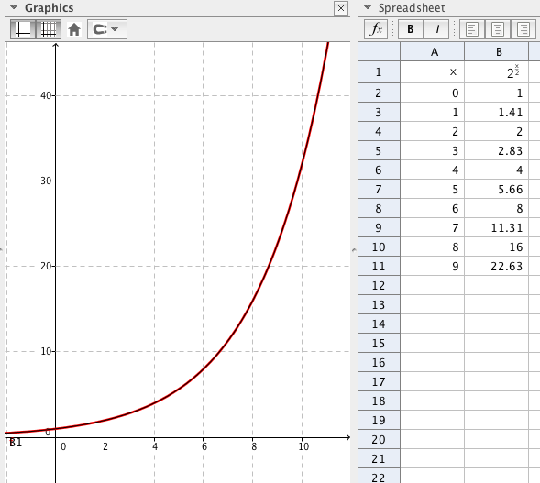

Students would then answer questions related to the nature of the growth of the number of transistors in a dense integrated circuit.

Afterwards, students would compare the growth of this function with that of the function $g(x)=x^{2}+1$. Using GeoGebra or another graphing utility to facilitate the initial comparison, students would examine the functions numerically and graphically for x from 0 to 12 and then again from 0 to 24 to make comparisons. The comparison for x from 0 to 12 can be seen below:
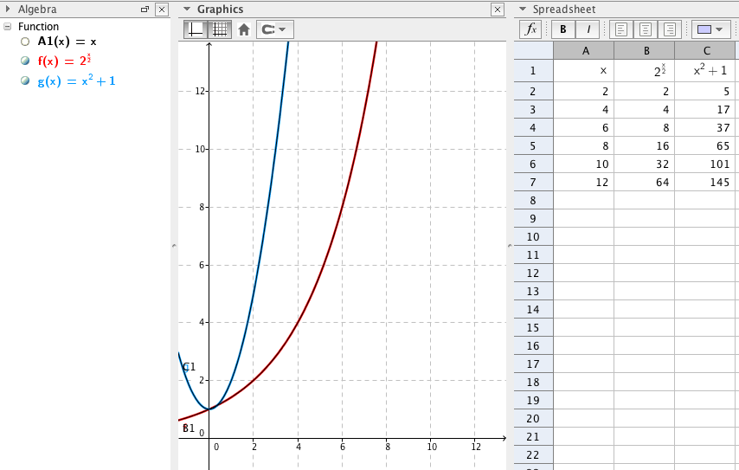

Students would then be asked to make predictions about the two functions as x increases. Students would then continue to examine the two functions as x increases by expanding the graph, scaling the x- and y-axes to fit the curves. This eventually leads to the discovery that the exponential function crosses back over the qudratic function for large values of x. Reasons for that behavior will be discussed as the closure to the activity.

To conclude the lesson, students will fill out Exit Slip 3.6.1 that asks them for what value of x will the function f(x) = 2^{x} surpass the function h(x) = x⁴ + 1.

- In Activity 3.6.2, students will compare the functions f(x) = a^{x} and g(x) = x^{b} +1 by exploring what happens if the base, a, of the exponential function is varied while the degree, b, of the polynomial function is held constant or what happens if the base of the exponential function is held constant while the degree of the polynomial function is varied. This exploration will be done in the context of exponential functions modeling compound interest. The investigation can be conducted on a graphing calculator using the table function to make a numerical comparison of the two functions. Graphically, the two functions can be compared using the graphing mode of GeoGebra or a similar graphing software. The graphing comparison is helpful for visual learners and if the software has the capability of easily changing the scale of the y- and x-axes, the point where the exponential function overtakes the polynomial function can be manipulated without difficulty. In addition, a numerical representation in the form of a spreadsheet can also represent the values of the functions as x approaches ∞. In comparing these functions and varying the values of a and b, students should be able to make the conjecture that the exponential function will ultimately exceed the polynomial function for all values of a>1. The graph below illustrates this investigation.

As Exit Slip 3.6.2, ask the students what would be a better model for the world’s population in billions of people, the model given by the polynomial function P(t) = 2t³ + 1 or the model given by the exponential function P(t) = 2•1.1^{t} for t decades after the year 2000? Explain your reasoning.
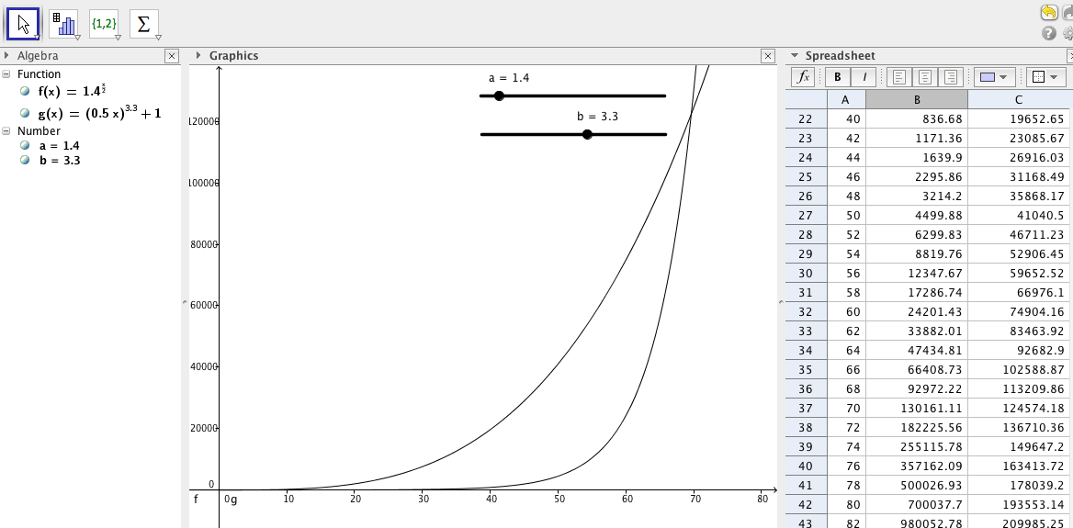

Differentiation:
This lesson may require more background review in order for it to be attainable by middle or lower level sections of Algebra 2. It may require time to review compound interest formula which states that A = P(1+r)^{t}, where P is the principle investment, r is the annual rate of interest compounded yearly, t is the number of years the investment is accruing interest and A is the annuity or total value of the investment after t years.

Journal Prompt 3.6.2 will ask the students to explain whether or not any exponential function with a base greater than one will eventually outgrow any polynomial function.

- Activity 3.6.3 will provide justification that the ratio of the terms of an exponential function with base greater than 1 will always eventually overcome any polynomial function regardless of its degree. The argument for this phenomenon will provide an introduction into rational functions and is based on a study of the ratio of the outputs of exponential functions versus polynomial functions of degree n when the input is increased by 1, i.e., by comparing f(x+1)/f(x) for an exponential function y = f(x), to P(x+1)/P(x) for a polynomial function y = P(x). This comparison can be done using the table feature of a graphing calculator or a graphing utility with specific functions. The comparison will show that as x approaches ∞, f(x+1)/f(x) = b >1, where b is the base of the exponential function f(x)=a•b^{x}, whereas P(x+1)/P(x) = 1 for any polynomial function of degree n. Thus the exponential function will outgrow the polynomial function as x approaches ∞. This argument can be seen in the Illustrative Mathematics Activity found on the web at https://www.illustrativemathematics.org/illustrations/367. When examining P(x+1), students will be able to use the Binomial Theorem to recognize that the x^{n} term of the numerator and the denominator will be the same and that as x approaches ∞, the ratio of P(x+1)/P(x) = 1 for all polynomial functions.

Differentiation:
This lesson is designed for upper level sections of Algebra 2 since it requires more abstract reasoning to interpret the meaning of f(x+1) and P(x+1) in their understanding of the problem.

Journal Prompt
Journal Prompt 3.6.3 will ask the students to explain what does it mean that the ratio P(x+1)/P(x) approaches 1 as x approaches ∞.

Vocabulary:
Students will need to be familiar with the following concepts and skills:
- mathematical model
- exponential growth
- compound interest

Resources:
- Illustrative Mathematics: https://www.illustrativemathematics.org/illustrations/367
- GeoGebra files
- Internet

