Unit 3: Investigation 3 (6 days)

Title: Factoring Polynomials

Common Core State Standards:

- A.APR.3 Identify zeros of polynomials when suitable factorizations are available, and use the zeros to construct a rough graph of the function defined by the polynomial.
- A.SSE.2 Use the structure of an expression to identify ways to rewrite it. For example, see x⁴ – y⁴ as (x²)² – (y²)², thus recognizing it as a difference of squares that can be factored as (x²–y²)• (x² + y²).
- A.APR.4 Prove polynomial identities and use them to describe numerical relationships. For example, the polynomial identity (x² + y²)² = (x² – y²)² + (2xy)² can be used to generate Pythagorean triples

Overview
Investigation 3 applies the Factor and Remainder Theorems for polynomials that establish the connection between the x-intercepts of the graph of a polynomial function, the zeros of the polynomial function, and the factors of the polynomial as a means to factor polynomials. Thus, the graph of a polynomial can be used to approximate the zeros of the polynomial and its corresponding factors. Conversely, the factors of a polynomial can be used to approximate the graph of a polynomial function. Identities of 2nd and 3rd degree polynomials can be applied to factor higher degree polynomials of similar structure. Finally, as possible enrichment activities, the factored form of polynomials of the form x^{n} – 1 and x^{n} + 1 are used to factor polynomials of parallel structure, and the formulas to represent the sums of the first n positive integers and the squares of the first n positive integers are examined.

Assessment Activities

Evidence of Success: What Will Students Be Able to Do?
- Use the Factor Theorem to factor a polynomial given the x-intercepts or zeros of the polynomial function.
- Determine the zeros of a polynomial based on the factored form of the polynomial.
- Approximate the graph of a polynomial based on the zeros of the polynomial and end behavior of the polynomial.
- Determine the exact equation of a polynomial function given its degree, its zeros (real or complex) and one other point on the graph.
- Use known polynomial identities to factor higher order polynomials of similar structure.
- Apply algebraic identities to numerical computations.

Assessment Strategies: How Will They Show What They Know?

- Journal Prompt 1. We saw in class that the graph of a polynomial can used to factor they polynomial. Describe, in general, how that can be done. Describe what limitations this method of factoring has, if any.
- Journal Prompt 3.3.2 asks students, “When given the graph of a polynomial function, is knowing the x-intercepts enough to determine the equation of the function? Why or why not?”
- Journal Entry 3.3.3. Ask students to create their own polynomial identity using either the difference of two squares, the sum or difference of two cubes, or a factorable trinomial. Be ready to share your identity with members of your group. The prompt can be modified based on the level of the class.
- Exit Slip 3.3.1. Create a cubic function such that it has one x-intercept at (-1,0) and one complex zero 2 – 3i.

Launch Notes

Students will examine a polynomial curve that models a roller coaster ride and make decisions about the ride based on the properties of the polynomial. Students will apply properties established in Investigations 1 and 2 to answer questions regarding the roller coaster ride. Subsequent activities will develop the students’ ability to factor polynomials using the Remainder and Factor Theorems.

Teaching Strategies
- To introduce this investigation, Activity 3.3.1 will ask students questions about a roller coaster ride given the graph of a polynomial that will model the ride for the first 500 feet of the ride. Students will need to apply the Factor Theorem to identify the linear factors of the function producing the graph, the multiplicity of each factor based on whether the graph passes through the x-axis or is tangent to it, and the minimum degree of the polynomial based the number of linear factors that can be determined.

From this launch activity, students will see that the x-intercepts of a graph of a polynomial correspond to the linear factors of the polynomial and the minimum degree of the polynomial. This will enable the student to factor the polynomial expression of the function whose graph is given. Subsequent problems will have students examine the graphs of polynomials and demonstrate that a polynomial can be written in the form f(x) = a(x – c₁) (x – c₂)••• (x – c_{n}) where the c_{i}; i = 1, 2, . . . ., n; are the zeros of the polynomial.

The last question on the worksheet, “Sketch the graph of h(x) = 4x⁴ + 10x³ − 6x² + 8 and explain how the graph could be used to predict the factored form”, can be used as the exit slip for this lesson or a journal prompt for deeper reflection

Group Activity:
Students will work in pairs to determine factors of a polynomial based on its graph.

Differentiation:
To differentiate this lesson, teachers can vary the number and multiplicity of the factors of the polynomial.

Journal Prompt 1: We saw in class that the graph of a polynomial can used to factor they polynomial. Describe, in general, how that can be done. Describe what limitations this method of factoring has, if any. Answers should note that for any x-intercept, (a,0), of a polynomial function y = P(x), P(a)=0. Therefore, (x–a) is a factor of P(x) by the Factor Theorem. The limitations of this conclusion is that the graph does not guarantee the multiplicity of the factor.

- Activity 3.3.2 will further develop how to determine the factors of a polynomial by establishing the connection between the zeros of a polynomial, the x-intercepts of the graph of the polynomial, and the factors of the polynomial. This activity will begin by giving students the polynomial function, V(x) = 4x³ – 84x² + 432x, that represents the volume of an open box. Ask the students if they can determine what the dimensions of the sheet of paper were from which the open box was formed. Students should be able to recognize that the factors of the polynomial will match with the zeros of the function. Students will need to interpret how the zeros of the function are connected to the factors of the polynomial. Based on their experience in constructing the open box, students will need to work backwards to determine the factors that make up the polynomial. In factoring the polynomial, they will see that the zeros of V(x) are half the dimensions of the sheet from which the x by x squares were cut. Students will need to apply their understanding of factoring from Algebra 1 to find the factors.

From this launch activity, students will investigate how to factor a polynomial knowing that the x-intercepts of a graph of the polynomial determine the linear factors with real coefficients of the polynomial and whether the graph crosses the x-axis or is tangent to the x-axis indicates the parity, that is whether the multiplicity is odd or even, of the corresponding linear factor. Exercises will require students to use the graph of the function to determine the x-intercepts and corresponding linear factors. Students will use long division to find quadratic factors that correspond to irrational or complex zeros of the polynomial. The problems will reinforce the fact that a polynomial can be written in the form f(x) = a(x – c₁) (x – c₂)••• (x – c_{n}) where the c_{i}; i =1, 2, …, n; are the zeros of the polynomial, regardless of whether the zeros are rational, irrational, or complex. Additional problems will demonstrate that when irrational or complex zeros are present, the quadratic factor will be represented in the form of x² – Sx + P where S is the sum of the zeros and P is the product of the zeros. Examples of factoring polynomials given its graph or its zeros will be given, and examples of graphing a polynomial given its factors will be given.

Use Exit Slip 3.3.1 to ask students to create a cubic polynomial with an x-intercept x=1 and a complex zero, 2 – 3i.

Differentiation:
To differentiate this lesson, teachers can vary the complexity of the questions. This can be achieved by changing the complexity of the rational, irrational, and complex zeros of the polynomials.

Journal Prompt 2: Ask students, “When given the graph of a polynomial function, is knowing the x-intercepts enough to determine the equation of the function? Why or why not?” Students must notice that knowing the x-intercepts does not guarantee that the exact equation can be found. Difficulties are that the multiplicity of the x-intercept must be known, that other points must be known, and the degree of the function must be known.

- Activity 3.3.3 will develop and extend the concept of identities from quadratic and cubic polynomials to polynomials of higher degree. To introduce the lesson, a pair of students will be given two quadratic functions, one in vertex form and the other in standard form. Each will be asked to graph their equations and compare their results. Noting that they are the same graph, the students are asked to make a conclusion about the quadratic expressions in each equation. Students should recognize that the two polynomial expressions are equal and that the equation showing the equality is called an “identity.”

An essential understanding that students need to develop is that for any identity, one side of the equation can be replaced by the other side of the equation in any expression while maintaining the equivalence of the two expressions. In addition, students need to see how basic identities of quadratic and cubic expressions can be applied to higher degree expressions with a similar form.

Activity 3.3.3 begins with a visual justification of the difference of two squares, an identity with which they should already be familiar: a² – b² = (a+b)(a–b). Students will factor expressions, both algebraic and numerical, that can be considered the difference of two squares.

Similar techniques will be applied to identities involving binomial factors and other identities such as the perfect square trinomial and the sum and difference of two cubes: (a$±$b)² = a² $±$ 2ab + b²; a³ – b³ = (a–b)(a²+ab+b²); and a³ – b³ = (a+b)(a²–ab+b²).

The use of identities can be used to evaluate numerical expressions mentally. For example, when students are asked to multiply 501 • 499, the computation can be expressed as the difference of two squares, (500+1)(500–1) which easily simplifies to 500² – 1 = 250,000 – 1 = 249,999. Similarly, (501)² = 500² +2•500•1+1 = 250,000 + 1000 + 1 = 251,001.

To demonstrate how to apply identities in an algebraic situation, pose the following question: An n x n x n cube, made up of small 1 x 1 x 1 cubes is painted on the outside. If the large cube is dismantled into its smaller its 1 x 1 x 1 cubes, how many of those cubes would have at least one side painted?

One solution to this problem would be n³ – (n–2)³, a solution that can be visually noted by removing the outer layer of cubes and noting the unpainted cubes would form an unpainted inner cube with (n–2)³ cubes. The solution to this problem can also be found by summing up the number of cubes with 3, 2, or 1 side painted. The figure below would help students visualize how that can be done. By examining the figure below, it is noted that there are 6 faces with (n–2)² blocks that would have 1 face painted. There are 12 edges with (x–2) blocks with 2 faces painted. Finally, there are 8 vertices with 3 faces painted. The number of painted blocks is given by the equation:
# of Painted Cubes = 6(n–2)² +12(n–2) + 8

Reconciling the equality of these two ways of describing the sums can be established using the identity a³ – b³ = (a–b)(a² + ab + b²). Applied in this problem we see that:
x³ – (x–2)³ =[x–(x–2)][x²+x(x–2)+(x–2)²]
= (2)(x² + x² – 2x + x² – 4x + 4]
= 2(3x² – 6x + 4)
= 6x² – 12x + 8

NOTE: The equality of these two expressions can also be shown using the counting principles of inclusion/exclusion on an actual cube. By inclusion/exclusion, this represents the number of squares on the six faces, minus the double counting of the number of square on each edge, but adding the eight corner squares which were included three times adding each face, but taken out three times subtracting the edges.

The activity illustrates the ability to rewrite polynomial expressions that have the same form as known identities. Students would then be given other expressions that can be written in the form of a known identity. Classic examples of this are expressions like x⁴ – y⁴; 8x³ + y⁶; etc. Such examples would be worked on with the students as a whole class and then students would work in groups to factor expressions in the form of known identities.

As an assessment of this objective, students would participate in a group–pairs–exchange. Each student would be asked to create his/her own factorable expression in the form of a known identity and then students would form groups of four and exchange their expressions to be factored in pairs.

Differentiation:
To differentiate this lesson, change the complexity of the polynomials to be factored. When factoring the difference of two squares, more familiar numerical and variable factors can be used.

Journal Prompt 3: Ask students to create their own polynomial identity using either the difference of two squares, the sum or difference of two cubes, or a factorable trinomial. Inform the students to be ready to share their identity with members of their group. The prompt can be modified based on the level of the class. Answers will vary, but the students should be able to develop appropriate identities.

- In Activity 3.3.4, students will examine how to find an exact equation for a polynomial function based on the x-intercepts of its graph, its degree, and at least one other point on the graph. The examination can begin by having students try to match curves based on the graph given four points of a cubic function, namely, the three x-intercepts and one additional point. Students will need to then find a cubic equation whose graph passes through the four points. The process to find the equation would require students to apply the Factor Theorem to identify the factors of the polynomial equation using the x-intercepts. Students will need to analyze the end behavior to determine the sign and magnitude of the leading coefficient of the polynomial equation. Finally, using one point additional point on the graph, they will identify the exact numerical coefficient that will produce the same graph. To help students understand how changing the value of the leading coefficient affects the graph of the function, students can use an additional slider in GeoGebra to allow the coefficient to vary and see what would happen to the graph. The figure below shows how the parameters a, b, c, and d in the GeoGebra equation f(x) = d(x–a)(x–b)(x–c) can be manipulated to pass through the x-intercepts and the point (–1, –2). In particular, once the values for a, b, and c are fixed at 1, 2, and -2 based on the known x-intercepts, the student can vary the value of d until the graph passes through the point (–1, –2) to determine the leading coefficient of the cubic function. One option that could be used in the activity is to use the regression feature of GeoGebra to already have the graph of the desired function displayed and asking the students to manipulate the parameters to make the graphs coincide.
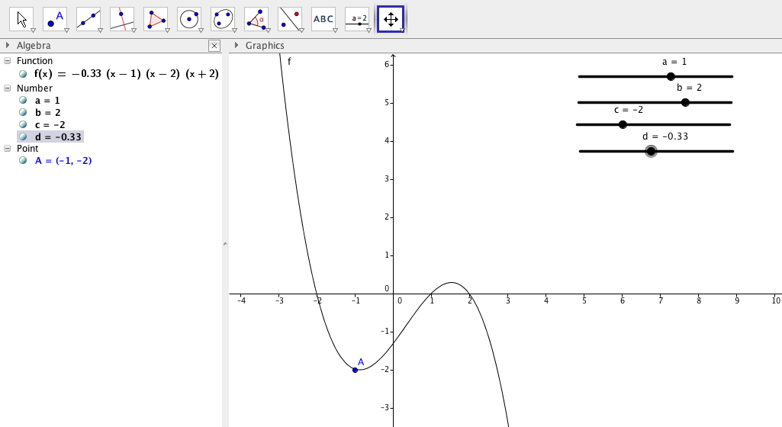
The final stage of the activity would be to calculate the value of d algebraically. This process can be connected to the procedure to find the value of b in a linear equation y=mx+b when given the slope or finding the equation of a parabola given the vertex and an additional point. Applications of this technique can then be used to solve problems.

Group Activity:
Students will work in pairs to devise a plan to identify the equation based on its x-intercepts and an additional point on the curve. Working in pairs allows students to verbalize their ideas and build on each other’s thinking.

Differentiation:
This lesson can be differentiated by varying the type of numbers used as the x-intercepts and the additional point on the curve. Hints can be provided to the students by the instructor based on the level of scaffolding needed by the students.

- Activity 3.3.5 is a supplementary activity in which students investigate identities of the form x^{n} – 1 and x^{n} + 1. The expression, x^{n} – 1, can always be factored as a result of the fact that x =1 is zero of the polynomial. Depending on whether students have see geometric series, they could also use the formula for the sum of a geometric series of the form 1 + x¹ + x² + x³+ . . .+ x^{n–1} = $\frac{1-x^{n}}{1-x}=\frac{x^{n}-1}{x-1}$ . This leads to the factorization x^{n} – 1 = (x–1)( 1 + x¹ + x² + x³ +. . . + x^{n–1}) for all n. Other students, not familiar with geometric series, could develop the relationship using the pattern:
x² – 1 = (x–1)(x+1)
x³ – 1 = (x–1)(x² + x + 1)
x⁴ – 1 = (x–1)(x³ + x² + x + 1)
•
•
•
A similar development could be established with the polynomial x^{n} + 1. This polynomial is not factorable over the real numbers for even values of n, but can be factored for odd values of n since x=-1 is a zero of the expression.
x³ + 1 = (x+1)(x² – x + 1)
x⁵ + 1 = (x+1)(x⁴ – x³ + x² – x + 1)
x⁷ + 1 = (x+1)( x⁶ – x⁵ + x⁴ – x³ + x² – x + 1)
•
•
x^{2n+1} +1 = (x+1)(x^{2n} – x^{2n–1} +x^{2n–2} – • • • – x + 1)

Extensions of this identity lead to the factorization of any expression of the form x^{n} – a^{n} or x^{2n+1} + a^{2n+1}

- In Activity 3.3.6, students will extend their understanding of the concept of algebraic identity by examining discrete sums that can be simplified into polynomial expressions.
The first identity is the simplification of the sum: $1+2+3+•••+n=\frac{n(n+1)}{2}$. This sum can be motivated in several ways. Historically, Pythagoras studied this sum when he examined triangle numbers. Students would be reminded that any sequence for which the second differences is a constant, the formula for the n^{th} term of the sequence will be a quadratic equation. Another way to motivate this sum is by examining the Handshake Problem in which students are asked to find the number of handshakes would be made when 20 students in a class introduce themselves to each other. In one solution of the Handshake problem, students would see that the total number of handshakes would equal 19+18+17+•••+2+1 = $\frac{19(20)}{2}$. The solution leads to the general solution of the sum of the first n integers as 1+2+3+••••+n = $\frac{n(n+1)}{2}$. This identity can be proved using the method historically attributed to Karl Gauss in which the order of the sum is reversed and then added to the original sum. This results in n terms each equaling n+1. Thus, dividing the product n(n+1) by 2 yields the original sum.

Another example of this process is to find the number of dots needed to extend the pattern below from 5 rows to 20 rows.

Students will see that the partial sums of the rows are 1, 4, 9, 16, •••. Therefore the sum 1 + 3 + 5 + ••• + (2n–1) = n². Students again should observe that the second differences of the pattern is a constant.

Depending on the class, a final sum of interest is the sum of the squares of the first n positive integers. To initiate the activity, introduce the problem: “How many oranges would you need to make a store display in the form of a pyramid that is 20 layers high in which each layer is a square array with one less orange per row than the layer below it?” The total number of oranges would be 1² + 2² + 3² + • • • + 20². As the students investigate this sum, they will be asked to examine the first, second and third differences in the sequence of partial sums 1², 1² + 2², 1² + 2² + 3², etc. The fact that the third differences are constant indicates that the formula will be a cubic equation. Access to a spreadsheet could facilitate recognizing the pattern of the successive differences, but hand or calculator generated computations would also suffice. The formula for the sum of the squares is not as evident as for square and triangle numbers. However, a proof without words shows the sum 1² + 2² + 3² + 4² + 5².

The picture below illustrated how the formula for the sum can be developed. Students would construct the figure using the fact that each square number, n², is the sum of the first n odd numbers.
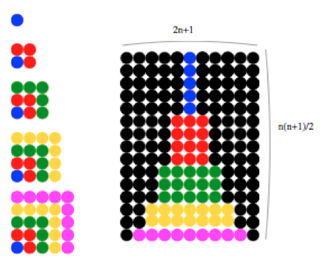
As seen in the figure, the sum 1² + 2² + 3² + 4² + 5² can accounted for three times, once by the sum of the colored balls in the middle and twice by the black balls on the left and right. The sum of the odd numbers can be see as 1 + (1 + 3) + (1 + 3 + 5 ) + (1 + 3 +5 + 7) + (1 + 3 + 5 + 7 + 9), which shows that there is one row in lavender with 9 balls, two rows in yellow with 7 balls, 3 rows in green with 5 balls, four rows in red with 3 balls, and five rows in blue with 1 ball. Therefore, the total number of balls in the array equals the sum 1² + 2² + 3² + 4² + 5² = [(2*5+1)(5+1)•5]/6. This example can be used to determine the identity that finds the sum of the first n square:
1² + 2² + 3² + • • • + n² = (2n+1)(n+1)•n/2.
Students would be informed that his identity is used in Calculus when developing the concept of definite integrals.

The formula for the series 1³ + 2³ + 3³ + • • • + n³ can also be developed using another visual proof. The figure below, a cover photo from the February, 1993 Mathematics Teacher, illustrates how 1³ + 2³ + 3³ + • • • + n³ = [n(n+1)/2]². While not recommended for the regular curriculum, students in advanced classes could be given the task of showing how the picture demonstrates that 1³ + 2³ + 3³ + 4³ = (1+2+3+4)² = [4(4+1)/2]² which leads to the general formula below.
$$1^{3}+2^{3}+3^{3}+•••+n^{3}={\left[\frac{n(n+1)}{2}\right]}^{2}$$

This development would again reinforce the concept that when the fourth differences are constant, the formula for the sum would have to be a fourth degree polynomial.

Differentiation:
This lesson can be tailored to the level of the students. The level of abstraction in this lesson can be adjusted to make it a challenge even for several levels of students.

Closure Notes

The principle goal of this investigation is to provide students with the tools to factor polynomials using the connection between the Factor Theorem, the Remainder Theorem, and long division. It is this connection that will allow students to move between the algebraic, numerical, and graphical representations of a polynomial function.

The number of days spent on this investigation will depend on the class and level of students. Some classes may choose to complete all the investigations, while many will focus only on the basic skills needed to factor polynomials without addressing the more complex polynomials and identities.

Vocabulary
- x-Intercepts
- y-Intercepts
- Algebraic Identity
- Zero
- Root
- Linear Factor
- Quadratic Factor
- Series

Properties
- Difference of Two Squares
- Sum of the positive integers from 1 to n
- Sum of Squares from 1 to n
- Sum of Cubes from 1 to n
- Sum of Powers of x from 1 to x^{n}
- Remainder Theorem
- Factor Theorem

Resources
- GeoGebra File: Finding a Specific Function.ggb
- http://www.dr-mikes-math-games-for-kids.com/rice-and-chessboard.html.

