Unit 3: Investigation 1 (6 days)

Title: Properties of Polynomial Functions

Common Core State Standards:

F.IF.7c Graph polynomial functions, identifying zeros when suitable factorizations are available, and showing end behavior.
F.IF.7 Graph functions expressed symbolically and show key features of the graph, by hand in simple cases and using technology for more complicated cases.
F.IF.4 For a function that models a relationship between two quantities, interpret key features of graphs and tables in terms of the quantities, and sketch graphs showing key features given a verbal description of the relationship. Key features include: intercepts; intervals where the function is increasing, decreasing, positive, or negative; relative maxima and minima; multiplicity of roots; symmetries; end behavior; and periodicity.

Overview:
Investigation 1 examines basic graphs of polynomial functions. It will be necessary to build from the students’ prior knowledge about polynomials, so review of the definition and key vocabulary words may precede the investigations. Key vocabulary terms include degree, coefficient, leading term, constant term, and leading coefficient. Included in this investigation are activities to develop: a) the end behavior of the y-values of the function as x approaches positive or negative infinity as determined by the degree of the polynomial; b) the x- and y-intercepts of the function; c) odd and even functions as reflections of a parent function over the x- and y-axes and the symmetry of odd and even functions about the origin and y-axis, respectively; d) the relationship between zeros of the polynomial and the factors of the polynomial; and e) the multiplicity of a factor of a polynomial and its connection to the x-intercepts of the graph; and f) real-world examples of polynomial functions and how to interpret properties of the graph of the function in the context of the scenario it represents.

Assessment Activities

Evidence of Success: What Will Students Be Able to Do?

- Determine the basic shape and end behavior of the graph of a polynomial function based on the term of highest degree of the polynomial.
- Determine the x- and y-intercepts of a polynomial function by inspection of the equation of the function when the polynomial is in factored form.
- Identify extrema of a polynomial function given the graphic, symbolic, or numerical representations of the polynomial.
- Interpret the meaning of intercepts and extrema of a polynomial in the context of a real-world problem.
- Determine if a graph of a polynomial function is tangent to the x-axis or crosses the x-axis depending on the multiplicity of the corresponding linear factor of the function.

Assessment Strategies: How Will They Show What They Know?

Exit Slip 3.1.1 asks students to explain the end behavior of a polynomial based on its degree and the sign of the leading coefficient. Best given after Activity 3.1.2.

Exit Slip 3.1.2 asks students to describe the relationship between the zeros of a polynomial function and its x-intercepts. Best given after Activity 3.1.4.

Exit Slip 3.1.3 asks students to create an equation of a polynomial function of degree five whose graph has three x-intercepts at which point the graph crosses the x-axis. Best given after Activity 3.1.5.

Exit Slip 3.1.4 will provide the students with a real-world scenario modeled by a polynomial function and requires the students to create and answer questions that use the given function. Best given after Activity 3.1.6.

Journal Prompt 1: Create your own graph of a possible day during the winter and with an weather report that would explain what happened during that day.

Journal Prompt 2: Explain why polynomial functions in which the degree of each term is an even number are “even” functions. Similarly, explain why polynomial functions in which the degree of each term is an odd number are “odd” functions.

Launch Notes

This investigation marks a new family of functions that continues to diverge from the family of linear functions. To illustrate this, the investigation begins with the graph of a polynomial function that models a time versus temperature function as shown below. Students will be asked to answer questions in the context of the time/temperature relationship in a 24-hour period that exemplify many aspects of a function as identified in the Common Core State Standards for Mathematics, such as, where the function has zeros, where the function is increasing or decreasing, and when maximum or minimum values of the temperature be attained during the 24-hour period.

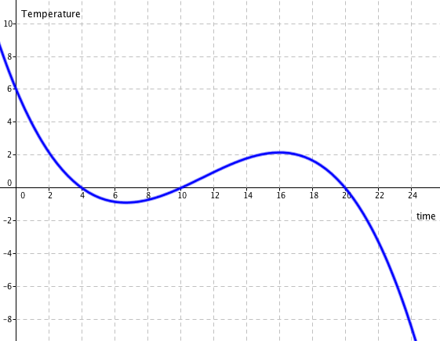

Students will notice that the graph is neither linear nor quadratic and be told that it is the graph of a polynomial function, the theme of this unit.

Teaching Strategies
- Activity 3.1.1 will launch the investigation and see if students can accurately interpret the time/temperature graph and introduce students to the graph of a polynomial function. As indicated in the Launch Notes, key vocabulary will be used to describe the relationship depicted by the graph and reinforced in the remainder of the investigation. Among the key words needed are: increasing/decreasing, relative maximum/minimum, x-intercept/zero, and positive/negative function values. Exit Slip 3.1.1 can be used to see if students are able to identify features of a graph.

Journal Prompt 1: Create your own temperature graph of a possible day during the winter and include a weather report that would explain what happened during that day. Students may include a graph that continues to drop drastically or show a warming trend.

- Activity 3.1.2 will use technology to manipulate the degree and leading coefficients of polynomial functions in order to see their impact of the basic shape of a polynomial of n^{th} degree. By changing the parameters of the polynomial function, students will see that two key features of the graph of the polynomial function will change: 1) the end behavior of the function as x approaches +∞ or –∞, and 2) the number of times that the graph intersects the x-axis, i.e., the number of x-intercepts. To facilitate this investigation, students will examine multiple examples of polynomial function using the sliders function of the GeoGebra software or the TRANSFORM APP on the TI83/84 graphing calculator. The image below shows the graph of the function created in GeoGebra. (See the file: Polynomial Investigation end behavior.ggb)
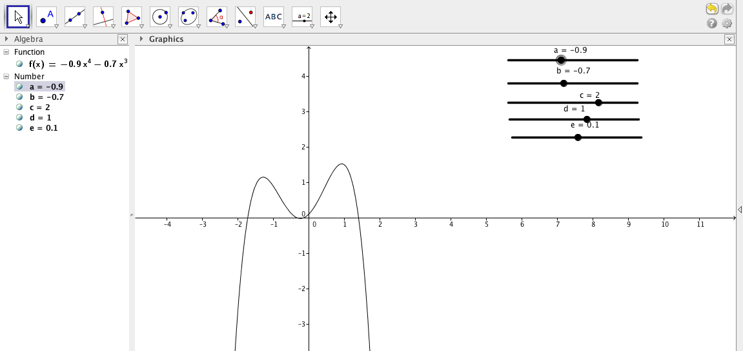

Once students have established the general relationship between the degree of a polynomial, its leading coefficient and its end behavior, students should be given a polynomial and asked to determine the general shape of the graph, indicating what its end behavior will be.

A way to assess student understanding is through the End Behavior Game found on the internet at http://www.epsilon-delta.org/2012/02/end-behavior-activities.html. This applet provides polynomial functions and asks the students to predict the end behavior by using their arms to indicate the direction of the function as x approaches + or – ∞. One example of this is shown below.
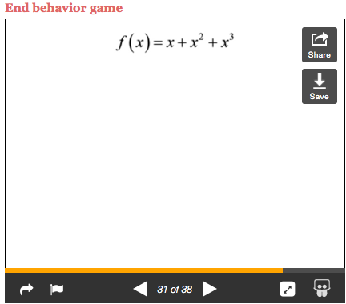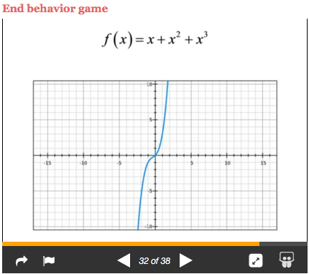
This formative assessment can also be carried out using many modes of presenting the function or through Exit Slip 3.1.2.

Group Activity:
Place the students in pairs of approximately equal ability to work on the activity. Each pair of students should have access to a graphing utility in order to examine the graphs of different polynomials.

Differentiation:
The lesson can be differentiated by scaffolding the questions on the worksheet in order to guide students to a conclusion about what happens to P(x) =a_{n}x^{n} + a_{n–1}x^{n–1} +•••+ a₁x¹ + a₀x⁰ as x approaches +∞ or –∞.

- In Activity 3.1.3, students will investigate the effects of the transformations f(–x), –f(x), and –f(–x) using a graphing utility, preferably a graphing calculator or a software like GeoGebra. Starting with a simple linear function, f(x) = x, and moving on to higher powers of x, students will compare its graph with that of f(–x), –f(x), and –f(–x). In doing so, students will recognize what transformation occurred to produce the new graph. In order to facilitate the discovery of the relationship between the graphs, charts and grids are provided where the student can register the results of their investigation. After generalizing the relationship between the graphs of these different transformations, some special cases can be examined to see the special properties of odd and even functions. To develop the property of even functions, students will examine functions like f(x) = x⁴ – x² and notice that the ordered pairs with opposite x-values have the same y-value, i.e. f(–x) = f(x), the property of even functions. Similarly, student will see that when the graph of f(x) is first reflected about the x-axis and then the y-axis (or vice-versa), opposite x-values are mapped opposite y-values, i.e. –f(x) = f(–x), the property of odd functions. This graph is symmetric with respect to the origin. The investigation of the graphs of f(x), f(-x), and –f(x) can be facilitated using the VARS key of the TI-84 series calculator. If f(x) = Y1, then f(-x) = Y1(-x) and –f(x) = –Y1(x). While not covered in the activity, the teacher could also demonstrate algebraic proofs for even and odd polynomial functions. For example, for f(x) = x⁴ – x², it can be easily shown that f(–x) = (–x)⁴ – (–x)² = x⁴ – x² = f(x). Therefore, the function is even.

Group Activity:
Students will work in pairs at a computer, if available, or on their individual graphing calculators.

Differentiation:
Patty paper is an excellent way to have students experience the rigid transformations performed when a graph is reflected about the x- and y-axes. Students can label a point on the patty paper and then see where that point is mapped when the transformation is performed. Students can then register those points and use technology to create a regression model of the data. Comparing the equations, students can make conjectures about the original polynomial and the equation of the transformed graph.

An additional approach to reinforce the concept that the opposite inputs have the same or opposite outputs for even and odd functions respectively is to use the split screen feature of the TI-83/84 calculator. The table would display the numerical confirmation of the properties of even and odd functions.

For advanced students, it is possible to have students provide the algebraic proof that f(–x) = f(x) for even functions or f(–x) = –f(x) for odd functions.

Journal Prompt 2: Explain why polynomial functions in which the degree of each term is an even number are “even” functions. Similarly, explain why polynomial functions in which the degree of each term is an odd number are “odd” functions. Students should be able to verbalize the fact that when the terms of a polynomial all have even degree, (-x)^{n} = x^{n}, for each term, therefore satisfying the definition of an even function. Similarly, students should be able to verbalize the fact that when the terms of a polynomial all have odd degree, (-x)^{n} = –x^{n}, for each term, therefore satisfying the definition of an odd function.

- In Activity 3.1.4, students will investigate the relationship between x-intercepts and factors of the polynomial function. This investigation will have students determine the volume of an open box when four, square corners are cut from a 12” x 18” sheet of paper. This can be done by cutting out squares, one at a time in 1-inch increments, to create the different boxes and then finding their volumes and recording the results in a table. This process leads to the equation of the volume as a function of x, the length of the square cut out. To differentiate the lesson, students can verify the equation for the volume by making a scatter plot of the volume as a function of the length of the square that is cut out. The equation that best fits the scatter plot can be found by performing cubic regression on the data. Once the equation is found, students can compare the zeroes of the equation with the factors of the cubic polynomial and the x-intercepts of the graph of the cubic polynomial. Students will be asked to make the connection between the three representations of the function. The generalization formulated by the investigation will be reinforced with questions that require students to predict the shape of the graph of a polynomial based on its zeros, it x-intercepts, and its leading coefficients. To end the lesson, Exit Slip 3.1.3 can be used to see if the students have made the connection between the zeros of the polynomial function and the x-intercepts.

Group Activity:
Students will work in pairs to investigate the open box problem.

Differentiation:
Students who are more hands-on learners will construct the boxes from sheets of paper of the desired dimensions. Other learners can perform regression on the data found for each square cut out. Finally, if available, students could investigate the problem virtually using a predetermined GeoGebra construction. Proper scaffolding will be provided depending on the level of the students.

- In Activity 3.1.5, students will examine the connection between the multiplicity of a zero of the function based on the degree of the linear factor connected to the zero and the graph of the polynomial. This investigation will use technology to change the degree of the linear factors that make up the function and allow students to see its effect on the graph. This can be done using the TRANSFORM APP on a TI-83/84 calculator or sliders in the GeoGebra software to allow the exponent to vary. As the degree of the factor changes, students will see that when a zero has odd multiplicity, the graph crosses the x-axis and when a zero has even multiplicity, the graph will be tangent to the x-axis. The image below shows the graph of a function with three factors having exponents A, B, or C respectively. The result of allowing the exponent of one factor to equal 2 produces a zero of multiplicity 2 and the other zeros, multiplicity 1. This creates a quartic function whose graph is tangent to the x-axis at the x-intercept corresponding to the zero with multiplicity 2. Since the exponent of the factor (x–1) is 2, the graph is tangent to the x-axis at the point (1,0). Students should vary the values of A, B, and C from 0 to 3 to see what effect the changes have and make a prediction about the exponent of the factor and whether the graph intersects the x-axis or it is tangent to the x-axis. The teacher can also change the leading coefficient to a negative value to illustrate that these properties are independent of the end behavior of the function.This investigation is also written to use sliders in the GeoGebra software to see the relation between the graph of the function and the multiplicity of the factor creating the x-intercept.
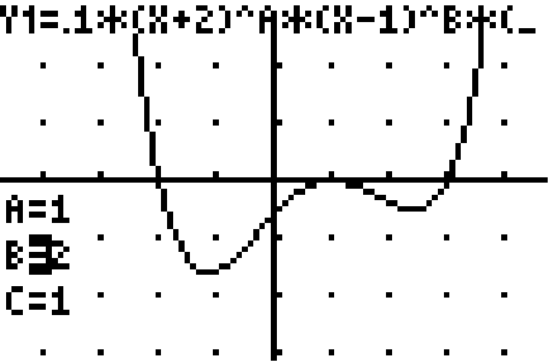
Exit Slip 3.1.4 can be used to ask students to create a 5th degree polynomial such that the graph has three x-intercepts, five linear factors, and crosses the x-axis that each x-intercept.

- In Activity 3.1.6, students will apply the concepts learned in the previous activities to real-world problems. Students will apply the concept of relative extrema for polynomial functions to find relative maxima and minima for functions from various disciplines. For example, from the business world a profit function can be determined from cost and revenue functions based on the number of units produced and sold and the price per unit or based on the level of production of the units. Other applications include:

a. Lung Capacity: The volume of air flowing into the lungs during a breath can be represented by the polynomial function V(t) = -0.041t³ + 0.181t² + 0.202t, where V is the volume in litres and t is the time in seconds. Use a graphing calculator to graph V(t).

b. Volume of Water: Water expands and contracts as the outside temperature changes. The volume, V, of 1 kg of water at the temperature, t, between 0˚C and 30˚C can be modelled by V(t) = –0.0000679t³ + 0.0085043t² – 0.06424t + 999.87 measured in cubic centimeters. At what temperature will the volume of the water be the greatest?

c. Doctor Visits: The number of doctor visits made by a person depends on their age. If the number of visits made by a person can be modelled by the equation f(x) = 6.95 – 0.3x + 0.0083x² – 0.00002x³, where 0 < x ≤ 100, at what age will a person expect to make their maximum number of visits to the doctor?

d. Landscaping: The profit (in thousands of dollars) for a landscaping company in Connecticut from the year 2000 to the year 2010, where t=0 is the year 2000, can be modeled by the funciton P(t) = –t⁴ + 19.75t³ – 133.25t² + 351.25t – 280.25 . Use a graphing utility to graph the function and determine when the company was losing money, at what time was the maximum profit achieved, and at what time was the profit increasing the most?

Exit Slip 3.1.5 can provide the students with a real-world scenario modeled by a polynomial function and requires the students to answer questions that use the graph of the function.

Group Activity:
Students can work in pairs to solve problems using appropriate technology. Given graphs, students can interpret the graphs to estimate where the extreme values are located and what the function values are in the context of the problem. If an equation of the function is given, students can use technology to investigate where extreme values occur numerically and graphically using the features of the chosen technology.

Differentiation:
Depending of the level of the students, the activities can be structured to offer more or less scaffolding. If students are already familiar with features of the available technology, it could be left to them to find the extreme values of the functions. Otherwise, the teacher can provide the necessary scaffolding to allow students to progress through the problems.

Closure Notes

Whole-class discussions will summarize the topic of the day, such as, the relationship between the degree of a polynomial, the basic shape of a polynomial, and the number of x-intercepts of a polynomial. Exit slips are used to identify any concept examined in the lesson that atudents still do not understand or to apply a concept that they studied in the lesson.

Vocabulary:
- polynomial
  - monomial
  - binomial
  - trinomial
  - cubic
  - quartic
- x- and y-intercepts
- zeros
- zero of multiplicity
- end behavior
- maximum/minimum
- increasing/decreasing
- transformation
- even/odd
- reflection
- coefficient/leading coefficient
- degree

Resources:
- definitions page
- GeoGebra software
- http://www.gilbertschools.net/cms/lib3/AZ01001722/Centricity/Domain/819/Algebra II Teachers Textbook Chapter 5.pdf
- http://www.gilbertschools.net/cms/lib3/AZ01001722/Centricity/Domain/819/Algebra II Teachers Textbook Chapter 4.pdf
- http://www.gilbertschools.net/cms/lib3/AZ01001722/Centricity/Domain/819/Algebra II Teachers Textbook Chapter 3.pdf

