Activity 4.1.3 Direct and Inverse Variation
- How can you determine if two variables are related directly ?

- How can you determine if two variables are related by an inverse variation relationship?

- Find the constant of variation k if y varies directly as x, and y = 14 when x = 3. Then write and equation relating x and y.

Which relationships have variables that are “directly proportional”, “inversely proportional,” or is the relationship a “neither.”

- The amount of salary you make to the number of hours worked.

- The faster your speed the less time the trip takes.

- The volume of the water in a swimming pool as it is filled at a rate of 150 gallons per minute.

- The temperature in measured in degrees Celcius and also in degree Fahrenheit.

- The area of a rectangle remains constant and the relationship between of the width to the length.

.
- Violet purchased a new car, as the car’s age increases, the resale price decreases.

Identify which graph displays two variables which are “directly proportional”, “inversely proportional”, or “neither.”

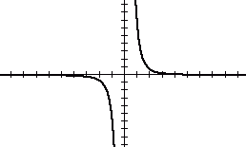
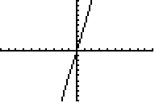
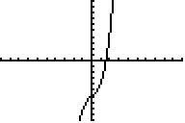
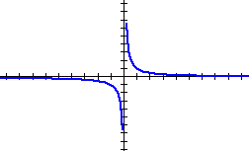
- 11. 12.

__________________ ________________ _________________

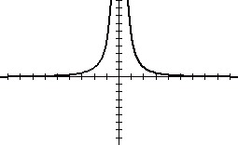
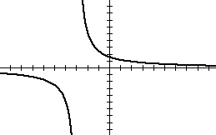
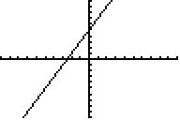
13. 14. 15.

__________________ ________________ _________________

Given a table identify which relationship is “directly proportional”, “inversely proportional”, or “neither”:

x | y
2 | 18
4 | 9
8 | 4.5
9 | 4
12 | 3
16 | 2.25
18 | 2
x | y
3 | 18
4 | 32
5 | 50
6 | 72
7 | 98
8 | 128
9 | 0.625
x | y
1 | 7
2 | 13
3 | 23
4 | 37
5 | 55
6 | 77
7 | 103
16. 17. 18.

__________________ ________________ _________________

Solve the following:

- The Law of Lever states that to balance a given person seated on a seesaw, the distance the other person is from the pivot (or fulcrum) is inversely proportional to that other persons’ weight .
- Write an equation for this situation. Let d = distance and w = weight.

- If Casandra, who weighs 40 lbs., is sitting 5 feet from the fulcrum how far away from the fulcrum will her friend Carlos, who weighs 100 lbs. need to sit to balance Casandra?

- The weight of a body above the surface of the Earth varies inversely as the square of its distance from the center of the Earth.
        - Write an equation to describe this situation. Define your variables.

- Assume the Earth’s radius is 4000 miles. If a man weights 165 lbs. at the Earth’s surface, how much would he weigh if he is 12,000 miles above the earth’s surface?

- The amount of money raised at a basketball game is directly proportional to the number of attendees. The amount of money raised for 300 attendees was $2100. How much money will be raised for 750 attendees?

- The volume of gas in a container varies inversely as the pressure. If the volume is 340 ft³ with pressure of 48 lbs/in², what pressure has to be applied to have a volume of 376 ft³?

- Distance in feet it takes a car to stop after the brakes are applied varies directly with the square of the car’s speed. The formula d = $\frac{1}{12}$s² describes this relation for a certain car.
        - If the car is traveling at a rate of 75 mph what is the stopping distance?

        - The average size car is about 13.5 feet. If you are going 75mph, how many cars away would you have to start breaking if a stopped car is in front of you and you want to avoid an accident?

