Activity 3.5.2 Roller Coaster Redux

For this activity, we are again going to model the curve of a roller coaster. You just watched the youtube video at https://www.youtube.com/watch?v=RcfMdHD_4ZI of two children who want to build a roller coaster whose graph looks like the graph below.
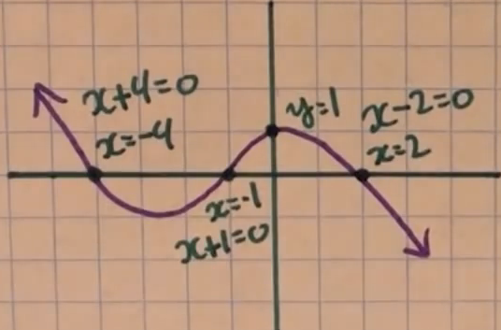

The children came up with the equation Y1 = 1(x+4)(x+1)(x–2) = x³ +3x² – 6x – 8 to model the graph. However, when they graphed that function on the TI-84, it looked like this:
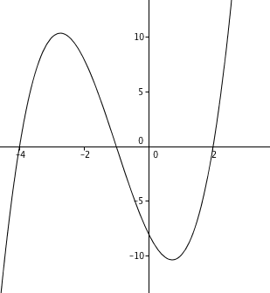

Work with your partner to answer the following questions.
- Why wasn’t the equation that the children found a good fit for the roller coaster that they wanted to model?

- What features of the actual graph will enable you to find an equation that better fits the curve of the roller coaster?

3. Determine the equation that will pass through the three x-intercepts and through the point (0,1) on the graph.
4. As a follow-up to the previous problem, find the image of an actual roller coaster on the internet and create a polynomial function to model the shape of the roller coaster. In order to insert the image into a GeoGebra graph, follow the instructions below.
a. Capture a screen of the image you want to create an equation for and save it as a file.
b. Open a new file in GeoGebra and show the grid on in the graphing view.
c. Click on the icon in functions menu and cursor down to the icon to insert an image into the file.
d. In the Edit menu, select “insert Image From” and select the image of the roller coaster you found.
e. The image will have two reference points, A and B. Move point A down to the lower left-hand corner of the graph and point B to the lower right-hand corner of the graph.
f. In the Edit menu, select “Object Properties.” From the Basic menu, click on the two boxes, “Fix Object” and “Background Image.” This will keep the image in place as you try to fit a curve to the image.

5. Select only a portion of the roller coaster to model, but try to create a polynomial of the highest degree possible to fit the greatest about on the roller coaster as possible.

6. Save your GeoGebra file with the graph of the polynomial that best fit your image and turn it in to the teacher.

