Activity 3.3.4 Finding an Equation versus Finding the Equation:
What’s the Difference?

In previous investigations, we have learned how to find an equation given its x-intercepts or given its roots. This investigation takes that process one step further to see what it takes to make the equation unique.
Open the GeoGebra file Finding a Specific Function.ggb in the Graphics view only. There are four sliders in the graph that regulate properties of the graph of the cubic polynomial, y = f(x). Set sliders a, b, c, and d equal to 1 for the first part of the investigation. The graph will look like this:
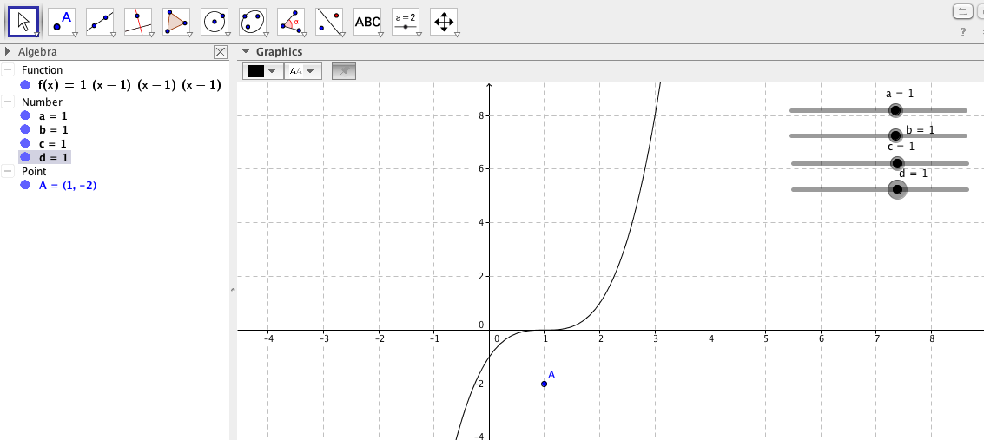

1. Move slider a so that it equals several different values. What property of the graph is slider a controlling. How does it change the graph?

2. Repeat #1 for sliders b and c. What property of the graph do these sliders control?

3. Manipulating the sliders, create a graph that has x-intercepts of (-1,0), (2,0) and (5,0). Trace its graph below.
4. Find an equation of the graph with the x-intercepts (-1,0), (2,0) and (5,0).

5. Now activate the Algebra View in the GeoGebra file. See if the equation you gave is the equation given.

6. Keep the sliders for a, b, and c in the same position to maintain the x-intercepts from #3. Now change the value of d using its slider. How does the value of d affect the graph?

7. Go to the Algebra View and click on the point A in order to show it in the graph. Does the graph currently go through point A?

8. Manipulate the value of d until the graph passes through the point A(1,-2). Describe how you know what changes to make in the value of d to make it pass through the point A.

9. What value of d makes the graph pass through point A?

10. Verify numerically that the value of d found in #8 does make the graph pass through the point (1,-2).

12. Another way to determine the value of d once the basic factors are known is to create the equation of the function using the x-intercepts or zeros of the polynomial in the form f(x) = d(x+1)(x–2)(x–5). Since the point A(1,-2) must be on the graph, it must also be a solution to the equation. Substitute the value 1 in for x and the value –2 in for y=f(1), then solve for d. Does this value match your previous value for d?

13. Find the exact equation for the polynomials given the following information:
a. f(x) is a cubic function with x-intercepts 0, -1, and 3 and passes through the point (4,-6).

b. g(x) is a cubic function a root x=-2 and a double root x=3 and passes through the point (0,-27).

c. h(x) is a quartic function with x-intercepts -3 and 1, has a complex root of -2i and passes through the point (2,40).

d. k(x) is a quartic function whose graph is shown below.
