Activity 3.3.3 Factoring Polynomials Using Identities

Understanding common polynomial identities is very important in successful factoring. Some identities can be easily shown with geometric representation.
1. Explain what identity is shown by the series of images below:
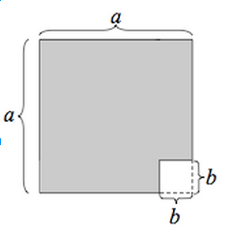
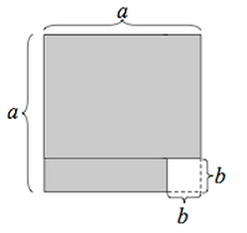
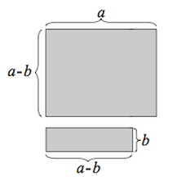
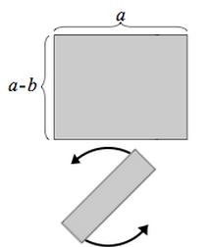
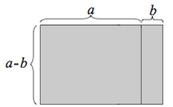

2. Multiply the following expressions and note the common pattern formed:
- $(4x-7)(4x+7)$

- $(-\frac{1}{4}x+10)(-\frac{1}{4}x-10)$

3. Based on observations above, factor the following expressions as a difference of squares:
- $16x^{2}-\frac{49}{64}$

- $81x^{6}-10000x^{10}$

4. Sometimes you can factor one polynomial because you know how to factor another polynomial of parallel structure. Follow the first example that uses the factored form of the polynomial on the left to factor the polynomial on the right. Then factor the polynomial on the left, and use its structure to factor the polynomial on the right.

$x^{2}+8x+15=(x+5)(x+3)$ | $$4x^{2}+16x+15={(2x)}^{2}+8\left(2x\right)+15$$  Notice that the polynomial now has the same structure as the polynomial on the left. Therefore it can be factored as:  $$(2x+5)(2x+3)$$  by replacing x with 2x in the factored form.
$$x^{2}+5x-6$$ | $$9x^{2}+15x-6$$
$$x^{2}+10x+21$$ | $$x^{10}+10x^{5}+21$$
$$x^{2}-4x-12$$ | $$(2x+3)^{2}-4(2x+3)-12$$

5. New identities can be found by observing patterns. Use long division to perform the following division problems. What conclusions can you make?
- $\frac{x^{3}-8}{x-2}$

- $\frac{x^{3}-27}{x-3}$

- $\frac{{64x}^{3}-1}{ 4x-1}$

- $\frac{x^{3}+8}{x+2}$

- $\frac{x^{3}+27}{x+3}$

- $\frac{{64x}^{3}+1}{ 4x+1}$

6. Based on your conclusions to (5) above, fill in the blanks in the equations below:

$$A^{3}-B^{3}=$$

$$A^{3}+B^{3}=$$

7. Problem: The outside of a wooden cube is painted green, and the cube is then divided up into $n^{3}$ smaller cubes. (The image below shows a cube that is divided into 4³ smaller cubes.)
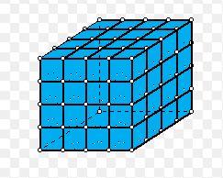
- What algebraic expression represents the number of cubes that have no paint on them?

- Write an expression that represents the amount of cubes with at least one side painted.

- What algebraic expression represents the number of cubes that have exactly one side painted?

- What algebraic expression represents the number of cubes that have exactly two sides painted?

- What algebraic expression represents the number of cubes that have exactly three sides painted?

- Find the sum of the cubes that have 1, 2, and 3 sides painted.

- Use an identity stated in #6 to verify that b and f represent equivalent expressions.
8. Use the identities in #6 to factor the following expressions:
- $8x^{3}-y^{6}$

- $64x^{12}+\frac{1}{27}$

- $(x+1)^{3}-(2x+1)^{3}$

