Activity 3.3.2 Roots and Factored Form of Polynomials

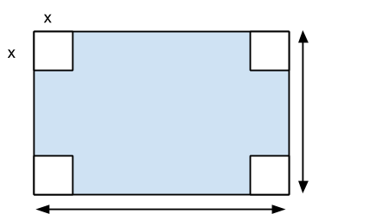

Given an open-top box constructed from a sheet of cardboard as shown above, the volume is given by V(x) = 4x³ – 84x² + 432x.

- Completely factor V(x) using any method.

- Use the factored form to deduce what the original dimensions of the cardboard must have been.

3. Remember that not all quadratic polynomials have real roots. The following polynomials can be written as a product of quadratic factors (that are irreducible with real coefficients) and/or linear factors. Find the factored form of each:
The first example is done for you...
- x³ – x² + 2x – 8

First create the polynomial function f(x) = x³ – x² + 2x – 8. Graphing the function as shown below, f(x) has only one x-intercept (real root) at x=2. By the Factor Theorem, we know that the linear factor (x-2) divides f(x). Using long division and the Division Algorithm, we see that f(x) = (x–2)(x²+ x + 4). Since there is only one x-intercept, the quadratic factor has no real roots, so it is irreducible over the set of real numbers.
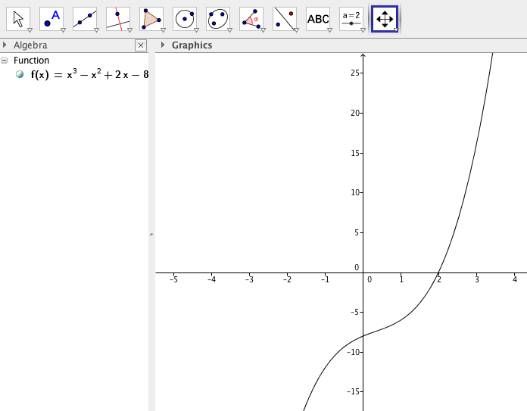

Using the example above, completely factor the following polynomial expressions using any method you know:
- 2x⁴ – 8x³ – 8x² – 8x – 10

- $9x^{4}+3x^{3}+25x^{2}+9x-6$

- $\frac{1}{4}x^{4}+\frac{1}{2}x^{3}-\frac{1}{4}x^{2}-2x-3$

- $x^{4}+10x^{2}+9$

4. The following functions are polynomials with complex coefficients in factored form that have real coefficients when written in standard form. Verify this by multiplying each expression to rewrite the polynomial in standard form and use a graphing utility to make a simple sketch of each to show x-intercept(s) and end behavior.

- $f(x)=(x-2i)(x+2i)$
Standard Form: Sketch:

- $g(x)=(x+1)(x-(3-4i))(x-(3+4i))$
Standard Form: Sketch:

- $h(x)=(x-i\sqrt{2})(x+i\sqrt{2})(x-(1-\sqrt{2}))(x-(1+\sqrt{2}))$
Standard Form: Sketch:

5. Based on the previous examples, what property of the roots of quadratic factors is illustrated when converting the factored form of the polynomial to the standard form of the polynomial?

From the property identified in #5, we see that if a polynomial p(x) with real coefficients has a complex root a+bi, then its conjugate, a-bi, must also be a complex root.

6. Based on this property, why would it be impossible to create a fifth degree polynomial with real coefficients under the following conditions?:
- Complex Roots $\{0, 3+i, -3i, 4, -3\}$

- Complex roots $\{-\sqrt{2} (multiplicity 2), \sqrt{3} (multiplicity 2), 1+i\sqrt{3}, 1-i\sqrt{3}\}$

- The graph of the polynomial looks like this:
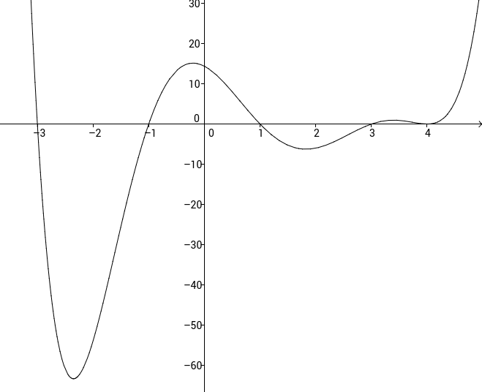

6. Create a polynomial with real coefficients, written in standard form, given the following conditions:

- Third degree, lead coefficient -2, x-intercept at (4, 0) complex root 4+i

- Fourth degree, y-intercept at (0, 8), complex root 2i with multiplicity of 2.

- Fifth degree, roots {3 (multiplicity 3), -1+5i}, graph passes through (1,1).

