Activity 3.2.1 Polynomial Operations Revisited

I. The shape below is a rectangular prism with length 3x+2 cm, width 2x+1 cm, and height x+5 cm.

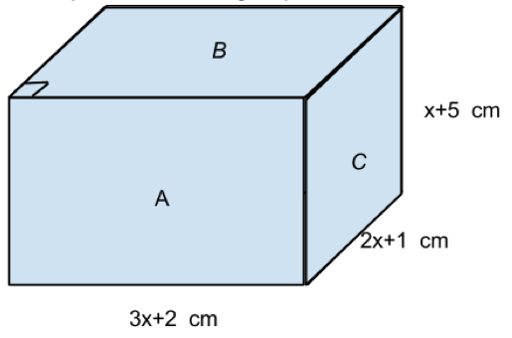

- Write a polynomial expression (in standard form) for the area of each rectangular region, A, B, and C:

A=

B=

C=

2. Write a polynomial expression (in standard form) that would represent the total surface area of the rectangular prism.

3. Write a polynomial expression (in standard form) that represents the volume of the rectangular prism.

II. A rectangular prism has a volume equal to 10x³ – 41x² + x + 12. The length is equal to 2x+1 cm and the width is x-4 cm.

4. Trevor believes that the height should be 5x–3 cm. Do you agree or disagree with Trevor? Explain your answer.

5. Based on your findings above, what would the total surface area of this rectangular prism be?

III. Revenue, Cost, and Profit: An Example from Business.
The demand function determines the selling price necessary for an item in order for x units of the item are to be sold. To create a low demand, the price is usually high. To create a large demand, the price is usually low. In business, the company tries to set production at a price that will generate the greatest profit. Profit is found by taking the difference between revenue, R(x), and cost, C(x), of producing x units of the item. The revenue function, R(x), is equal to the number of units sold times the price per unit determined by the demand function, D(x), for that item.

A tech company is making a hard drive whose demand function, D(x) = -.018x² – 0.03x + 30, for x hundreds of units. If the cost of making x hundred units is given by the function, C(x) = 15x + 100, answer the following questions.

6. What is the function for the revenue generated by selling x hundred units of the hard drive?

7. How much revenue will be generated when 1000 hard drives are sold?

8. What is the function for the profit generated by selling x hundred units of the hard drive?

9. At what level of production will the company begin to make a profit?

10. What level of production should the company establish in order to make a maximum profit? Explain how you determined your answer.

