Activity 3.1.1 Winter in Connecticut

Winter in Connecticut can experience some pretty cold temperatures. The graph below shows a 24-hour period during which time the temperature (measured in °C) dropped well below freezing. Study the graph and answer the questions based on the features of the graph. Time t = 0 is the equivalent of 12:00 midnight.

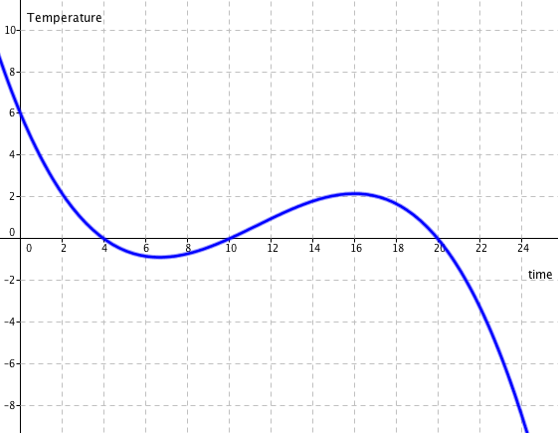

- What was the temperature at 12:00 midnight?

- How much did the overall temperature drop in the 24 – hour period?

- How many times during the day did the temperature read exactly 0˚C? At what time(s) did that occur?

- During what times during the day was the temperature below 0˚C? Explain how you determined those times.

- At what time is the temperature at a relative maximum, that is, when the temperature stops increasing and starts decreasing?

- At what time is the temperature at a relative minimum, that is when the temperature stops decreasing and starts increasing?

- Are the answers for questions 5 & 6 the highest and lowest temperatures of the 24-hour period? If not, what are the highest and lowest temperatures reached?

- During what times during the day was the temperature decreasing? Can you provide an explanation why that was happening?

- During what times during the day was the temperature increasing? Can you provide an explanation why that was happening?

- What is happening at the beginning and end of this graph? Should arrows be placed on those ends? Why or why not?

Activity Overview
This activity is designed to demonstrate student’s ability to interpret graphs when given in the context of a real-world problem. Students should be made aware of the fact that the same analysis that they applied to the graph in this problem can be applied to any relationship when a graph of the relationship can be determined. This unit will allow students to develop the skills needed to create accurate graphs of polynomial functions and interpret their meaning, either in their abstract form or in the context of a real-world problem.

