Activity 3.1.1 Winter in Connecticut

Winter in Connecticut can experience some pretty cold temperatures. The graph below shows a 24-hour period during which time the temperature (measured in °C) dropped well below freezing. Study the graph and answer the questions based on the features of the graph. Time t = 0 is the equivalent of 12:00 midnight.

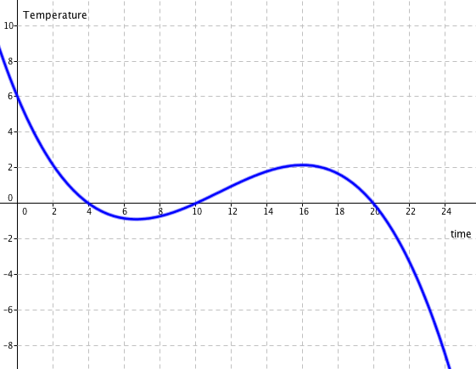

- What was the temperature at 12:00 midnight?

- How much did the overall temperature drop in the 24 – hour period?

- How many times during the day did the temperature read exactly 0˚C? At what time(s) did that occur?

- During what times during the day was the temperature below 0˚C? Explain how you determined those times.

- At what time is the temperature at a relative maximum, that is, when the temperature stops increasing and starts decreasing?

- At what time is the temperature at a relative minimum, that is when the temperature stops decreasing and starts increasing?

- Are the answers for questions 5 & 6 the highest and lowest temperatures of the 24-hour period? If not, what are the highest and lowest temperatures reached?

- During what times during the day was the temperature decreasing? Can you provide an explanation why that was happening?

- During what times during the day was the temperature increasing? Can you provide an explanation why that was happening?

- What is happening at the beginning and end of this graph? Should arrows be placed on those ends? Why or why not?

