Unit 1: Investigation 5 (3 Days)

Composition of Transformations

Common Core State Standards

- G-CO.5. Given a geometric figure and a rotation, reflection, or translation, draw the transformed figure using, e.g., graph paper, tracing paper, or geometry software. Specify a sequence of transformations that will carry a given figure onto another.

Overview

This investigation explores composition of transformations—or what happens when successive transformations are done on an object. Students will see that two reflections in parallel lines produce a translation and two reflections in intersecting lines produce a rotation. They will also see that two rotations produce another rotation and two translations produce another translation. In the case of the rotations, we add the two angles of rotation together to get the new angle of rotation. Similarly, with the translations, we add the two vectors together to the get the new translation vector. Students will also be introduced to glide reflections—the result of a translation followed by a reflection parallel to the translation vector.

Assessment Activities

Evidence of Success: What Will Students Be Able to Do?

- Explain what the result will be when doing successive reflections in both parallel and intersecting lines and will be able to find the sum of the new angle of rotation in the latter
- Determine the result of composing two rotations and two translations
- Determine the result of performing glide reflections on an object

Assessment Strategies: How Will They Show What They Know?

- Exit Slip 1.5.1 gives students a figure and two intersecting lines and asks them to approximate reflecting the object over the first line and then the second. They are also asked to estimate the angle of rotation between the pre-image and the second reflected image.
- Exit Slip 1.5.2 asks students to perform the composition of two translations.
- Journal Entry asks students to explain why we get a glide reflection regardless of the order we perform the translation and the reflection in.

Launch Notes

Begin the investigation with a survey question.

Ask students what they think will happen to an object if you perform a reflection and then another reflection. Give them the following multiple-choice answers (or add your own additional choices).
- The result will be a reflection of the original object
- The result will be a rotation of the original object
- Both A and B are possible
- The world may end

As a technology note, you can also conduct the survey using either PollEverywhere (http://www.polleverywhere.com/) or Socrative (http://socrative.com/)

Teaching Strategies

Activity 1.5.1 Composition of Two Reflections I is an extension of the launch. Have students work in pairs or small groups and give them graph paper, rulers, and protractors. Ask them to create an object and then reflect it over one line and then over another. They should then explain how the final image compares to the original object. That is, how could you describe the reflection in terms of the pre-image (i.e., a rotation, a reflection, etc.). For differentiation purposes, you can either let students explore this in a true inquiry fashion or you could explicitly instruct some groups to reflect the object over parallel lines and some to reflect over intersecting lines. The goal is for all students to see the two different scenarios.

Activity 1.5.2 Composition of Two Reflections II uses Geogebra to go into more depth. One of the objectives of the activity is to see that the angle of rotation between the pre-image and the final image is exactly twice the angle formed by the intersecting lines.

They will be instructed to first create an object and then reflect it over a line:

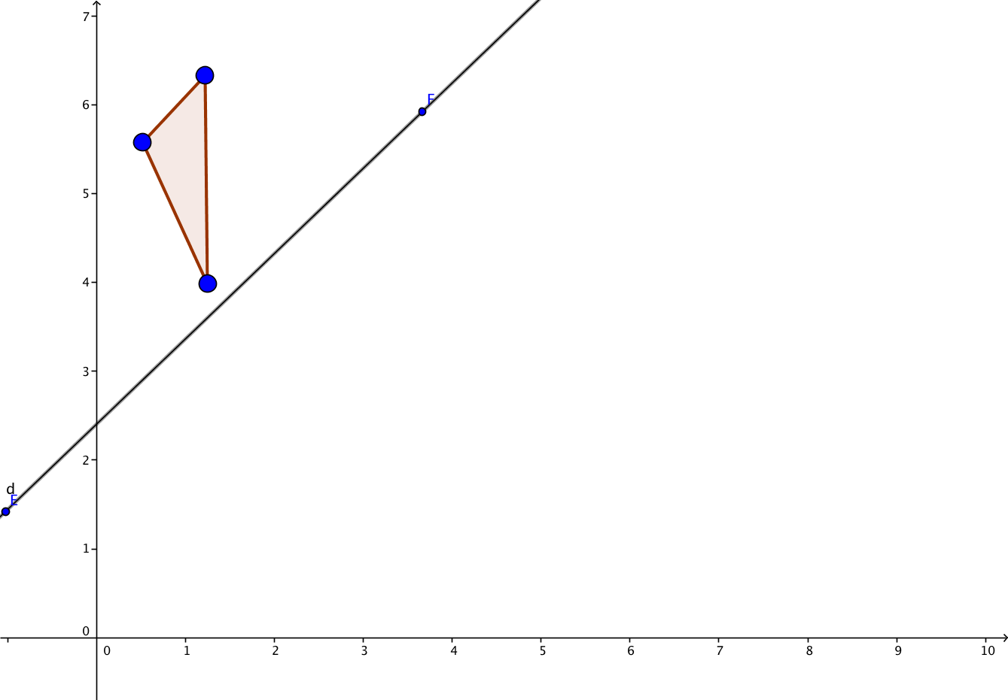
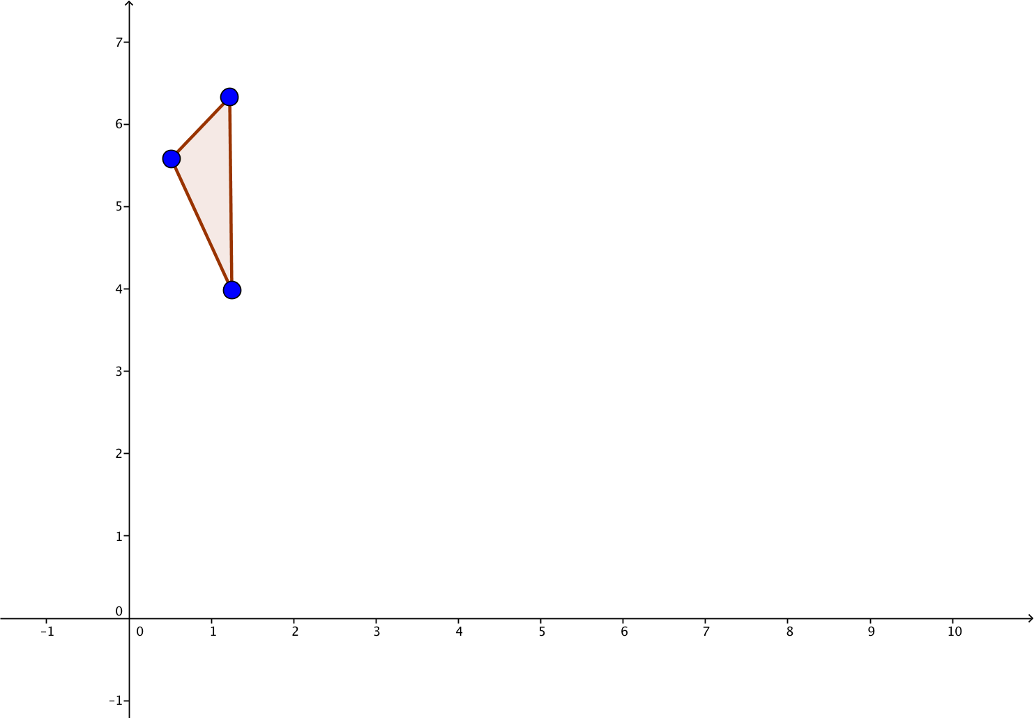

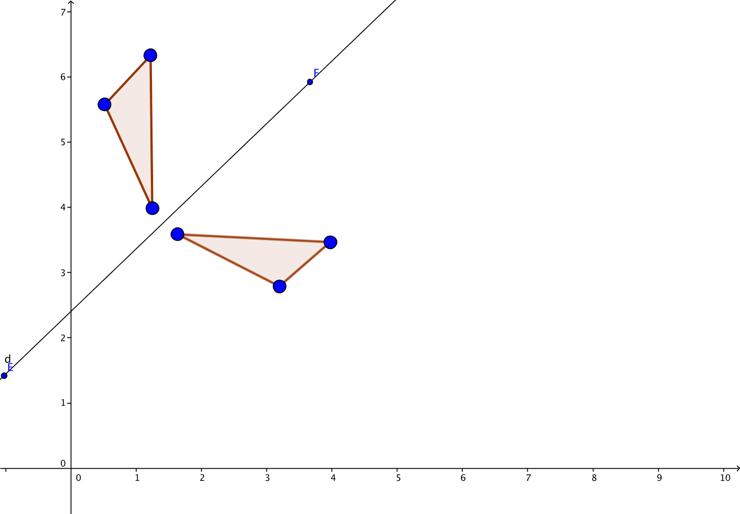

The students will then be instructed to create another line that intersects with the first.

Differentiated Instruction (for Leaners Needing More Help)
For most students, you may want to instruct them to create the second line so as not to intersect the reflected shape. This will make it much harder to “see” the next reflection.

They then will reflect the reflected image over that new line. They can also “hide” the first reflection so only the pre-image and the second reflection are showing.

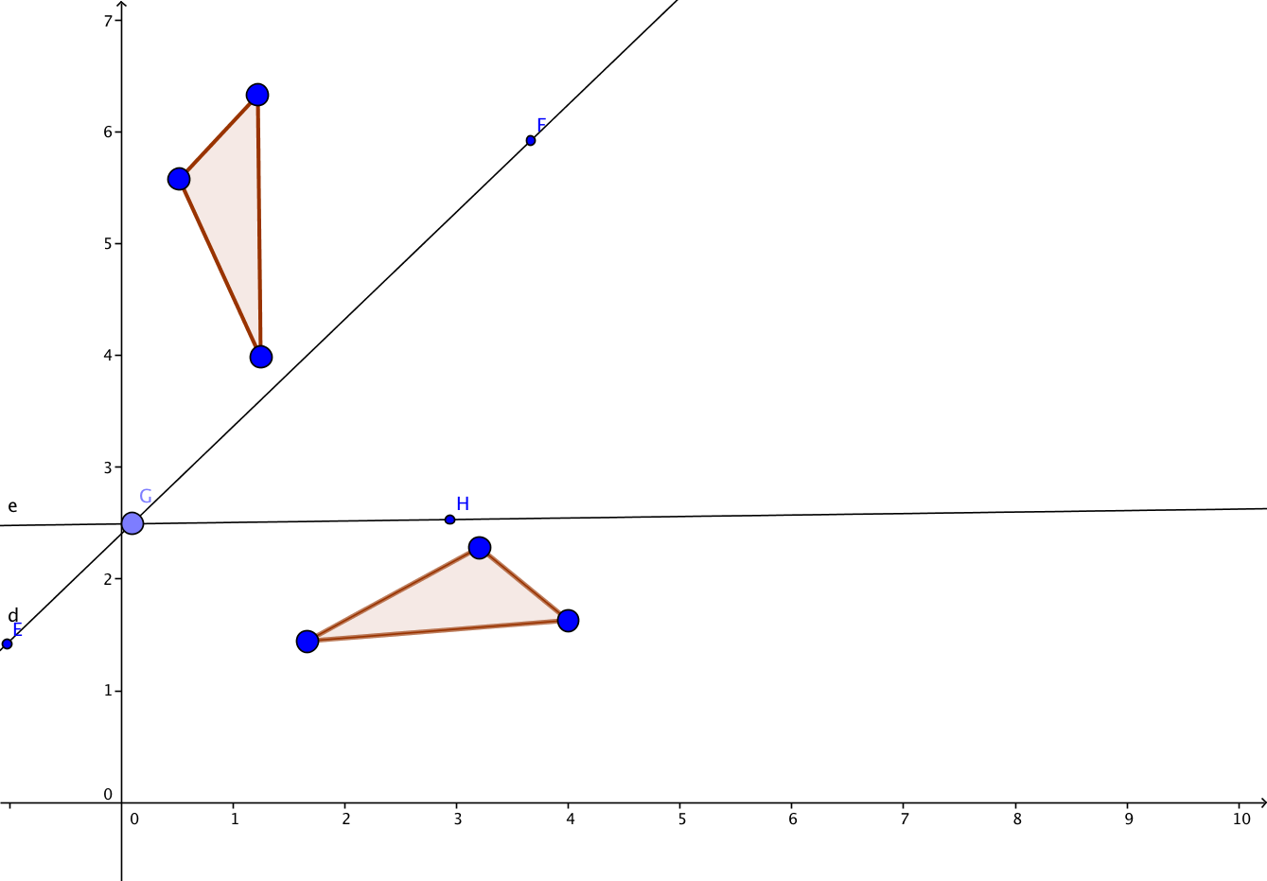
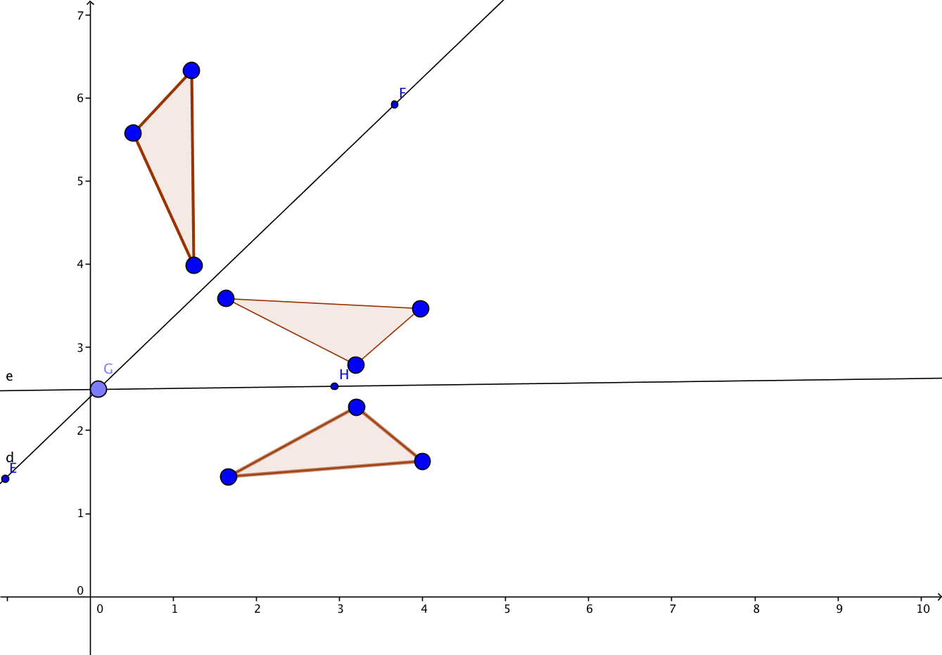

Students will then find the measure of the angle formed by the intersecting lines, as well as the measure of the angle of rotation. They should see that the latter is exactly twice the former.

At the end of Day 1 you may give students Exit Slip 1.5.1 which gives them a figure and two intersecting lines and asks them to approximate reflecting the object over the first line and then the second. They are also asked to estimate the angle of rotation between the pre-image and the second reflected image.

To begin Day 2 and Activity 1.5.3 Composition of Two Rotations have students work in pairs or small groups. This activity has them creating an object, then performing two rotations on the object. They will also discover that the adding the measures of the two smaller rotations will lead to the measure of the larger rotation. There are two versions of this activity. Activity 1.5.3a uses Geogebra. Activity 1.5.3b uses graph paper, rulers, and protractors.

Similarly, in Activity 1.5.4 Composition of Two Translations students will create an object and then perform two translations on it. Also similar to the previous activity, they will observe that adding the two vectors together gives the translation vector. This activity is based on coordinate geometry. Thus a variety of different tools are used throughout this investigation.

At the end of Day 2, you may give students Exit Slip 1.5.2, which asks them to perform a composition of translations, showing the final image and determining the translation vector.

Day 3 and Activity 1.5.5 Glide Reflections introduces a new transformation that is the composition of a reflection and a translation.. Footprints are often used to teach this concept because they represent a perfect illustration of it. Glide reflections are compositions of a reflection and a translation—in either order. Additionally, the line of reflection is parallel to the direction of the translation. So, again, footprints really illuminate this action.

To add some variety and a real-world tie-in, this activity uses animal footprints instead of human footprints. You may want to begin the activity with this video which explains the science of tracking animals by their footprints: http://www.globalpost.com/video/5688103/location-video-the-science-animal-tracking. Students will be creating glide reflections based on different animal footprints.

Note that question #6 in the activity calls for students to find a paw print image online. As an alternative, you can have students use the paw print jpeg that is included in this unit.

Journal Prompt: Why do you get a glide reflection regardless of whether you translate first or reflect first? Look for students to draw a picture to show two different ways to get from the pre-image to the final image.

Differentiated Instruction (Enrichment)
There are other combinations of two transformations that we have not yet explored. Some students might want to experiment to see what happens when:

- a translation is followed by a rotation, and vice versa
- a rotation is followed by a reflection (either over a line through the center of rotation or over a line that does not pass through the center of rotation)
- a translation followed by a reflection over a line that is NOT parallel to the translation vector, and vice versa

Closure Notes

In this investigation we have discovered the major compositions of transformations – reflecting an object twice over parallel lines and intersecting lines, two successive rotations, two successive translations, and guide reflections. Students should be able to visualize composing any two transformations. They should be able to explain the difference in the final reflected object (as compared to pre-image) if reflected over the two parallel lines or the two intersecting lines. They should also be able to explain that when we do two rotations the final angle of rotation is equal to the sum of the two smaller angles and when we do successive translations, the resulting translation vector is the sum of the two translation vectors. They should also understand that a glide reflection is the composition of a translation and reflection in a line parallel to the translation vector.

Vocabulary

Composition (of transformations)
Glide reflection

Resources and Materials

Web site on animal tracking: http://www.globalpost.com/video/5688103/location-video-the-science-animal-tracking

Activities:
Activity 1.5.1 Composition – Two Reflections I
Activity 1.5.2 Composition – Two Reflections II
Activity 1.5.3 Composition –Two Rotations
Activity 1.5.4 Composition –Two Translations
Activity 1.5.5 Glide reflections

Rulers, protractors, graph paper for Activity 1.5.1 and 1.5.3
Geogebra for Activity 1.5.2 and 1.5.5

