Unit 1: Investigation 4 (1 Day)

Reflections

Common Core State Standards

- G-CO.2. Represent transformations in the plane using, e.g., transparencies and geometry software; describe transformations as functions that take points in the plane as inputs and give other points as outputs. Compare transformations that preserve distance and angle to those that do not (e.g., translation versus horizontal stretch).
- G-CO.4. Develop definitions of rotations, reflections, and translations in terms of angles, circles, perpendicular lines, parallel lines, and line segments.

Overview

In previous investigations, students have explored translations and rotations. This investigation exposes students to the last of the three main transformations, rotations. They will see that reflections reverse the orientation of an object. They will examine reflections across the x- and y-axes, as well as, the lines y = x and y= –x.

Assessment Activities

Evidence of Success: What Will Students Be Able to Do?

- Explain what happens to the coordinates when a point or object is reflected about the x-axis, the y-axis, the line y=x, and the line y = –x
- Use dynamic software (such as Geogebra) to create reflections of objects

Assessment Strategies: How Will They Show What They Know?

- Exit Slip 1.4 asks students to reflect an object about the line y-axis
- Journal Entry asks students to explain what happens to the coordinates of a point when it is reflected about the x-axis and about the y-axis.

Launch Notes

Begin the class with this video on geometric transformations used by Discovery Education when creating animated dinosaurs. Not only does it discuss reflections, but it also reviews translations and rotations for students as well. from PBS on reflections.: http://www.pbslearningmedia.org/resource/muen-math-g-reflection/reflection/

Teaching Strategies

Begin by showing students the Symmetry Artist from mathisfun.com (http://www.mathsisfun.com/geometry/symmetry-artist.html). You can choose to reflect drawn images over the x-axis, the y-axis, or the lines y=x and y=-x. It also allows for reflections about the origin, but this could be a little abstract for some students. This virtual activity works well on an Interactive White Board. Also, as a note, try the dots pen style. That is always a crowd pleaser.

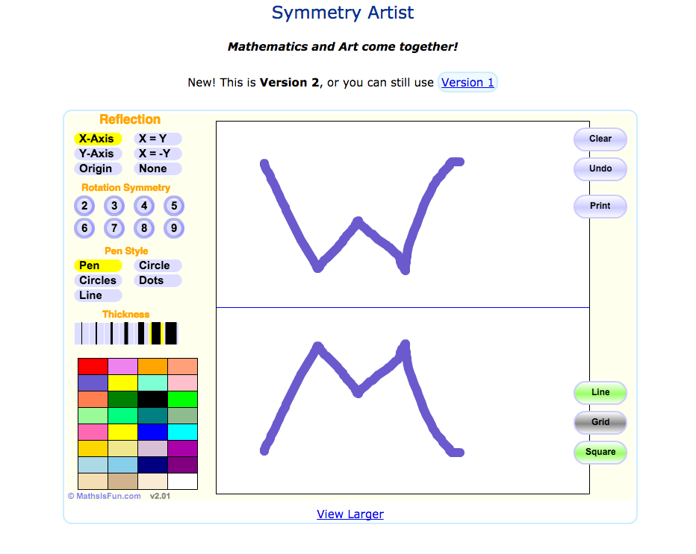

Now ask students to think of what happens to the coordinates of points when we reflect them about various lines. Have students turn and talk to discuss what will happen to the point (3,5) if it is reflected across the y-axis.

Activity 1.4.1 Reflection in Geogebra has students creating reflections in Geogebra. They will be creating polygons and reflecting those, as well as, importing images and reflecting those.

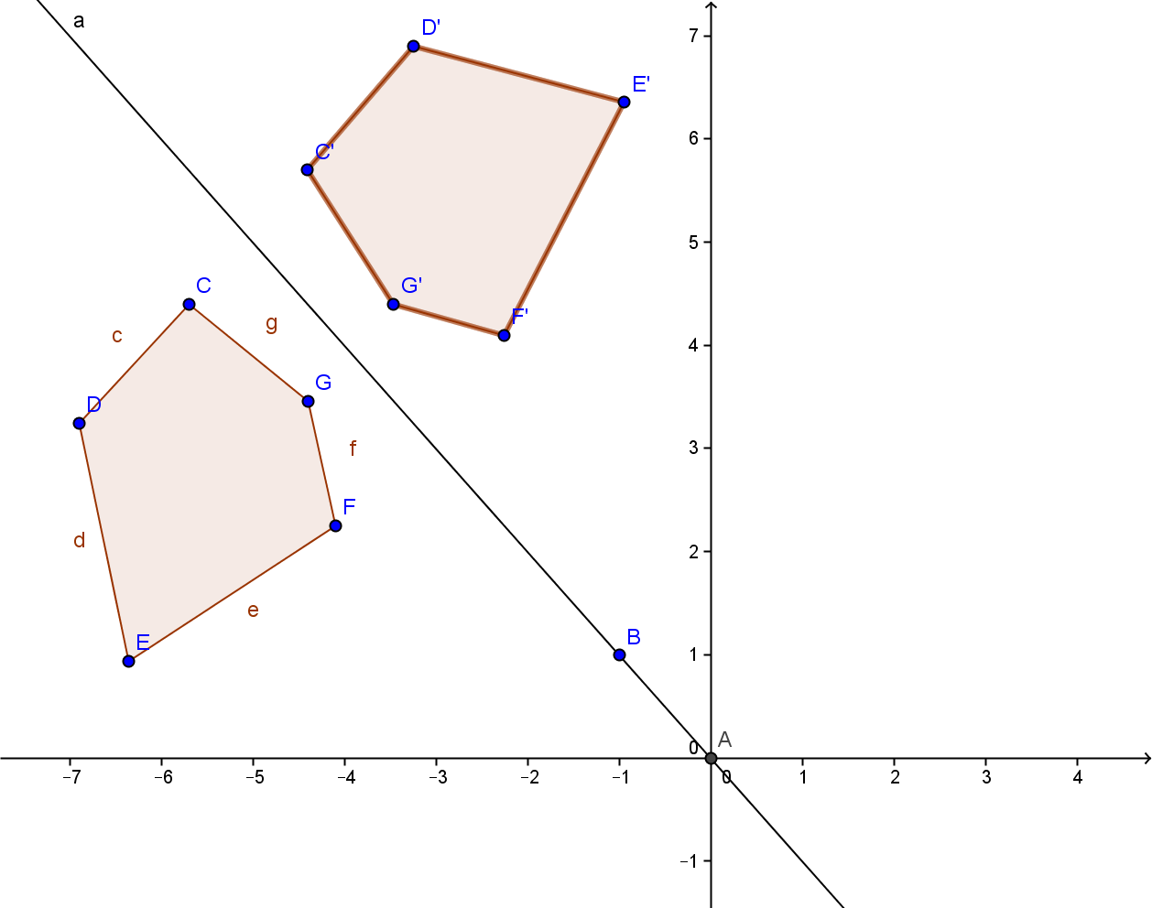
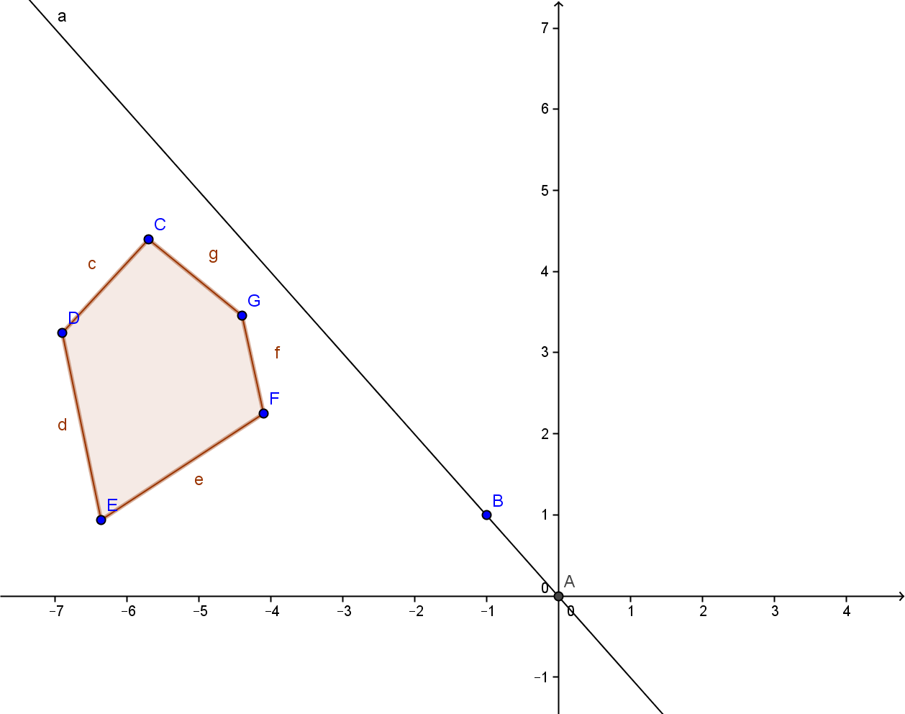

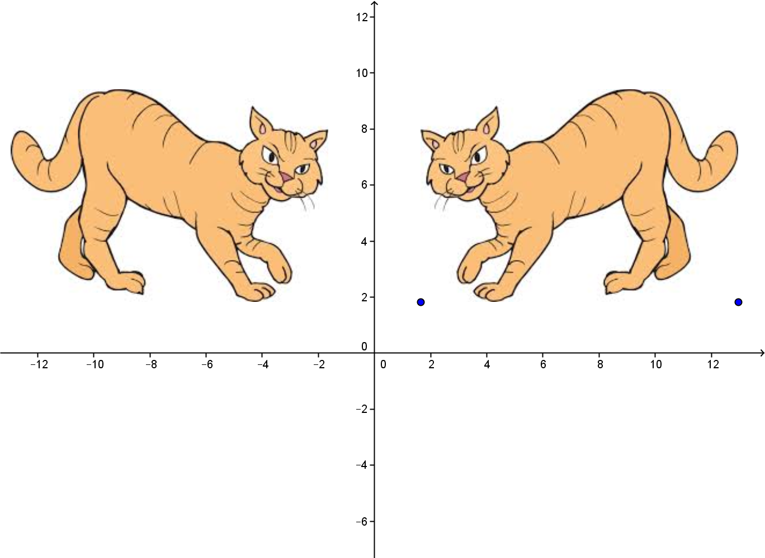
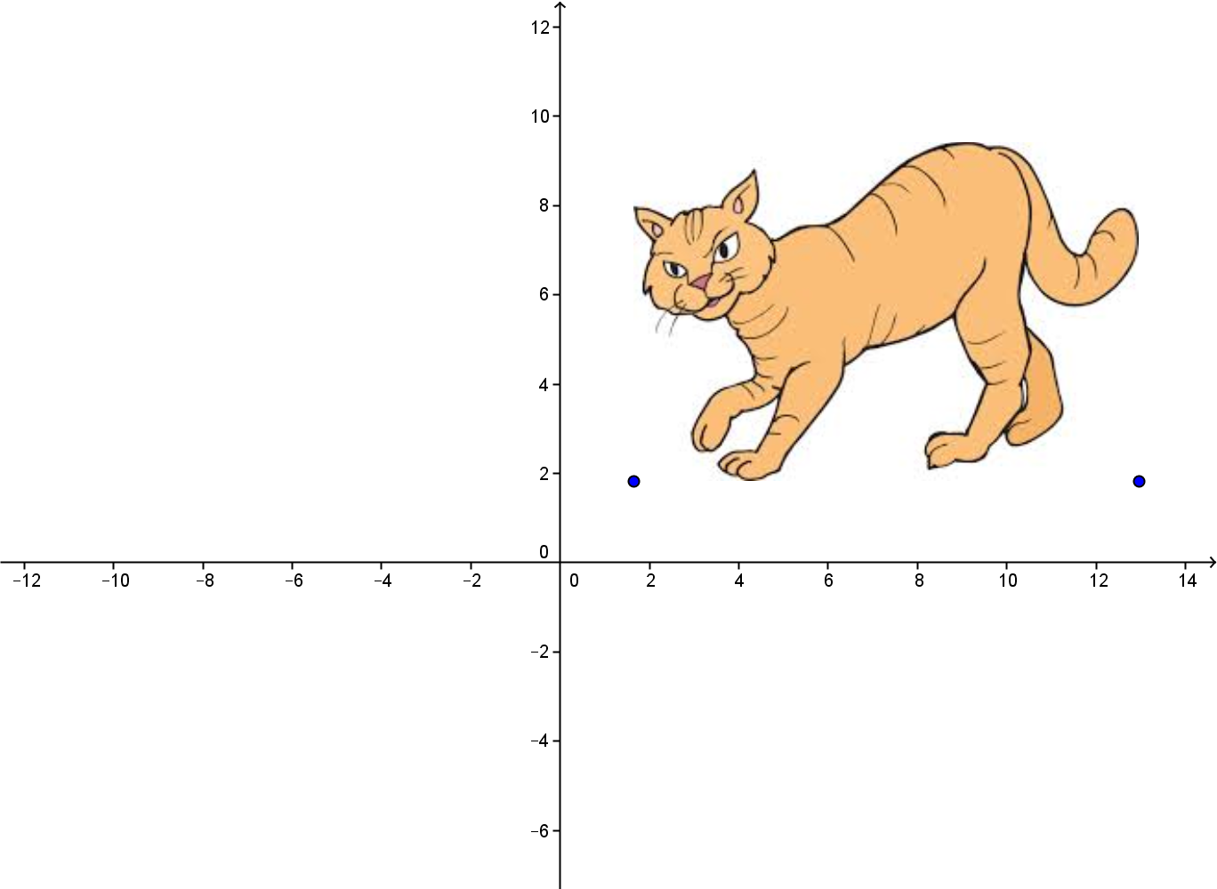

Once students have learned how to create reflections in Geogebra, Activity 1.4.2 Reflection Behavior leads them through an exploration of what happens to the x- and y-coordinates when reflected about the four lines of interest (x-axis, y-axis, y=x, and y = –x). This activity should be done on a coordinate plane with graph paper. The final Activity 1.4.3 Exploring Reflections has students explore properties of reflections. In this activity students use paper folding to create images and rulers and protractors to compare measurements in pre-images and images. They discover some important properties of reflections. Some are shared by other isometries and others are unique to reflections. Later in the unit students will be compiling lists of properties of all the transformations studied in this unit.

Students will notice that when a point is reflected over a line, the pre-image and image lie on opposite sides of the line. Based on that observation you may want to introduce the Plane Separation Postulate: If a line l lies in a plane then every point in the plane not on l lies on one side or the other side of l. If B lies on the opposite side of l from A then the line segment $\overline{AB}$ intersects line l in one point. This property of lines will be used in Unit 2 when we prove the triangle congruence theorems.

At the end of the day, you may give students Exit Slip 1.4 which asks them reflect a triangle about the y-axis.

Journal Prompt: Why does the x-coordinate change when reflecting about the y-axis and the y-coordinate change when reflecting about the x-axis? Look for students to reference the four quadrants and/or recognize that the direction of motion is horizontal when reflecting about the y-axis and vertical when reflecting about the x-axis.

Closure Notes

This investigation examined reflections, the last of the three geometric transformations that preserve distance and angle measures. Students should come away from this lesson with the understanding that reflections represent mirror images across the line of reflection. They should also be able to determine what will happen to the coordinates of points when reflected about the four lines examined in this lesson.

You may want to ask students to summarize what they have learned about transformations, how what three transformations studied so far have in common, and how they differ from one another.

Vocabulary

Reflections
Mirror line or reflection line

Resources and Materials

Videos:
PBS Learning video Describes reflections: http://www.pbslearningmedia.org/resource/muen-math-g-reflection/reflection/

Web sites:
http://www.mathsisfun.com/geometry/symmetry-artist.html

Activities:
Activity 1.4.1 Reflecting Objects
Activity 1.4.2 Reflection Behavior
Activity 1.4.3 Exploring Reflections

